--------------------------------------------------------------------------------

Setup the parameters...

number of variables : 10

number of objectives : 3

reference point : [0, 0, 0]

interval of #weights : [(100, 100), (500, 500), (1000, 1000), (1500, 1500), (2000, 2000), (5000, 5000), (10000, 10000)]

solver MIP invoked : GLPK.Optimizer

number of trials : 20

Generate an mo01UKP instance...

Compute S, the set of nondominated points...

|S| = 11 (0.12s)

Compute H, the hypervolume measure...

H(S) = 36323233.0

Compute H̃, the estimation of H...

H estimated with rp=[0, 0, 0] and 100 weight: 34989674.7 (0.19s)

H estimated with rp=[0, 0, 0] and 100 weight: 40723139.9 (0.01s)

H estimated with rp=[0, 0, 0] and 100 weight: 37727631.5 (0.01s)

H estimated with rp=[0, 0, 0] and 100 weight: 31970781.8 (0.01s)

H estimated with rp=[0, 0, 0] and 100 weight: 36401811.8 (0.01s)

H estimated with rp=[0, 0, 0] and 100 weight: 35245578.8 (0.01s)

H estimated with rp=[0, 0, 0] and 100 weight: 38989575.9 (0.01s)

H estimated with rp=[0, 0, 0] and 100 weight: 36402867.4 (0.01s)

H estimated with rp=[0, 0, 0] and 100 weight: 35391029.7 (0.01s)

H estimated with rp=[0, 0, 0] and 100 weight: 35042584.0 (0.01s)

H estimated with rp=[0, 0, 0] and 100 weight: 39527005.3 (0.01s)

H estimated with rp=[0, 0, 0] and 100 weight: 36609107.1 (0.01s)

H estimated with rp=[0, 0, 0] and 100 weight: 36045482.0 (0.01s)

H estimated with rp=[0, 0, 0] and 100 weight: 34272816.3 (0.01s)

H estimated with rp=[0, 0, 0] and 100 weight: 36832592.0 (0.01s)

H estimated with rp=[0, 0, 0] and 100 weight: 38473840.8 (0.02s)

H estimated with rp=[0, 0, 0] and 100 weight: 39211850.7 (0.01s)

H estimated with rp=[0, 0, 0] and 100 weight: 36230285.6 (0.01s)

H estimated with rp=[0, 0, 0] and 100 weight: 33303338.8 (0.01s)

H estimated with rp=[0, 0, 0] and 100 weight: 35661346.2 (0.01s)

Analyze the results...

value H(S) = 36323233.0

average value H̃ = 36452617.0

average absolue error H̃ = 1637325.2

average relative error H̃ = 0.045077

Compute H̃, the estimation of H...

H estimated with rp=[0, 0, 0] and 500 weight: 37467221.0 (0.05s)

H estimated with rp=[0, 0, 0] and 500 weight: 35988001.3 (0.05s)

H estimated with rp=[0, 0, 0] and 500 weight: 36254163.5 (0.05s)

H estimated with rp=[0, 0, 0] and 500 weight: 36703160.2 (0.05s)

H estimated with rp=[0, 0, 0] and 500 weight: 37166242.5 (0.05s)

H estimated with rp=[0, 0, 0] and 500 weight: 36870853.7 (0.05s)

H estimated with rp=[0, 0, 0] and 500 weight: 37378795.5 (0.05s)

H estimated with rp=[0, 0, 0] and 500 weight: 36883354.5 (0.05s)

H estimated with rp=[0, 0, 0] and 500 weight: 35824632.6 (0.05s)

H estimated with rp=[0, 0, 0] and 500 weight: 36960529.8 (0.05s)

H estimated with rp=[0, 0, 0] and 500 weight: 36383289.4 (0.05s)

H estimated with rp=[0, 0, 0] and 500 weight: 34992350.9 (0.05s)

H estimated with rp=[0, 0, 0] and 500 weight: 35952462.5 (0.05s)

H estimated with rp=[0, 0, 0] and 500 weight: 36540519.2 (0.05s)

H estimated with rp=[0, 0, 0] and 500 weight: 35228294.4 (0.05s)

H estimated with rp=[0, 0, 0] and 500 weight: 36543424.2 (0.05s)

H estimated with rp=[0, 0, 0] and 500 weight: 36363261.1 (0.07s)

H estimated with rp=[0, 0, 0] and 500 weight: 36367545.9 (0.05s)

H estimated with rp=[0, 0, 0] and 500 weight: 36138148.6 (0.05s)

H estimated with rp=[0, 0, 0] and 500 weight: 36826898.2 (0.05s)

Analyze the results...

value H(S) = 36323233.0

average value H̃ = 36441657.4

average absolue error H̃ = 506882.2

average relative error H̃ = 0.013955

Compute H̃, the estimation of H...

H estimated with rp=[0, 0, 0] and 1000 weight: 36034298.7 (0.1s)

H estimated with rp=[0, 0, 0] and 1000 weight: 35883678.9 (0.1s)

H estimated with rp=[0, 0, 0] and 1000 weight: 36046744.2 (0.09s)

H estimated with rp=[0, 0, 0] and 1000 weight: 35351258.5 (0.1s)

H estimated with rp=[0, 0, 0] and 1000 weight: 37816165.3 (0.1s)

H estimated with rp=[0, 0, 0] and 1000 weight: 37165723.9 (0.1s)

H estimated with rp=[0, 0, 0] and 1000 weight: 36199598.0 (0.1s)

H estimated with rp=[0, 0, 0] and 1000 weight: 36086587.8 (0.1s)

H estimated with rp=[0, 0, 0] and 1000 weight: 35617654.2 (0.1s)

H estimated with rp=[0, 0, 0] and 1000 weight: 35855542.9 (0.1s)

H estimated with rp=[0, 0, 0] and 1000 weight: 35941224.0 (0.1s)

H estimated with rp=[0, 0, 0] and 1000 weight: 36152049.2 (0.1s)

H estimated with rp=[0, 0, 0] and 1000 weight: 35786746.5 (0.1s)

H estimated with rp=[0, 0, 0] and 1000 weight: 35683425.6 (0.1s)

H estimated with rp=[0, 0, 0] and 1000 weight: 36753669.0 (0.1s)

H estimated with rp=[0, 0, 0] and 1000 weight: 37298637.7 (0.1s)

H estimated with rp=[0, 0, 0] and 1000 weight: 35990402.7 (0.1s)

H estimated with rp=[0, 0, 0] and 1000 weight: 36276843.4 (0.1s)

H estimated with rp=[0, 0, 0] and 1000 weight: 35642464.3 (0.1s)

H estimated with rp=[0, 0, 0] and 1000 weight: 36691914.5 (0.1s)

Analyze the results...

value H(S) = 36323233.0

average value H̃ = 36213731.5

average absolue error H̃ = 520496.1

average relative error H̃ = 0.014330

Compute H̃, the estimation of H...

H estimated with rp=[0, 0, 0] and 1500 weight: 36032662.9 (0.15s)

H estimated with rp=[0, 0, 0] and 1500 weight: 36139335.1 (0.15s)

H estimated with rp=[0, 0, 0] and 1500 weight: 36211172.3 (0.15s)

H estimated with rp=[0, 0, 0] and 1500 weight: 36762409.4 (0.14s)

H estimated with rp=[0, 0, 0] and 1500 weight: 36317645.4 (0.15s)

H estimated with rp=[0, 0, 0] and 1500 weight: 36483078.0 (0.14s)

H estimated with rp=[0, 0, 0] and 1500 weight: 36306920.8 (0.14s)

H estimated with rp=[0, 0, 0] and 1500 weight: 36337464.0 (0.15s)

H estimated with rp=[0, 0, 0] and 1500 weight: 35928530.3 (0.14s)

H estimated with rp=[0, 0, 0] and 1500 weight: 36218383.5 (0.14s)

H estimated with rp=[0, 0, 0] and 1500 weight: 36237260.0 (0.15s)

H estimated with rp=[0, 0, 0] and 1500 weight: 36118884.4 (0.15s)

H estimated with rp=[0, 0, 0] and 1500 weight: 35895910.1 (0.14s)

H estimated with rp=[0, 0, 0] and 1500 weight: 35707629.7 (0.14s)

H estimated with rp=[0, 0, 0] and 1500 weight: 36384563.4 (0.15s)

H estimated with rp=[0, 0, 0] and 1500 weight: 35824429.5 (0.14s)

H estimated with rp=[0, 0, 0] and 1500 weight: 35885652.6 (0.15s)

H estimated with rp=[0, 0, 0] and 1500 weight: 36310475.2 (0.15s)

H estimated with rp=[0, 0, 0] and 1500 weight: 36463385.7 (0.15s)

H estimated with rp=[0, 0, 0] and 1500 weight: 36649717.4 (0.15s)

Analyze the results...

value H(S) = 36323233.0

average value H̃ = 36210775.5

average absolue error H̃ = 226579.5

average relative error H̃ = 0.006238

Compute H̃, the estimation of H...

H estimated with rp=[0, 0, 0] and 2000 weight: 36464629.2 (0.19s)

H estimated with rp=[0, 0, 0] and 2000 weight: 35811457.4 (0.19s)

H estimated with rp=[0, 0, 0] and 2000 weight: 35972453.2 (0.19s)

H estimated with rp=[0, 0, 0] and 2000 weight: 36789578.0 (0.19s)

H estimated with rp=[0, 0, 0] and 2000 weight: 36316904.3 (0.19s)

H estimated with rp=[0, 0, 0] and 2000 weight: 36291963.4 (0.19s)

H estimated with rp=[0, 0, 0] and 2000 weight: 36424304.1 (0.2s)

H estimated with rp=[0, 0, 0] and 2000 weight: 36324575.8 (0.19s)

H estimated with rp=[0, 0, 0] and 2000 weight: 36078612.9 (0.19s)

H estimated with rp=[0, 0, 0] and 2000 weight: 36583030.6 (0.19s)

H estimated with rp=[0, 0, 0] and 2000 weight: 36436888.1 (0.19s)

H estimated with rp=[0, 0, 0] and 2000 weight: 36557935.5 (0.19s)

H estimated with rp=[0, 0, 0] and 2000 weight: 36017567.5 (0.19s)

H estimated with rp=[0, 0, 0] and 2000 weight: 35554877.0 (0.19s)

H estimated with rp=[0, 0, 0] and 2000 weight: 35529562.4 (0.19s)

H estimated with rp=[0, 0, 0] and 2000 weight: 36009336.0 (0.19s)

H estimated with rp=[0, 0, 0] and 2000 weight: 35991693.2 (0.19s)

H estimated with rp=[0, 0, 0] and 2000 weight: 36157090.3 (0.19s)

H estimated with rp=[0, 0, 0] and 2000 weight: 36048491.6 (0.19s)

H estimated with rp=[0, 0, 0] and 2000 weight: 36512014.2 (0.2s)

Analyze the results...

value H(S) = 36323233.0

average value H̃ = 36193648.2

average absolue error H̃ = 280293.9

average relative error H̃ = 0.007717

Compute H̃, the estimation of H...

H estimated with rp=[0, 0, 0] and 5000 weight: 36514780.1 (0.47s)

H estimated with rp=[0, 0, 0] and 5000 weight: 36067556.9 (0.47s)

H estimated with rp=[0, 0, 0] and 5000 weight: 36651653.1 (0.47s)

H estimated with rp=[0, 0, 0] and 5000 weight: 36100302.4 (0.47s)

H estimated with rp=[0, 0, 0] and 5000 weight: 37161610.4 (0.47s)

H estimated with rp=[0, 0, 0] and 5000 weight: 36211108.6 (0.48s)

H estimated with rp=[0, 0, 0] and 5000 weight: 36303940.8 (0.47s)

H estimated with rp=[0, 0, 0] and 5000 weight: 36267837.2 (0.48s)

H estimated with rp=[0, 0, 0] and 5000 weight: 36074431.9 (0.47s)

H estimated with rp=[0, 0, 0] and 5000 weight: 36532554.0 (0.47s)

H estimated with rp=[0, 0, 0] and 5000 weight: 36441187.4 (0.48s)

H estimated with rp=[0, 0, 0] and 5000 weight: 36182236.2 (0.47s)

H estimated with rp=[0, 0, 0] and 5000 weight: 36303241.3 (0.47s)

H estimated with rp=[0, 0, 0] and 5000 weight: 36476555.0 (0.47s)

H estimated with rp=[0, 0, 0] and 5000 weight: 36744423.9 (0.47s)

H estimated with rp=[0, 0, 0] and 5000 weight: 36256568.8 (0.47s)

H estimated with rp=[0, 0, 0] and 5000 weight: 36536085.9 (0.48s)

H estimated with rp=[0, 0, 0] and 5000 weight: 36119581.7 (0.47s)

H estimated with rp=[0, 0, 0] and 5000 weight: 36124536.1 (0.48s)

H estimated with rp=[0, 0, 0] and 5000 weight: 36223802.5 (0.47s)

Analyze the results...

value H(S) = 36323233.0

average value H̃ = 36364699.7

average absolue error H̃ = 205831.9

average relative error H̃ = 0.005667

Compute H̃, the estimation of H...

H estimated with rp=[0, 0, 0] and 10000 weight: 36134674.9 (0.98s)

H estimated with rp=[0, 0, 0] and 10000 weight: 36189595.3 (0.96s)

H estimated with rp=[0, 0, 0] and 10000 weight: 36386786.3 (0.96s)

H estimated with rp=[0, 0, 0] and 10000 weight: 35953407.6 (0.96s)

H estimated with rp=[0, 0, 0] and 10000 weight: 36228235.7 (0.95s)

H estimated with rp=[0, 0, 0] and 10000 weight: 36368371.3 (0.95s)

H estimated with rp=[0, 0, 0] and 10000 weight: 36001144.8 (0.96s)

H estimated with rp=[0, 0, 0] and 10000 weight: 36474256.8 (0.96s)

H estimated with rp=[0, 0, 0] and 10000 weight: 36231497.0 (0.95s)

H estimated with rp=[0, 0, 0] and 10000 weight: 36393352.0 (0.95s)

H estimated with rp=[0, 0, 0] and 10000 weight: 36243129.0 (0.96s)

H estimated with rp=[0, 0, 0] and 10000 weight: 36550700.0 (0.97s)

H estimated with rp=[0, 0, 0] and 10000 weight: 36142040.6 (0.97s)

H estimated with rp=[0, 0, 0] and 10000 weight: 36036857.9 (0.96s)

H estimated with rp=[0, 0, 0] and 10000 weight: 36537490.8 (0.95s)

H estimated with rp=[0, 0, 0] and 10000 weight: 36325241.5 (0.96s)

H estimated with rp=[0, 0, 0] and 10000 weight: 36693105.2 (0.96s)

H estimated with rp=[0, 0, 0] and 10000 weight: 36349181.1 (0.97s)

H estimated with rp=[0, 0, 0] and 10000 weight: 36287996.6 (0.97s)

H estimated with rp=[0, 0, 0] and 10000 weight: 36371747.1 (0.97s)

Analyze the results...

value H(S) = 36323233.0

average value H̃ = 36294940.6

average absolue error H̃ = 150082.6

average relative error H̃ = 0.004132

All average relative error H̃ = [0.04507652767648993, 0.013954765001015506, 0.014329563416161383, 0.006237867138612331, 0.00771665702372072, 0.005666672774532443, 0.004131863402700579]

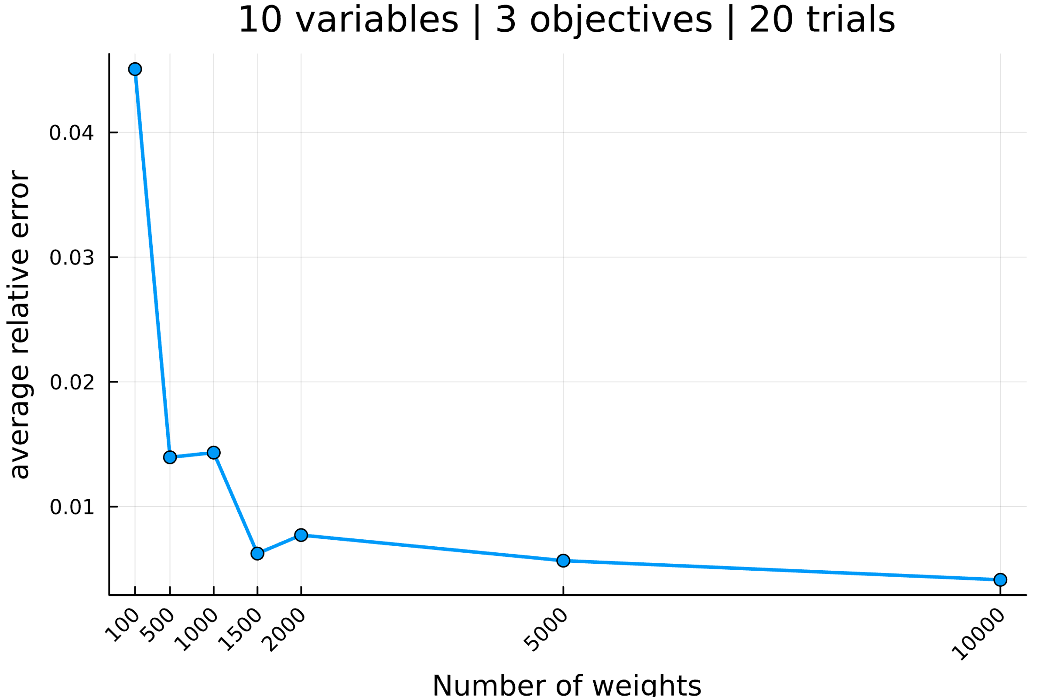

--------------------------------------------------------------------------------

Setup the parameters...

number of variables : 25

number of objectives : 3

reference point : [0, 0, 0]

interval of #weights : [(100, 100), (500, 500), (1000, 1000), (1500, 1500), (2000, 2000), (5000, 5000), (10000, 10000)]

solver MIP invoked : GLPK.Optimizer

number of trials : 20

Generate an mo01UKP instance...

Compute S, the set of nondominated points...

|S| = 67 (0.31s)

Compute H, the hypervolume measure...

H(S) = 872807262.0

Compute H̃, the estimation of H...

H estimated with rp=[0, 0, 0] and 100 weight: 863318324.1 (0.21s)

H estimated with rp=[0, 0, 0] and 100 weight: 872095488.4 (0.03s)

H estimated with rp=[0, 0, 0] and 100 weight: 854664102.8 (0.03s)

H estimated with rp=[0, 0, 0] and 100 weight: 850040114.4 (0.03s)

H estimated with rp=[0, 0, 0] and 100 weight: 852632479.8 (0.03s)

H estimated with rp=[0, 0, 0] and 100 weight: 908914564.2 (0.04s)

H estimated with rp=[0, 0, 0] and 100 weight: 901453372.0 (0.03s)

H estimated with rp=[0, 0, 0] and 100 weight: 897006982.7 (0.03s)

H estimated with rp=[0, 0, 0] and 100 weight: 921737441.0 (0.03s)

H estimated with rp=[0, 0, 0] and 100 weight: 840971700.1 (0.03s)

H estimated with rp=[0, 0, 0] and 100 weight: 869269408.1 (0.03s)

H estimated with rp=[0, 0, 0] and 100 weight: 854551665.5 (0.03s)

H estimated with rp=[0, 0, 0] and 100 weight: 882567780.4 (0.03s)

H estimated with rp=[0, 0, 0] and 100 weight: 878426498.9 (0.03s)

H estimated with rp=[0, 0, 0] and 100 weight: 888917722.2 (0.03s)

H estimated with rp=[0, 0, 0] and 100 weight: 885568091.4 (0.03s)

H estimated with rp=[0, 0, 0] and 100 weight: 806029025.0 (0.03s)

H estimated with rp=[0, 0, 0] and 100 weight: 899899198.3 (0.03s)

H estimated with rp=[0, 0, 0] and 100 weight: 892100726.5 (0.04s)

H estimated with rp=[0, 0, 0] and 100 weight: 872903981.2 (0.03s)

Analyze the results...

value H(S) = 872807262.0

average value H̃ = 874653433.4

average absolue error H̃ = 21015476.3

average relative error H̃ = 0.024078

Compute H̃, the estimation of H...

H estimated with rp=[0, 0, 0] and 500 weight: 880285868.1 (0.16s)

H estimated with rp=[0, 0, 0] and 500 weight: 883166908.0 (0.15s)

H estimated with rp=[0, 0, 0] and 500 weight: 880916157.1 (0.15s)

H estimated with rp=[0, 0, 0] and 500 weight: 868664142.1 (0.15s)

H estimated with rp=[0, 0, 0] and 500 weight: 899680180.1 (0.15s)

H estimated with rp=[0, 0, 0] and 500 weight: 875777615.5 (0.15s)

H estimated with rp=[0, 0, 0] and 500 weight: 883701248.5 (0.15s)

H estimated with rp=[0, 0, 0] and 500 weight: 877047499.4 (0.15s)

H estimated with rp=[0, 0, 0] and 500 weight: 873683422.1 (0.15s)

H estimated with rp=[0, 0, 0] and 500 weight: 875185458.7 (0.15s)

H estimated with rp=[0, 0, 0] and 500 weight: 861874387.9 (0.15s)

H estimated with rp=[0, 0, 0] and 500 weight: 881038065.5 (0.15s)

H estimated with rp=[0, 0, 0] and 500 weight: 873252217.8 (0.16s)

H estimated with rp=[0, 0, 0] and 500 weight: 886143442.3 (0.15s)

H estimated with rp=[0, 0, 0] and 500 weight: 893650056.6 (0.16s)

H estimated with rp=[0, 0, 0] and 500 weight: 861831453.0 (0.15s)

H estimated with rp=[0, 0, 0] and 500 weight: 876544244.2 (0.15s)

H estimated with rp=[0, 0, 0] and 500 weight: 851854394.2 (0.15s)

H estimated with rp=[0, 0, 0] and 500 weight: 887563494.6 (0.16s)

H estimated with rp=[0, 0, 0] and 500 weight: 899612620.4 (0.15s)

Analyze the results...

value H(S) = 872807262.0

average value H̃ = 878573643.8

average absolue error H̃ = 10466848.9

average relative error H̃ = 0.011992

Compute H̃, the estimation of H...

H estimated with rp=[0, 0, 0] and 1000 weight: 870572298.2 (0.31s)

H estimated with rp=[0, 0, 0] and 1000 weight: 875063382.6 (0.3s)

H estimated with rp=[0, 0, 0] and 1000 weight: 852964993.3 (0.29s)

H estimated with rp=[0, 0, 0] and 1000 weight: 865353956.1 (0.3s)

H estimated with rp=[0, 0, 0] and 1000 weight: 860186740.4 (0.3s)

H estimated with rp=[0, 0, 0] and 1000 weight: 885956570.9 (0.3s)

H estimated with rp=[0, 0, 0] and 1000 weight: 867829573.7 (0.29s)

H estimated with rp=[0, 0, 0] and 1000 weight: 863727822.6 (0.29s)

H estimated with rp=[0, 0, 0] and 1000 weight: 879182360.2 (0.3s)

H estimated with rp=[0, 0, 0] and 1000 weight: 886036001.6 (0.3s)

H estimated with rp=[0, 0, 0] and 1000 weight: 867249363.2 (0.29s)

H estimated with rp=[0, 0, 0] and 1000 weight: 875078359.7 (0.29s)

H estimated with rp=[0, 0, 0] and 1000 weight: 860970352.3 (0.3s)

H estimated with rp=[0, 0, 0] and 1000 weight: 874628948.3 (0.3s)

H estimated with rp=[0, 0, 0] and 1000 weight: 879728855.5 (0.29s)

H estimated with rp=[0, 0, 0] and 1000 weight: 862190102.0 (0.29s)

H estimated with rp=[0, 0, 0] and 1000 weight: 870611908.9 (0.29s)

H estimated with rp=[0, 0, 0] and 1000 weight: 897753432.7 (0.3s)

H estimated with rp=[0, 0, 0] and 1000 weight: 864391570.4 (0.3s)

H estimated with rp=[0, 0, 0] and 1000 weight: 908298607.6 (0.31s)

Analyze the results...

value H(S) = 872807262.0

average value H̃ = 873388760.0

average absolue error H̃ = 10064618.1

average relative error H̃ = 0.011531

Compute H̃, the estimation of H...

H estimated with rp=[0, 0, 0] and 1500 weight: 867983983.8 (0.44s)

H estimated with rp=[0, 0, 0] and 1500 weight: 879287159.9 (0.45s)

H estimated with rp=[0, 0, 0] and 1500 weight: 874779210.8 (0.44s)

H estimated with rp=[0, 0, 0] and 1500 weight: 876252263.8 (0.44s)

H estimated with rp=[0, 0, 0] and 1500 weight: 871966821.5 (0.45s)

H estimated with rp=[0, 0, 0] and 1500 weight: 874954493.8 (0.44s)

H estimated with rp=[0, 0, 0] and 1500 weight: 872657486.1 (0.45s)

H estimated with rp=[0, 0, 0] and 1500 weight: 858419325.4 (0.45s)

H estimated with rp=[0, 0, 0] and 1500 weight: 867067643.9 (0.45s)

H estimated with rp=[0, 0, 0] and 1500 weight: 864160873.8 (0.45s)

H estimated with rp=[0, 0, 0] and 1500 weight: 867900727.1 (0.44s)

H estimated with rp=[0, 0, 0] and 1500 weight: 859979870.8 (0.45s)

H estimated with rp=[0, 0, 0] and 1500 weight: 876673179.8 (0.45s)

H estimated with rp=[0, 0, 0] and 1500 weight: 868858391.5 (0.46s)

H estimated with rp=[0, 0, 0] and 1500 weight: 864942736.5 (0.45s)

H estimated with rp=[0, 0, 0] and 1500 weight: 870535086.4 (0.44s)

H estimated with rp=[0, 0, 0] and 1500 weight: 879740538.1 (0.43s)

H estimated with rp=[0, 0, 0] and 1500 weight: 876501201.2 (0.44s)

H estimated with rp=[0, 0, 0] and 1500 weight: 861211412.6 (0.43s)

H estimated with rp=[0, 0, 0] and 1500 weight: 879972244.0 (0.44s)

Analyze the results...

value H(S) = 872807262.0

average value H̃ = 870692232.5

average absolue error H̃ = 5685249.0

average relative error H̃ = 0.006514

Compute H̃, the estimation of H...

H estimated with rp=[0, 0, 0] and 2000 weight: 870995785.8 (0.59s)

H estimated with rp=[0, 0, 0] and 2000 weight: 872304362.5 (0.59s)

H estimated with rp=[0, 0, 0] and 2000 weight: 875203967.0 (0.63s)

H estimated with rp=[0, 0, 0] and 2000 weight: 883892618.1 (0.6s)

H estimated with rp=[0, 0, 0] and 2000 weight: 879357496.3 (0.59s)

H estimated with rp=[0, 0, 0] and 2000 weight: 873901149.8 (0.59s)

H estimated with rp=[0, 0, 0] and 2000 weight: 875852407.6 (0.59s)

H estimated with rp=[0, 0, 0] and 2000 weight: 870756339.9 (0.6s)

H estimated with rp=[0, 0, 0] and 2000 weight: 869960949.6 (0.59s)

H estimated with rp=[0, 0, 0] and 2000 weight: 867092443.2 (0.59s)

H estimated with rp=[0, 0, 0] and 2000 weight: 872968212.8 (0.6s)

H estimated with rp=[0, 0, 0] and 2000 weight: 877380261.6 (0.6s)

H estimated with rp=[0, 0, 0] and 2000 weight: 871206425.2 (0.6s)

H estimated with rp=[0, 0, 0] and 2000 weight: 859468182.4 (0.58s)

H estimated with rp=[0, 0, 0] and 2000 weight: 864396416.3 (0.6s)

H estimated with rp=[0, 0, 0] and 2000 weight: 873152988.1 (0.58s)

H estimated with rp=[0, 0, 0] and 2000 weight: 874641687.8 (0.6s)

H estimated with rp=[0, 0, 0] and 2000 weight: 870562457.9 (0.6s)

H estimated with rp=[0, 0, 0] and 2000 weight: 865926787.4 (0.59s)

H estimated with rp=[0, 0, 0] and 2000 weight: 864265565.9 (0.6s)

Analyze the results...

value H(S) = 872807262.0

average value H̃ = 871664325.2

average absolue error H̃ = 4251479.8

average relative error H̃ = 0.004871

Compute H̃, the estimation of H...

H estimated with rp=[0, 0, 0] and 5000 weight: 874899412.3 (1.46s)

H estimated with rp=[0, 0, 0] and 5000 weight: 869470595.1 (1.46s)

H estimated with rp=[0, 0, 0] and 5000 weight: 876119925.5 (1.48s)

H estimated with rp=[0, 0, 0] and 5000 weight: 874934451.0 (1.51s)

H estimated with rp=[0, 0, 0] and 5000 weight: 877073092.1 (1.49s)

H estimated with rp=[0, 0, 0] and 5000 weight: 874741550.2 (1.5s)

H estimated with rp=[0, 0, 0] and 5000 weight: 872957467.9 (1.5s)

H estimated with rp=[0, 0, 0] and 5000 weight: 875294594.2 (1.49s)

H estimated with rp=[0, 0, 0] and 5000 weight: 867173111.5 (1.49s)

H estimated with rp=[0, 0, 0] and 5000 weight: 871532252.8 (1.48s)

H estimated with rp=[0, 0, 0] and 5000 weight: 871236346.5 (1.49s)

H estimated with rp=[0, 0, 0] and 5000 weight: 877110559.4 (1.48s)

H estimated with rp=[0, 0, 0] and 5000 weight: 871860064.6 (1.49s)

H estimated with rp=[0, 0, 0] and 5000 weight: 878498596.7 (1.51s)

H estimated with rp=[0, 0, 0] and 5000 weight: 869086156.4 (1.5s)

H estimated with rp=[0, 0, 0] and 5000 weight: 873319991.1 (1.52s)

H estimated with rp=[0, 0, 0] and 5000 weight: 874638900.3 (1.51s)

H estimated with rp=[0, 0, 0] and 5000 weight: 875847054.4 (1.49s)

H estimated with rp=[0, 0, 0] and 5000 weight: 872618925.8 (1.5s)

H estimated with rp=[0, 0, 0] and 5000 weight: 873604535.7 (1.5s)

Analyze the results...

value H(S) = 872807262.0

average value H̃ = 873600879.2

average absolue error H̃ = 2460955.3

average relative error H̃ = 0.002820

Compute H̃, the estimation of H...

H estimated with rp=[0, 0, 0] and 10000 weight: 869412570.2 (2.99s)

H estimated with rp=[0, 0, 0] and 10000 weight: 871911545.7 (2.98s)

H estimated with rp=[0, 0, 0] and 10000 weight: 870986550.7 (3.02s)

H estimated with rp=[0, 0, 0] and 10000 weight: 875899481.3 (3.05s)

H estimated with rp=[0, 0, 0] and 10000 weight: 869557316.9 (2.99s)

H estimated with rp=[0, 0, 0] and 10000 weight: 870950976.4 (2.99s)

H estimated with rp=[0, 0, 0] and 10000 weight: 869589793.5 (3.06s)

H estimated with rp=[0, 0, 0] and 10000 weight: 863833392.0 (3.01s)

H estimated with rp=[0, 0, 0] and 10000 weight: 875162316.1 (3.05s)

H estimated with rp=[0, 0, 0] and 10000 weight: 866396783.1 (3.03s)

H estimated with rp=[0, 0, 0] and 10000 weight: 875954453.0 (3.04s)

H estimated with rp=[0, 0, 0] and 10000 weight: 869090647.0 (3.04s)

H estimated with rp=[0, 0, 0] and 10000 weight: 870448203.8 (3.04s)

H estimated with rp=[0, 0, 0] and 10000 weight: 873833011.3 (3.03s)

H estimated with rp=[0, 0, 0] and 10000 weight: 871654403.3 (3.03s)

H estimated with rp=[0, 0, 0] and 10000 weight: 872189703.6 (3.04s)

H estimated with rp=[0, 0, 0] and 10000 weight: 870869700.1 (3.04s)

H estimated with rp=[0, 0, 0] and 10000 weight: 870380656.4 (3.08s)

H estimated with rp=[0, 0, 0] and 10000 weight: 869572630.3 (3.25s)

H estimated with rp=[0, 0, 0] and 10000 weight: 870895429.2 (2.95s)

Analyze the results...

value H(S) = 872807262.0

average value H̃ = 870929478.2

average absolue error H̃ = 2839805.2

average relative error H̃ = 0.003254

All average relative error H̃ = [0.024078026440435454, 0.01199216523013762, 0.011531318021913737, 0.0065137507837182956, 0.00487104087403054, 0.0028195861912659248, 0.0032536452046630924]

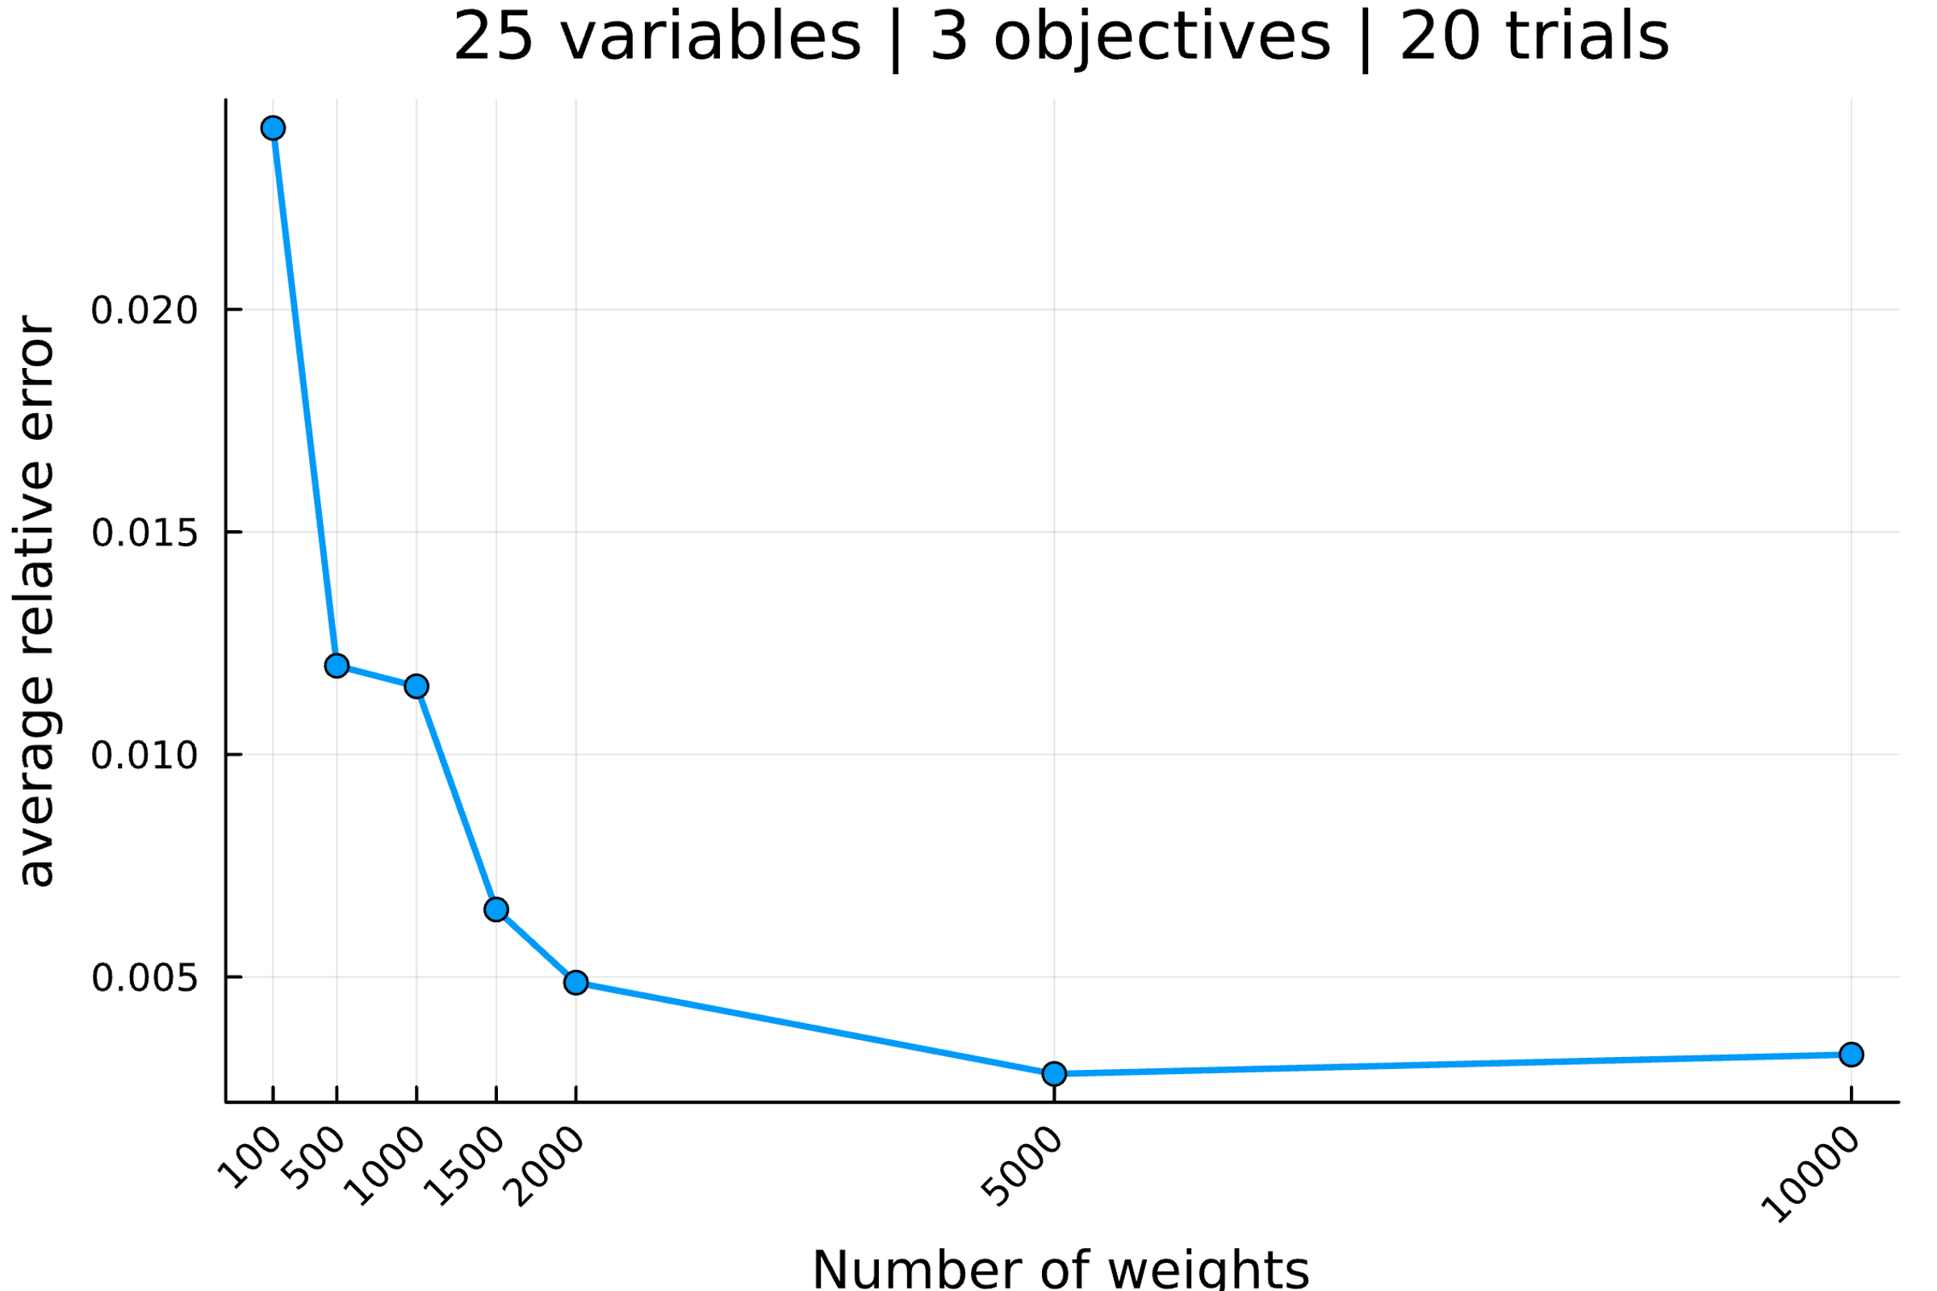

--------------------------------------------------------------------------------

Setup the parameters...

number of variables : 50

number of objectives : 3

reference point : [0, 0, 0]

interval of #weights : [(100, 100), (500, 500), (1000, 1000), (1500, 1500), (2000, 2000), (5000, 5000), (10000, 10000)]

solver MIP invoked : GLPK.Optimizer

number of trials : 20

Generate an mo01UKP instance...

Compute S, the set of nondominated points...

|S| = 815 (35.53s)

Compute H, the hypervolume measure...

H(S) = 7675763429.0

Compute H̃, the estimation of H...

H estimated with rp=[0, 0, 0] and 100 weight: 6811575356.2 (0.24s)

H estimated with rp=[0, 0, 0] and 100 weight: 8132397139.4 (0.09s)

H estimated with rp=[0, 0, 0] and 100 weight: 7677168950.4 (0.08s)

H estimated with rp=[0, 0, 0] and 100 weight: 7885090496.3 (0.09s)

H estimated with rp=[0, 0, 0] and 100 weight: 7911874133.5 (0.08s)

H estimated with rp=[0, 0, 0] and 100 weight: 7768863859.3 (0.07s)

H estimated with rp=[0, 0, 0] and 100 weight: 7466691838.8 (0.07s)

H estimated with rp=[0, 0, 0] and 100 weight: 7567245864.5 (0.08s)

H estimated with rp=[0, 0, 0] and 100 weight: 8014687393.4 (0.09s)

H estimated with rp=[0, 0, 0] and 100 weight: 7897434336.5 (0.08s)

H estimated with rp=[0, 0, 0] and 100 weight: 6943358665.0 (0.06s)

H estimated with rp=[0, 0, 0] and 100 weight: 7769346937.4 (0.07s)

H estimated with rp=[0, 0, 0] and 100 weight: 7460866334.7 (0.08s)

H estimated with rp=[0, 0, 0] and 100 weight: 7152619246.4 (0.07s)

H estimated with rp=[0, 0, 0] and 100 weight: 7353204268.4 (0.07s)

H estimated with rp=[0, 0, 0] and 100 weight: 7064682431.1 (0.07s)

H estimated with rp=[0, 0, 0] and 100 weight: 7330889941.1 (0.07s)

H estimated with rp=[0, 0, 0] and 100 weight: 7799665232.8 (0.09s)

H estimated with rp=[0, 0, 0] and 100 weight: 7448416960.8 (0.08s)

H estimated with rp=[0, 0, 0] and 100 weight: 7619928429.1 (0.08s)

Analyze the results...

value H(S) = 7675763429.0

average value H̃ = 7553800390.8

average absolue error H̃ = 299428800.0

average relative error H̃ = 0.039010

Compute H̃, the estimation of H...

H estimated with rp=[0, 0, 0] and 500 weight: 7495069817.5 (0.39s)

H estimated with rp=[0, 0, 0] and 500 weight: 7570999633.5 (0.38s)

H estimated with rp=[0, 0, 0] and 500 weight: 7773306216.2 (0.4s)

H estimated with rp=[0, 0, 0] and 500 weight: 7639900098.4 (0.43s)

H estimated with rp=[0, 0, 0] and 500 weight: 7610087630.9 (0.41s)

H estimated with rp=[0, 0, 0] and 500 weight: 7565172214.7 (0.42s)

H estimated with rp=[0, 0, 0] and 500 weight: 7769532043.7 (0.43s)

H estimated with rp=[0, 0, 0] and 500 weight: 7735311537.8 (0.4s)

H estimated with rp=[0, 0, 0] and 500 weight: 7682773184.5 (0.43s)

H estimated with rp=[0, 0, 0] and 500 weight: 7588220074.0 (0.4s)

H estimated with rp=[0, 0, 0] and 500 weight: 7574253544.4 (0.4s)

H estimated with rp=[0, 0, 0] and 500 weight: 7780482869.5 (0.4s)

H estimated with rp=[0, 0, 0] and 500 weight: 7714759606.3 (0.4s)

H estimated with rp=[0, 0, 0] and 500 weight: 7467255991.9 (0.39s)

H estimated with rp=[0, 0, 0] and 500 weight: 7591375027.5 (0.42s)

H estimated with rp=[0, 0, 0] and 500 weight: 7659262711.2 (0.39s)

H estimated with rp=[0, 0, 0] and 500 weight: 7788390484.4 (0.43s)

H estimated with rp=[0, 0, 0] and 500 weight: 7676107089.1 (0.39s)

H estimated with rp=[0, 0, 0] and 500 weight: 7879382484.5 (0.46s)

H estimated with rp=[0, 0, 0] and 500 weight: 7687076308.4 (0.44s)

Analyze the results...

value H(S) = 7675763429.0

average value H̃ = 7662435928.4

average absolue error H̃ = 86276254.0

average relative error H̃ = 0.011240

Compute H̃, the estimation of H...

H estimated with rp=[0, 0, 0] and 1000 weight: 7671656095.4 (0.78s)

H estimated with rp=[0, 0, 0] and 1000 weight: 7709062728.5 (0.8s)

H estimated with rp=[0, 0, 0] and 1000 weight: 7711430844.0 (0.79s)

H estimated with rp=[0, 0, 0] and 1000 weight: 7688744845.3 (0.8s)

H estimated with rp=[0, 0, 0] and 1000 weight: 7799039930.3 (0.86s)

H estimated with rp=[0, 0, 0] and 1000 weight: 7699722810.1 (0.83s)

H estimated with rp=[0, 0, 0] and 1000 weight: 7656346339.6 (0.81s)

H estimated with rp=[0, 0, 0] and 1000 weight: 7609853283.7 (0.81s)

H estimated with rp=[0, 0, 0] and 1000 weight: 7730084319.4 (0.84s)

H estimated with rp=[0, 0, 0] and 1000 weight: 7538696556.4 (0.82s)

H estimated with rp=[0, 0, 0] and 1000 weight: 7442608045.3 (0.75s)

H estimated with rp=[0, 0, 0] and 1000 weight: 7782696809.5 (0.83s)

H estimated with rp=[0, 0, 0] and 1000 weight: 7637295935.1 (0.79s)

H estimated with rp=[0, 0, 0] and 1000 weight: 7619925692.6 (0.8s)

H estimated with rp=[0, 0, 0] and 1000 weight: 7722701215.6 (0.82s)

H estimated with rp=[0, 0, 0] and 1000 weight: 7567852399.7 (0.8s)

H estimated with rp=[0, 0, 0] and 1000 weight: 7646475843.1 (0.81s)

H estimated with rp=[0, 0, 0] and 1000 weight: 7624322614.4 (0.86s)

H estimated with rp=[0, 0, 0] and 1000 weight: 7799643647.3 (0.87s)

H estimated with rp=[0, 0, 0] and 1000 weight: 7676361985.4 (0.8s)

Analyze the results...

value H(S) = 7675763429.0

average value H̃ = 7666726097.0

average absolue error H̃ = 65222816.5

average relative error H̃ = 0.008497

Compute H̃, the estimation of H...

H estimated with rp=[0, 0, 0] and 1500 weight: 7581000346.0 (1.22s)

H estimated with rp=[0, 0, 0] and 1500 weight: 7666873331.2 (1.24s)

H estimated with rp=[0, 0, 0] and 1500 weight: 7641779521.9 (1.22s)

H estimated with rp=[0, 0, 0] and 1500 weight: 7672473001.3 (1.27s)

H estimated with rp=[0, 0, 0] and 1500 weight: 7763438315.8 (1.27s)

H estimated with rp=[0, 0, 0] and 1500 weight: 7590600315.4 (1.23s)

H estimated with rp=[0, 0, 0] and 1500 weight: 7660605314.6 (1.19s)

H estimated with rp=[0, 0, 0] and 1500 weight: 7758566663.7 (1.25s)

H estimated with rp=[0, 0, 0] and 1500 weight: 7680299417.4 (1.18s)

H estimated with rp=[0, 0, 0] and 1500 weight: 7766969575.5 (1.25s)

H estimated with rp=[0, 0, 0] and 1500 weight: 7690970823.7 (1.22s)

H estimated with rp=[0, 0, 0] and 1500 weight: 7514225810.9 (1.19s)

H estimated with rp=[0, 0, 0] and 1500 weight: 7605152400.4 (1.2s)

H estimated with rp=[0, 0, 0] and 1500 weight: 7684192484.3 (1.21s)

H estimated with rp=[0, 0, 0] and 1500 weight: 7669757742.4 (1.26s)

H estimated with rp=[0, 0, 0] and 1500 weight: 7880886351.3 (1.27s)

H estimated with rp=[0, 0, 0] and 1500 weight: 7609502339.4 (1.23s)

H estimated with rp=[0, 0, 0] and 1500 weight: 7715126313.1 (1.25s)

H estimated with rp=[0, 0, 0] and 1500 weight: 7701774356.8 (1.22s)

H estimated with rp=[0, 0, 0] and 1500 weight: 7701755442.5 (1.31s)

Analyze the results...

value H(S) = 7675763429.0

average value H̃ = 7677797493.4

average absolue error H̃ = 56600481.0

average relative error H̃ = 0.007374

Compute H̃, the estimation of H...

H estimated with rp=[0, 0, 0] and 2000 weight: 7653470947.7 (1.62s)

H estimated with rp=[0, 0, 0] and 2000 weight: 7678995248.8 (1.6s)

H estimated with rp=[0, 0, 0] and 2000 weight: 7596367003.2 (1.63s)

H estimated with rp=[0, 0, 0] and 2000 weight: 7719203128.1 (1.67s)

H estimated with rp=[0, 0, 0] and 2000 weight: 7592678115.9 (1.66s)

H estimated with rp=[0, 0, 0] and 2000 weight: 7669473653.2 (1.65s)

H estimated with rp=[0, 0, 0] and 2000 weight: 7657077643.3 (1.62s)

H estimated with rp=[0, 0, 0] and 2000 weight: 7685908799.6 (1.61s)

H estimated with rp=[0, 0, 0] and 2000 weight: 7576463355.2 (1.62s)

H estimated with rp=[0, 0, 0] and 2000 weight: 7702494141.4 (1.64s)

H estimated with rp=[0, 0, 0] and 2000 weight: 7714461153.0 (1.71s)

H estimated with rp=[0, 0, 0] and 2000 weight: 7720352179.7 (1.69s)

H estimated with rp=[0, 0, 0] and 2000 weight: 7601210297.2 (1.67s)

H estimated with rp=[0, 0, 0] and 2000 weight: 7576265528.0 (1.62s)

H estimated with rp=[0, 0, 0] and 2000 weight: 7662676059.6 (1.6s)

H estimated with rp=[0, 0, 0] and 2000 weight: 7639907221.6 (1.64s)

H estimated with rp=[0, 0, 0] and 2000 weight: 7675616645.9 (1.63s)

H estimated with rp=[0, 0, 0] and 2000 weight: 7784766585.0 (1.72s)

H estimated with rp=[0, 0, 0] and 2000 weight: 7656807571.7 (1.62s)

H estimated with rp=[0, 0, 0] and 2000 weight: 7654719730.3 (1.65s)

Analyze the results...

value H(S) = 7675763429.0

average value H̃ = 7660945750.4

average absolue error H̃ = 42401401.8

average relative error H̃ = 0.005524

Compute H̃, the estimation of H...

H estimated with rp=[0, 0, 0] and 5000 weight: 7648070271.1 (4.12s)

H estimated with rp=[0, 0, 0] and 5000 weight: 7626730911.3 (4.06s)

H estimated with rp=[0, 0, 0] and 5000 weight: 7715292097.0 (4.13s)

H estimated with rp=[0, 0, 0] and 5000 weight: 7672977156.2 (4.09s)

H estimated with rp=[0, 0, 0] and 5000 weight: 7704122497.6 (4.09s)

H estimated with rp=[0, 0, 0] and 5000 weight: 7673092961.9 (4.03s)

H estimated with rp=[0, 0, 0] and 5000 weight: 7652589838.8 (4.09s)

H estimated with rp=[0, 0, 0] and 5000 weight: 7699033381.6 (4.16s)

H estimated with rp=[0, 0, 0] and 5000 weight: 7651957302.3 (4.15s)

H estimated with rp=[0, 0, 0] and 5000 weight: 7672699359.9 (4.23s)

H estimated with rp=[0, 0, 0] and 5000 weight: 7626670253.8 (4.04s)

H estimated with rp=[0, 0, 0] and 5000 weight: 7570661300.6 (4.04s)

H estimated with rp=[0, 0, 0] and 5000 weight: 7696167321.9 (4.2s)

H estimated with rp=[0, 0, 0] and 5000 weight: 7728196359.6 (4.21s)

H estimated with rp=[0, 0, 0] and 5000 weight: 7626394612.4 (4.07s)

H estimated with rp=[0, 0, 0] and 5000 weight: 7718596434.2 (4.16s)

H estimated with rp=[0, 0, 0] and 5000 weight: 7682220841.9 (4.24s)

H estimated with rp=[0, 0, 0] and 5000 weight: 7668890282.1 (4.21s)

H estimated with rp=[0, 0, 0] and 5000 weight: 7721213922.5 (4.21s)

H estimated with rp=[0, 0, 0] and 5000 weight: 7636887343.4 (4.19s)

Analyze the results...

value H(S) = 7675763429.0

average value H̃ = 7669623222.5

average absolue error H̃ = 32013748.9

average relative error H̃ = 0.004171

Compute H̃, the estimation of H...

H estimated with rp=[0, 0, 0] and 10000 weight: 7660222522.8 (8.24s)

H estimated with rp=[0, 0, 0] and 10000 weight: 7733782400.7 (8.44s)

H estimated with rp=[0, 0, 0] and 10000 weight: 7656210625.8 (8.32s)

H estimated with rp=[0, 0, 0] and 10000 weight: 7673930005.3 (8.16s)

H estimated with rp=[0, 0, 0] and 10000 weight: 7712234204.2 (8.16s)

H estimated with rp=[0, 0, 0] and 10000 weight: 7719200932.6 (8.18s)

H estimated with rp=[0, 0, 0] and 10000 weight: 7680760072.8 (8.2s)

H estimated with rp=[0, 0, 0] and 10000 weight: 7671839083.9 (8.13s)

H estimated with rp=[0, 0, 0] and 10000 weight: 7629009100.5 (7.96s)

H estimated with rp=[0, 0, 0] and 10000 weight: 7664696286.8 (8.15s)

H estimated with rp=[0, 0, 0] and 10000 weight: 7680889076.0 (8.14s)

H estimated with rp=[0, 0, 0] and 10000 weight: 7649098992.8 (8.05s)

H estimated with rp=[0, 0, 0] and 10000 weight: 7638239757.7 (8.11s)

H estimated with rp=[0, 0, 0] and 10000 weight: 7688684838.4 (8.2s)

H estimated with rp=[0, 0, 0] and 10000 weight: 7659349181.8 (8.25s)

H estimated with rp=[0, 0, 0] and 10000 weight: 7692682869.5 (8.66s)

H estimated with rp=[0, 0, 0] and 10000 weight: 7669220125.4 (8.24s)

H estimated with rp=[0, 0, 0] and 10000 weight: 7657785855.2 (8.09s)

H estimated with rp=[0, 0, 0] and 10000 weight: 7665728573.3 (8.1s)

H estimated with rp=[0, 0, 0] and 10000 weight: 7670490469.8 (8.14s)

Analyze the results...

value H(S) = 7675763429.0

average value H̃ = 7673702748.8

average absolue error H̃ = 19849719.4

average relative error H̃ = 0.002586

All average relative error H̃ = [0.03900964416311635, 0.011240087689786004, 0.008497241624009609, 0.007373922028842639, 0.00552406314123899, 0.004170757635285372, 0.0025860254220003145]

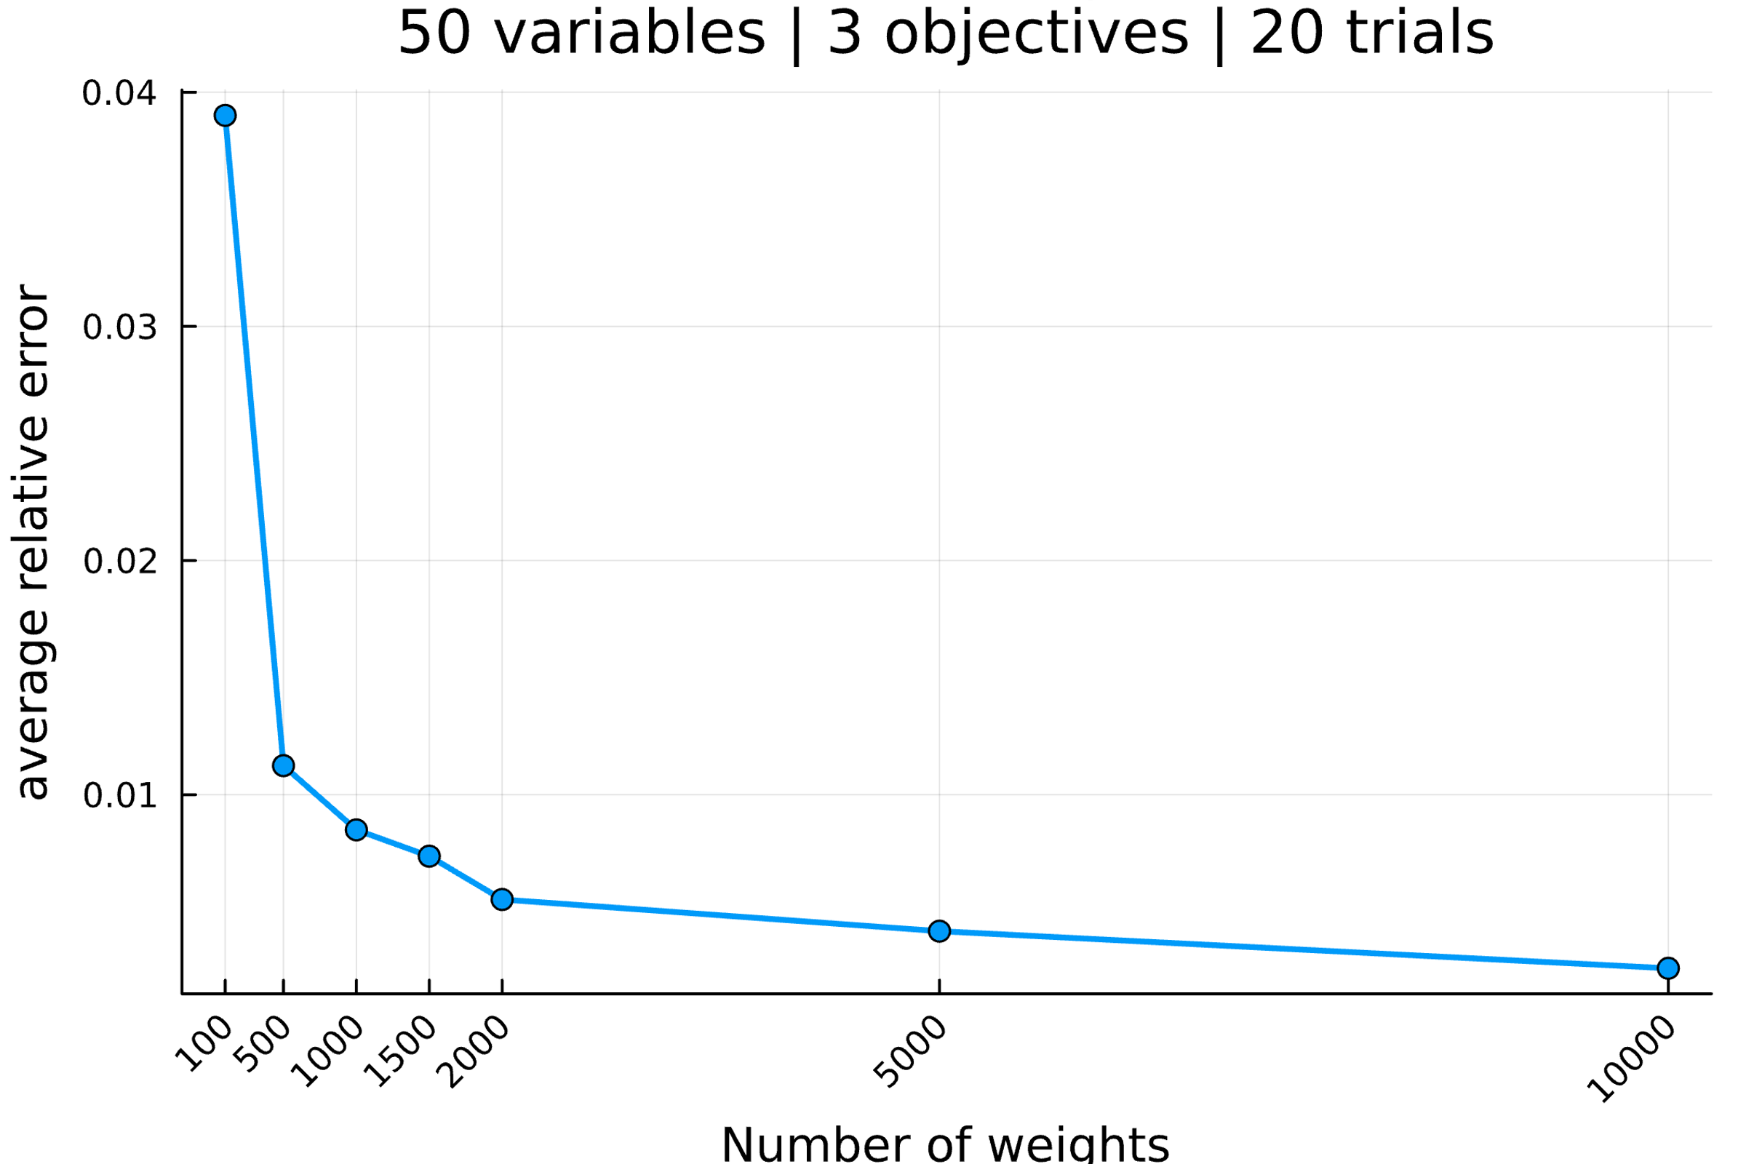

--------------------------------------------------------------------------------

Setup the parameters...

number of variables : 55

number of objectives : 3

reference point : [0, 0, 0]

interval of #weights : [(100, 100), (500, 500), (1000, 1000), (1500, 1500), (2000, 2000), (5000, 5000), (10000, 10000)]

solver MIP invoked : GLPK.Optimizer

number of trials : 20

Generate an mo01UKP instance...

Compute S, the set of nondominated points...

|S| = 537 (18.43s)

Compute H, the hypervolume measure...

H(S) = 9428492812.0

Compute H̃, the estimation of H...

H estimated with rp=[0, 0, 0] and 100 weight: 9263628353.1 (2.56s)

H estimated with rp=[0, 0, 0] and 100 weight: 9805939104.5 (0.07s)

H estimated with rp=[0, 0, 0] and 100 weight: 10049987708.4 (0.08s)

H estimated with rp=[0, 0, 0] and 100 weight: 9287128821.0 (0.06s)

H estimated with rp=[0, 0, 0] and 100 weight: 9415979179.0 (0.07s)

H estimated with rp=[0, 0, 0] and 100 weight: 9436404974.4 (0.07s)

H estimated with rp=[0, 0, 0] and 100 weight: 10200085591.1 (0.08s)

H estimated with rp=[0, 0, 0] and 100 weight: 9912606870.5 (0.08s)

H estimated with rp=[0, 0, 0] and 100 weight: 9464186900.9 (0.07s)

H estimated with rp=[0, 0, 0] and 100 weight: 9093007930.8 (0.07s)

H estimated with rp=[0, 0, 0] and 100 weight: 9112740520.5 (0.06s)

H estimated with rp=[0, 0, 0] and 100 weight: 10126680674.7 (0.08s)

H estimated with rp=[0, 0, 0] and 100 weight: 9543976991.6 (0.08s)

H estimated with rp=[0, 0, 0] and 100 weight: 9173989985.1 (0.07s)

H estimated with rp=[0, 0, 0] and 100 weight: 9084547942.1 (0.07s)

H estimated with rp=[0, 0, 0] and 100 weight: 8822412452.2 (0.07s)

H estimated with rp=[0, 0, 0] and 100 weight: 9640113126.9 (0.07s)

H estimated with rp=[0, 0, 0] and 100 weight: 9499889395.8 (0.07s)

H estimated with rp=[0, 0, 0] and 100 weight: 9853656005.9 (0.07s)

H estimated with rp=[0, 0, 0] and 100 weight: 9766736419.5 (0.07s)

Analyze the results...

value H(S) = 9428492812.0

average value H̃ = 9527684947.4

average absolue error H̃ = 316642866.6

average relative error H̃ = 0.033584

Compute H̃, the estimation of H...

H estimated with rp=[0, 0, 0] and 500 weight: 9385519418.8 (0.34s)

H estimated with rp=[0, 0, 0] and 500 weight: 9476167028.6 (0.34s)

H estimated with rp=[0, 0, 0] and 500 weight: 9418215950.1 (0.37s)

H estimated with rp=[0, 0, 0] and 500 weight: 9593341026.7 (0.38s)

H estimated with rp=[0, 0, 0] and 500 weight: 9595486932.2 (0.34s)

H estimated with rp=[0, 0, 0] and 500 weight: 9643648758.1 (0.34s)

H estimated with rp=[0, 0, 0] and 500 weight: 9609288872.8 (0.33s)

H estimated with rp=[0, 0, 0] and 500 weight: 9455240880.0 (0.34s)

H estimated with rp=[0, 0, 0] and 500 weight: 9286053143.5 (0.33s)

H estimated with rp=[0, 0, 0] and 500 weight: 9202716175.8 (0.33s)

H estimated with rp=[0, 0, 0] and 500 weight: 9563316308.1 (0.33s)

H estimated with rp=[0, 0, 0] and 500 weight: 9592823477.6 (0.33s)

H estimated with rp=[0, 0, 0] and 500 weight: 9353415480.8 (0.36s)

H estimated with rp=[0, 0, 0] and 500 weight: 9283044711.3 (0.33s)

H estimated with rp=[0, 0, 0] and 500 weight: 9335946385.0 (0.33s)

H estimated with rp=[0, 0, 0] and 500 weight: 9571190048.1 (0.33s)

H estimated with rp=[0, 0, 0] and 500 weight: 9316526146.5 (0.32s)

H estimated with rp=[0, 0, 0] and 500 weight: 9374049236.5 (0.32s)

H estimated with rp=[0, 0, 0] and 500 weight: 9351255689.0 (0.32s)

H estimated with rp=[0, 0, 0] and 500 weight: 9869036739.0 (0.36s)

Analyze the results...

value H(S) = 9428492812.0

average value H̃ = 9463814120.4

average absolue error H̃ = 133139886.7

average relative error H̃ = 0.014121

Compute H̃, the estimation of H...

H estimated with rp=[0, 0, 0] and 1000 weight: 9271376601.7 (0.69s)

H estimated with rp=[0, 0, 0] and 1000 weight: 9616553016.9 (0.69s)

H estimated with rp=[0, 0, 0] and 1000 weight: 9537439079.5 (0.7s)

H estimated with rp=[0, 0, 0] and 1000 weight: 9204943972.9 (0.67s)

H estimated with rp=[0, 0, 0] and 1000 weight: 9383392450.8 (0.68s)

H estimated with rp=[0, 0, 0] and 1000 weight: 9375761435.2 (0.69s)

H estimated with rp=[0, 0, 0] and 1000 weight: 9457966138.6 (0.7s)

H estimated with rp=[0, 0, 0] and 1000 weight: 9629901914.7 (0.71s)

H estimated with rp=[0, 0, 0] and 1000 weight: 9515593123.2 (0.69s)

H estimated with rp=[0, 0, 0] and 1000 weight: 9323317922.0 (0.66s)

H estimated with rp=[0, 0, 0] and 1000 weight: 9221660313.1 (0.66s)

H estimated with rp=[0, 0, 0] and 1000 weight: 9618129918.5 (0.68s)

H estimated with rp=[0, 0, 0] and 1000 weight: 9293839214.6 (0.67s)

H estimated with rp=[0, 0, 0] and 1000 weight: 9292366574.3 (0.67s)

H estimated with rp=[0, 0, 0] and 1000 weight: 9233679131.5 (0.68s)

H estimated with rp=[0, 0, 0] and 1000 weight: 9478797904.4 (0.67s)

H estimated with rp=[0, 0, 0] and 1000 weight: 9483913669.5 (0.72s)

H estimated with rp=[0, 0, 0] and 1000 weight: 9649817619.4 (0.7s)

H estimated with rp=[0, 0, 0] and 1000 weight: 9314620148.2 (0.65s)

H estimated with rp=[0, 0, 0] and 1000 weight: 9506071662.8 (0.69s)

Analyze the results...

value H(S) = 9428492812.0

average value H̃ = 9420457090.6

average absolue error H̃ = 128961314.2

average relative error H̃ = 0.013678

Compute H̃, the estimation of H...

H estimated with rp=[0, 0, 0] and 1500 weight: 9557735368.2 (1.02s)

H estimated with rp=[0, 0, 0] and 1500 weight: 9452954177.3 (1.04s)

H estimated with rp=[0, 0, 0] and 1500 weight: 9367194385.4 (1.06s)

H estimated with rp=[0, 0, 0] and 1500 weight: 9287528071.2 (0.96s)

H estimated with rp=[0, 0, 0] and 1500 weight: 9440163018.2 (1.02s)

H estimated with rp=[0, 0, 0] and 1500 weight: 9535475657.3 (1.02s)

H estimated with rp=[0, 0, 0] and 1500 weight: 9353666154.2 (1.05s)

H estimated with rp=[0, 0, 0] and 1500 weight: 9362802430.9 (1.03s)

H estimated with rp=[0, 0, 0] and 1500 weight: 9626014443.7 (1.03s)

H estimated with rp=[0, 0, 0] and 1500 weight: 9378537683.9 (1.02s)

H estimated with rp=[0, 0, 0] and 1500 weight: 9488460435.8 (1.03s)

H estimated with rp=[0, 0, 0] and 1500 weight: 9469595765.5 (1.01s)

H estimated with rp=[0, 0, 0] and 1500 weight: 9230326611.9 (1.02s)

H estimated with rp=[0, 0, 0] and 1500 weight: 9555576684.9 (1.04s)

H estimated with rp=[0, 0, 0] and 1500 weight: 9401192942.3 (1.02s)

H estimated with rp=[0, 0, 0] and 1500 weight: 9500035511.2 (0.99s)

H estimated with rp=[0, 0, 0] and 1500 weight: 9473011348.4 (1.07s)

H estimated with rp=[0, 0, 0] and 1500 weight: 9406950421.4 (0.98s)

H estimated with rp=[0, 0, 0] and 1500 weight: 9267595704.0 (0.94s)

H estimated with rp=[0, 0, 0] and 1500 weight: 9506574406.1 (1.02s)

Analyze the results...

value H(S) = 9428492812.0

average value H̃ = 9433069561.1

average absolue error H̃ = 84640839.4

average relative error H̃ = 0.008977

Compute H̃, the estimation of H...

H estimated with rp=[0, 0, 0] and 2000 weight: 9541996312.5 (1.44s)

H estimated with rp=[0, 0, 0] and 2000 weight: 9478140768.2 (1.36s)

H estimated with rp=[0, 0, 0] and 2000 weight: 9411442130.6 (1.35s)

H estimated with rp=[0, 0, 0] and 2000 weight: 9529238375.4 (1.32s)

H estimated with rp=[0, 0, 0] and 2000 weight: 9435542477.5 (1.36s)

H estimated with rp=[0, 0, 0] and 2000 weight: 9407106102.7 (1.38s)

H estimated with rp=[0, 0, 0] and 2000 weight: 9425277946.8 (1.37s)

H estimated with rp=[0, 0, 0] and 2000 weight: 9378162369.1 (1.36s)

H estimated with rp=[0, 0, 0] and 2000 weight: 9407848884.4 (1.35s)

H estimated with rp=[0, 0, 0] and 2000 weight: 9570228426.8 (1.39s)

H estimated with rp=[0, 0, 0] and 2000 weight: 9396164174.2 (1.36s)

H estimated with rp=[0, 0, 0] and 2000 weight: 9296689899.8 (1.31s)

H estimated with rp=[0, 0, 0] and 2000 weight: 9409521426.2 (1.36s)

H estimated with rp=[0, 0, 0] and 2000 weight: 9587642802.0 (1.4s)

H estimated with rp=[0, 0, 0] and 2000 weight: 9565284577.7 (1.36s)

H estimated with rp=[0, 0, 0] and 2000 weight: 9337872661.8 (1.33s)

H estimated with rp=[0, 0, 0] and 2000 weight: 9443418737.1 (1.34s)

H estimated with rp=[0, 0, 0] and 2000 weight: 9420022261.8 (1.36s)

H estimated with rp=[0, 0, 0] and 2000 weight: 9522803161.9 (1.35s)

H estimated with rp=[0, 0, 0] and 2000 weight: 9364221020.0 (1.38s)

Analyze the results...

value H(S) = 9428492812.0

average value H̃ = 9446431225.8

average absolue error H̃ = 63847619.3

average relative error H̃ = 0.006772

Compute H̃, the estimation of H...

H estimated with rp=[0, 0, 0] and 5000 weight: 9401688846.3 (3.46s)

H estimated with rp=[0, 0, 0] and 5000 weight: 9429812146.1 (3.41s)

H estimated with rp=[0, 0, 0] and 5000 weight: 9450911889.7 (3.44s)

H estimated with rp=[0, 0, 0] and 5000 weight: 9395286436.8 (3.36s)

H estimated with rp=[0, 0, 0] and 5000 weight: 9395084206.1 (3.38s)

H estimated with rp=[0, 0, 0] and 5000 weight: 9381414104.6 (3.4s)

H estimated with rp=[0, 0, 0] and 5000 weight: 9416200621.6 (3.38s)

H estimated with rp=[0, 0, 0] and 5000 weight: 9377915253.7 (3.43s)

H estimated with rp=[0, 0, 0] and 5000 weight: 9383488275.5 (3.37s)

H estimated with rp=[0, 0, 0] and 5000 weight: 9411039021.9 (3.39s)

H estimated with rp=[0, 0, 0] and 5000 weight: 9306151067.4 (3.25s)

H estimated with rp=[0, 0, 0] and 5000 weight: 9346349284.0 (3.39s)

H estimated with rp=[0, 0, 0] and 5000 weight: 9453693833.6 (3.45s)

H estimated with rp=[0, 0, 0] and 5000 weight: 9440203702.4 (3.41s)

H estimated with rp=[0, 0, 0] and 5000 weight: 9488179274.2 (3.51s)

H estimated with rp=[0, 0, 0] and 5000 weight: 9422999207.5 (3.57s)

H estimated with rp=[0, 0, 0] and 5000 weight: 9429960363.9 (3.32s)

H estimated with rp=[0, 0, 0] and 5000 weight: 9389781280.6 (3.36s)

H estimated with rp=[0, 0, 0] and 5000 weight: 9429330319.0 (3.36s)

H estimated with rp=[0, 0, 0] and 5000 weight: 9379914090.6 (3.35s)

Analyze the results...

value H(S) = 9428492812.0

average value H̃ = 9406470161.3

average absolue error H̃ = 34286835.2

average relative error H̃ = 0.003637

Compute H̃, the estimation of H...

H estimated with rp=[0, 0, 0] and 10000 weight: 9422286482.8 (6.67s)

H estimated with rp=[0, 0, 0] and 10000 weight: 9538465038.9 (6.68s)

H estimated with rp=[0, 0, 0] and 10000 weight: 9402309964.3 (6.71s)

H estimated with rp=[0, 0, 0] and 10000 weight: 9399389391.6 (6.63s)

H estimated with rp=[0, 0, 0] and 10000 weight: 9463617856.9 (6.78s)

H estimated with rp=[0, 0, 0] and 10000 weight: 9441734847.9 (6.74s)

H estimated with rp=[0, 0, 0] and 10000 weight: 9365196600.6 (6.65s)

H estimated with rp=[0, 0, 0] and 10000 weight: 9456297766.8 (6.76s)

H estimated with rp=[0, 0, 0] and 10000 weight: 9453495389.2 (6.86s)

H estimated with rp=[0, 0, 0] and 10000 weight: 9466246219.1 (6.78s)

H estimated with rp=[0, 0, 0] and 10000 weight: 9498496779.6 (6.78s)

H estimated with rp=[0, 0, 0] and 10000 weight: 9391530806.9 (6.74s)

H estimated with rp=[0, 0, 0] and 10000 weight: 9458281784.0 (6.89s)

H estimated with rp=[0, 0, 0] and 10000 weight: 9483880249.2 (6.84s)

H estimated with rp=[0, 0, 0] and 10000 weight: 9486545199.0 (6.82s)

H estimated with rp=[0, 0, 0] and 10000 weight: 9364701852.4 (6.65s)

H estimated with rp=[0, 0, 0] and 10000 weight: 9340429549.0 (6.73s)

H estimated with rp=[0, 0, 0] and 10000 weight: 9392242745.1 (6.66s)

H estimated with rp=[0, 0, 0] and 10000 weight: 9370427549.4 (6.81s)

H estimated with rp=[0, 0, 0] and 10000 weight: 9409486273.7 (6.78s)

Analyze the results...

value H(S) = 9428492812.0

average value H̃ = 9430253117.3

average absolue error H̃ = 44452995.7

average relative error H̃ = 0.004715

All average relative error H̃ = [0.03358361436277146, 0.01412101481681905, 0.013677829184789514, 0.008977133574478224, 0.0067717736607484464, 0.003636512843583547, 0.004714750981298648]

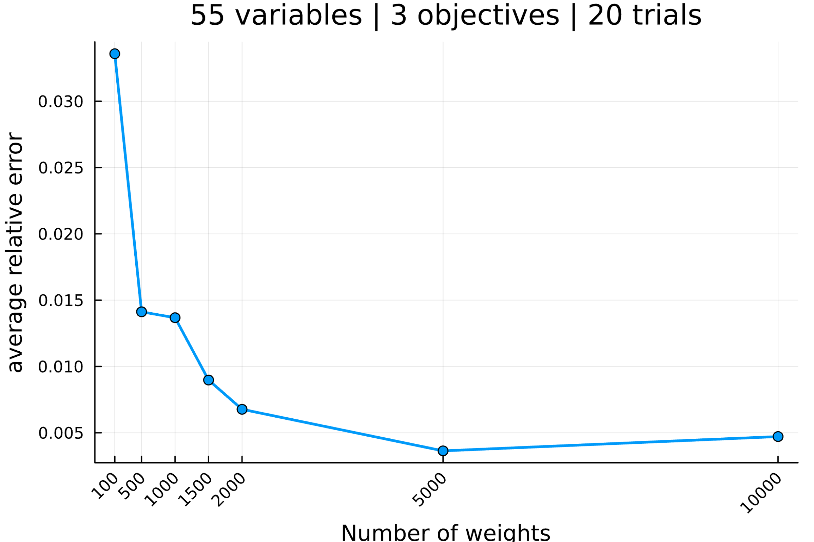

--------------------------------------------------------------------------------

Setup the parameters...

number of variables : 60

number of objectives : 3

reference point : [0, 0, 0]

interval of #weights : [(100, 100), (500, 500), (1000, 1000), (1500, 1500), (2000, 2000), (5000, 5000), (10000, 10000)]

solver MIP invoked : GLPK.Optimizer

number of trials : 20

Generate an mo01UKP instance...

Compute S, the set of nondominated points...

|S| = 1001 (64.81s)

Compute H, the hypervolume measure...

H(S) = 13161177838.0

Compute H̃, the estimation of H...

H estimated with rp=[0, 0, 0] and 100 weight: 12957236979.0 (0.28s)

H estimated with rp=[0, 0, 0] and 100 weight: 12601387517.9 (0.11s)

H estimated with rp=[0, 0, 0] and 100 weight: 13465794229.2 (0.12s)

H estimated with rp=[0, 0, 0] and 100 weight: 12501597679.4 (0.11s)

H estimated with rp=[0, 0, 0] and 100 weight: 13278020332.5 (0.12s)

H estimated with rp=[0, 0, 0] and 100 weight: 12599610220.4 (0.09s)

H estimated with rp=[0, 0, 0] and 100 weight: 13126712903.7 (0.11s)

H estimated with rp=[0, 0, 0] and 100 weight: 12465465829.3 (0.11s)

H estimated with rp=[0, 0, 0] and 100 weight: 12076885245.5 (0.09s)

H estimated with rp=[0, 0, 0] and 100 weight: 13295889022.4 (0.12s)

H estimated with rp=[0, 0, 0] and 100 weight: 12833238059.0 (0.11s)

H estimated with rp=[0, 0, 0] and 100 weight: 13953674808.4 (0.13s)

H estimated with rp=[0, 0, 0] and 100 weight: 12802061321.6 (0.1s)

H estimated with rp=[0, 0, 0] and 100 weight: 12908655167.5 (0.13s)

H estimated with rp=[0, 0, 0] and 100 weight: 13448438586.2 (0.09s)

H estimated with rp=[0, 0, 0] and 100 weight: 13011849636.1 (0.13s)

H estimated with rp=[0, 0, 0] and 100 weight: 12624648457.5 (0.09s)

H estimated with rp=[0, 0, 0] and 100 weight: 12181947680.5 (0.1s)

H estimated with rp=[0, 0, 0] and 100 weight: 12673602447.5 (0.1s)

H estimated with rp=[0, 0, 0] and 100 weight: 12674033500.6 (0.1s)

Analyze the results...

value H(S) = 13161177838.0

average value H̃ = 12874037481.2

average absolue error H̃ = 450733135.7

average relative error H̃ = 0.034247

Compute H̃, the estimation of H...

H estimated with rp=[0, 0, 0] and 500 weight: 13205161182.7 (0.52s)

H estimated with rp=[0, 0, 0] and 500 weight: 12620581279.1 (0.51s)

H estimated with rp=[0, 0, 0] and 500 weight: 13211954091.3 (0.51s)

H estimated with rp=[0, 0, 0] and 500 weight: 13157452860.6 (0.59s)

H estimated with rp=[0, 0, 0] and 500 weight: 13016675016.8 (0.55s)

H estimated with rp=[0, 0, 0] and 500 weight: 13188364874.5 (0.56s)

H estimated with rp=[0, 0, 0] and 500 weight: 13333849037.9 (0.52s)

H estimated with rp=[0, 0, 0] and 500 weight: 13273787616.2 (0.56s)

H estimated with rp=[0, 0, 0] and 500 weight: 13271822715.8 (0.57s)

H estimated with rp=[0, 0, 0] and 500 weight: 13317705412.8 (0.62s)

H estimated with rp=[0, 0, 0] and 500 weight: 13257212095.1 (0.57s)

H estimated with rp=[0, 0, 0] and 500 weight: 13573814993.9 (0.58s)

H estimated with rp=[0, 0, 0] and 500 weight: 13113131081.4 (0.58s)

H estimated with rp=[0, 0, 0] and 500 weight: 12940145403.1 (0.49s)

H estimated with rp=[0, 0, 0] and 500 weight: 13132754919.8 (0.52s)

H estimated with rp=[0, 0, 0] and 500 weight: 13111380193.8 (0.55s)

H estimated with rp=[0, 0, 0] and 500 weight: 13470903384.2 (0.54s)

H estimated with rp=[0, 0, 0] and 500 weight: 13559014719.5 (0.52s)

H estimated with rp=[0, 0, 0] and 500 weight: 13476996517.4 (0.6s)

H estimated with rp=[0, 0, 0] and 500 weight: 13267181973.9 (0.52s)

Analyze the results...

value H(S) = 13161177838.0

average value H̃ = 13224994468.5

average absolue error H̃ = 167429041.6

average relative error H̃ = 0.012721

Compute H̃, the estimation of H...

H estimated with rp=[0, 0, 0] and 1000 weight: 13463983491.4 (1.21s)

H estimated with rp=[0, 0, 0] and 1000 weight: 13376167300.5 (1.13s)

H estimated with rp=[0, 0, 0] and 1000 weight: 13259707554.3 (1.18s)

H estimated with rp=[0, 0, 0] and 1000 weight: 13550549105.7 (1.14s)

H estimated with rp=[0, 0, 0] and 1000 weight: 13069783893.6 (1.1s)

H estimated with rp=[0, 0, 0] and 1000 weight: 13269767035.6 (1.12s)

H estimated with rp=[0, 0, 0] and 1000 weight: 12923408660.6 (1.02s)

H estimated with rp=[0, 0, 0] and 1000 weight: 13193595542.3 (1.1s)

H estimated with rp=[0, 0, 0] and 1000 weight: 13069612874.5 (1.12s)

H estimated with rp=[0, 0, 0] and 1000 weight: 13355152094.2 (1.04s)

H estimated with rp=[0, 0, 0] and 1000 weight: 13119835294.6 (1.05s)

H estimated with rp=[0, 0, 0] and 1000 weight: 13036574748.3 (1.01s)

H estimated with rp=[0, 0, 0] and 1000 weight: 12968613729.7 (1.0s)

H estimated with rp=[0, 0, 0] and 1000 weight: 13065632836.2 (1.06s)

H estimated with rp=[0, 0, 0] and 1000 weight: 13091086425.1 (1.06s)

H estimated with rp=[0, 0, 0] and 1000 weight: 13108995448.8 (1.13s)

H estimated with rp=[0, 0, 0] and 1000 weight: 13467722365.2 (1.19s)

H estimated with rp=[0, 0, 0] and 1000 weight: 13172834867.3 (1.09s)

H estimated with rp=[0, 0, 0] and 1000 weight: 13432656041.2 (1.14s)

H estimated with rp=[0, 0, 0] and 1000 weight: 13305199976.7 (1.08s)

Analyze the results...

value H(S) = 13161177838.0

average value H̃ = 13215043964.3

average absolue error H̃ = 153571789.4

average relative error H̃ = 0.011669

Compute H̃, the estimation of H...

H estimated with rp=[0, 0, 0] and 1500 weight: 13232759302.2 (1.65s)

H estimated with rp=[0, 0, 0] and 1500 weight: 13200686833.1 (1.67s)

H estimated with rp=[0, 0, 0] and 1500 weight: 13104875837.4 (1.6s)

H estimated with rp=[0, 0, 0] and 1500 weight: 12875209007.2 (1.54s)

H estimated with rp=[0, 0, 0] and 1500 weight: 13307007624.9 (1.72s)

H estimated with rp=[0, 0, 0] and 1500 weight: 13136064510.5 (1.6s)

H estimated with rp=[0, 0, 0] and 1500 weight: 13117251639.2 (1.63s)

H estimated with rp=[0, 0, 0] and 1500 weight: 13100346863.2 (1.65s)

H estimated with rp=[0, 0, 0] and 1500 weight: 12943400614.1 (1.63s)

H estimated with rp=[0, 0, 0] and 1500 weight: 13325015526.2 (1.64s)

H estimated with rp=[0, 0, 0] and 1500 weight: 13128263569.0 (1.6s)

H estimated with rp=[0, 0, 0] and 1500 weight: 13316139901.9 (1.67s)

H estimated with rp=[0, 0, 0] and 1500 weight: 12922825125.7 (1.54s)

H estimated with rp=[0, 0, 0] and 1500 weight: 13156732622.6 (1.7s)

H estimated with rp=[0, 0, 0] and 1500 weight: 13108625113.9 (1.65s)

H estimated with rp=[0, 0, 0] and 1500 weight: 13241351947.9 (1.74s)

H estimated with rp=[0, 0, 0] and 1500 weight: 13090199206.1 (1.66s)

H estimated with rp=[0, 0, 0] and 1500 weight: 13156397784.7 (1.6s)

H estimated with rp=[0, 0, 0] and 1500 weight: 13066930463.1 (1.59s)

H estimated with rp=[0, 0, 0] and 1500 weight: 12879589830.1 (1.54s)

Analyze the results...

value H(S) = 13161177838.0

average value H̃ = 13120483666.1

average absolue error H̃ = 106283582.7

average relative error H̃ = 0.008076

Compute H̃, the estimation of H...

H estimated with rp=[0, 0, 0] and 2000 weight: 13117627507.3 (2.24s)

H estimated with rp=[0, 0, 0] and 2000 weight: 13118378861.5 (2.16s)

H estimated with rp=[0, 0, 0] and 2000 weight: 12982632973.6 (2.18s)

H estimated with rp=[0, 0, 0] and 2000 weight: 13103177943.3 (2.25s)

H estimated with rp=[0, 0, 0] and 2000 weight: 12973571923.8 (2.15s)

H estimated with rp=[0, 0, 0] and 2000 weight: 13104288568.2 (2.13s)

H estimated with rp=[0, 0, 0] and 2000 weight: 13190953311.2 (2.14s)

H estimated with rp=[0, 0, 0] and 2000 weight: 13013181605.3 (2.16s)

H estimated with rp=[0, 0, 0] and 2000 weight: 12819502663.8 (2.24s)

H estimated with rp=[0, 0, 0] and 2000 weight: 13232548700.4 (2.24s)

H estimated with rp=[0, 0, 0] and 2000 weight: 13199786587.7 (2.31s)

H estimated with rp=[0, 0, 0] and 2000 weight: 13270272983.4 (2.22s)

H estimated with rp=[0, 0, 0] and 2000 weight: 13311829251.6 (2.25s)

H estimated with rp=[0, 0, 0] and 2000 weight: 12870442890.6 (2.16s)

H estimated with rp=[0, 0, 0] and 2000 weight: 12996498240.1 (2.16s)

H estimated with rp=[0, 0, 0] and 2000 weight: 13188242220.4 (2.3s)

H estimated with rp=[0, 0, 0] and 2000 weight: 13294971890.5 (2.4s)

H estimated with rp=[0, 0, 0] and 2000 weight: 13057253725.5 (2.23s)

H estimated with rp=[0, 0, 0] and 2000 weight: 13243224990.4 (2.17s)

H estimated with rp=[0, 0, 0] and 2000 weight: 13398155032.7 (2.25s)

Analyze the results...

value H(S) = 13161177838.0

average value H̃ = 13124327093.6

average absolue error H̃ = 124789187.1

average relative error H̃ = 0.009482

Compute H̃, the estimation of H...

H estimated with rp=[0, 0, 0] and 5000 weight: 13182351846.1 (5.69s)

H estimated with rp=[0, 0, 0] and 5000 weight: 13110567094.2 (5.5s)

H estimated with rp=[0, 0, 0] and 5000 weight: 13056617859.3 (5.59s)

H estimated with rp=[0, 0, 0] and 5000 weight: 13232953545.8 (5.61s)

H estimated with rp=[0, 0, 0] and 5000 weight: 13225547057.5 (5.53s)

H estimated with rp=[0, 0, 0] and 5000 weight: 13132437801.4 (5.64s)

H estimated with rp=[0, 0, 0] and 5000 weight: 13165783121.0 (5.67s)

H estimated with rp=[0, 0, 0] and 5000 weight: 13036607784.3 (5.54s)

H estimated with rp=[0, 0, 0] and 5000 weight: 13217442540.8 (5.47s)

H estimated with rp=[0, 0, 0] and 5000 weight: 13275049169.8 (5.72s)

H estimated with rp=[0, 0, 0] and 5000 weight: 13137924562.2 (5.61s)

H estimated with rp=[0, 0, 0] and 5000 weight: 13216030970.9 (5.77s)

H estimated with rp=[0, 0, 0] and 5000 weight: 13224591989.6 (5.49s)

H estimated with rp=[0, 0, 0] and 5000 weight: 13195886977.7 (5.73s)

H estimated with rp=[0, 0, 0] and 5000 weight: 13009489220.4 (5.5s)

H estimated with rp=[0, 0, 0] and 5000 weight: 13282957811.7 (5.67s)

H estimated with rp=[0, 0, 0] and 5000 weight: 13240978618.5 (5.64s)

H estimated with rp=[0, 0, 0] and 5000 weight: 13068987307.6 (5.58s)

H estimated with rp=[0, 0, 0] and 5000 weight: 13064630369.8 (5.61s)

H estimated with rp=[0, 0, 0] and 5000 weight: 13239222993.9 (5.59s)

Analyze the results...

value H(S) = 13161177838.0

average value H̃ = 13165802932.1

average absolue error H̃ = 71841164.6

average relative error H̃ = 0.005459

Compute H̃, the estimation of H...

H estimated with rp=[0, 0, 0] and 10000 weight: 13135863888.9 (11.28s)

H estimated with rp=[0, 0, 0] and 10000 weight: 13247690309.9 (11.37s)

H estimated with rp=[0, 0, 0] and 10000 weight: 13125569648.6 (10.94s)

H estimated with rp=[0, 0, 0] and 10000 weight: 13062036092.9 (10.86s)

H estimated with rp=[0, 0, 0] and 10000 weight: 13153244730.3 (11.48s)

H estimated with rp=[0, 0, 0] and 10000 weight: 13161518222.8 (11.63s)

H estimated with rp=[0, 0, 0] and 10000 weight: 13328601312.5 (11.84s)

H estimated with rp=[0, 0, 0] and 10000 weight: 13217684374.7 (11.31s)

H estimated with rp=[0, 0, 0] and 10000 weight: 13115999182.7 (11.11s)

H estimated with rp=[0, 0, 0] and 10000 weight: 13168058551.4 (11.27s)

H estimated with rp=[0, 0, 0] and 10000 weight: 13174826386.5 (11.19s)

H estimated with rp=[0, 0, 0] and 10000 weight: 13175279296.2 (11.16s)

H estimated with rp=[0, 0, 0] and 10000 weight: 13213445616.7 (11.55s)

H estimated with rp=[0, 0, 0] and 10000 weight: 13077021910.1 (11.21s)

H estimated with rp=[0, 0, 0] and 10000 weight: 13120743411.5 (10.92s)

H estimated with rp=[0, 0, 0] and 10000 weight: 13148685619.8 (11.3s)

H estimated with rp=[0, 0, 0] and 10000 weight: 13163755402.6 (10.89s)

H estimated with rp=[0, 0, 0] and 10000 weight: 13312163206.3 (11.5s)

H estimated with rp=[0, 0, 0] and 10000 weight: 13142812024.2 (10.84s)

H estimated with rp=[0, 0, 0] and 10000 weight: 13164839498.8 (10.8s)

Analyze the results...

value H(S) = 13161177838.0

average value H̃ = 13170491934.4

average absolue error H̃ = 46176499.7

average relative error H̃ = 0.003509

All average relative error H̃ = [0.03424717310295161, 0.01272143296634958, 0.011668544506139493, 0.008075537309863387, 0.009481612406500747, 0.005458566512477387, 0.0035085385398128032]

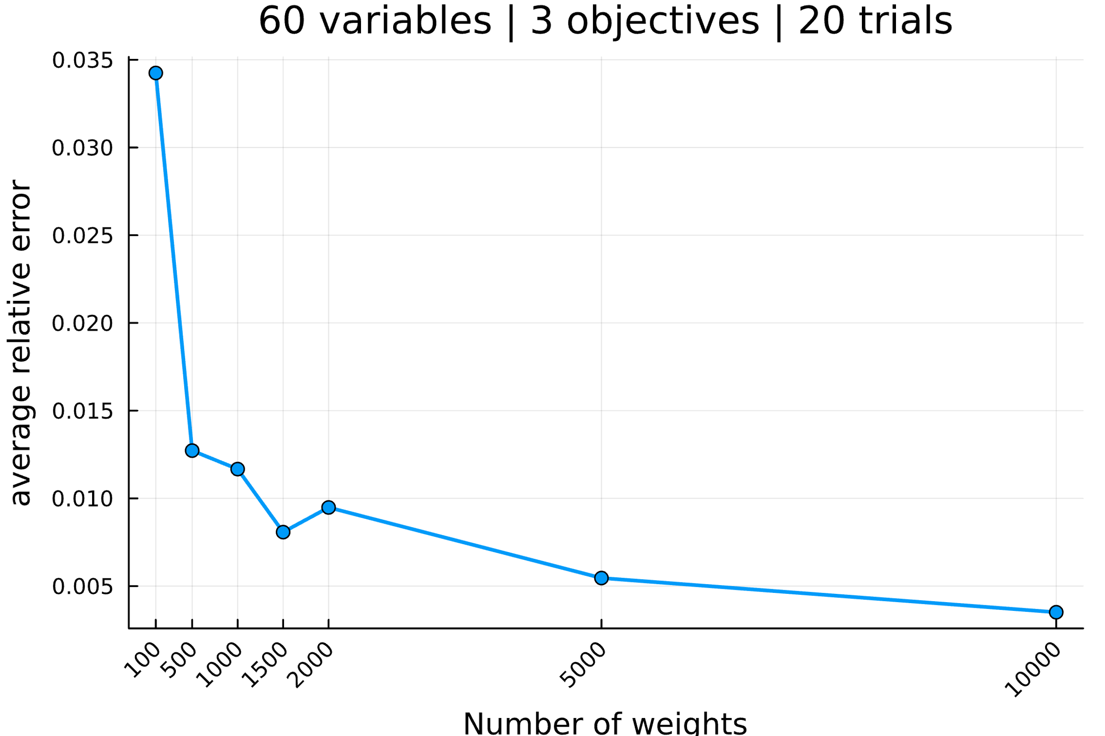

--------------------------------------------------------------------------------

Setup the parameters...

number of variables : 65

number of objectives : 3

reference point : [0, 0, 0]

interval of #weights : [(100, 100), (500, 500), (1000, 1000), (1500, 1500), (2000, 2000), (5000, 5000), (10000, 10000)]

solver MIP invoked : GLPK.Optimizer

number of trials : 20

Generate an mo01UKP instance...

Compute S, the set of nondominated points...

|S| = 472 (14.93s)

Compute H, the hypervolume measure...

H(S) = 17951308851.0

Compute H̃, the estimation of H...

H estimated with rp=[0, 0, 0] and 100 weight: 16715023648.3 (0.3s)

H estimated with rp=[0, 0, 0] and 100 weight: 17092375068.9 (0.13s)

H estimated with rp=[0, 0, 0] and 100 weight: 17502874821.2 (0.11s)

H estimated with rp=[0, 0, 0] and 100 weight: 17635783572.4 (0.13s)

H estimated with rp=[0, 0, 0] and 100 weight: 17896780869.9 (0.13s)

H estimated with rp=[0, 0, 0] and 100 weight: 18877727215.0 (0.13s)

H estimated with rp=[0, 0, 0] and 100 weight: 17448333169.9 (0.14s)

H estimated with rp=[0, 0, 0] and 100 weight: 16852236221.4 (0.13s)

H estimated with rp=[0, 0, 0] and 100 weight: 18022834324.3 (0.11s)

H estimated with rp=[0, 0, 0] and 100 weight: 18316774013.9 (0.13s)

H estimated with rp=[0, 0, 0] and 100 weight: 16925281923.9 (0.12s)

H estimated with rp=[0, 0, 0] and 100 weight: 18876319454.1 (0.13s)

H estimated with rp=[0, 0, 0] and 100 weight: 18234423429.5 (0.13s)

H estimated with rp=[0, 0, 0] and 100 weight: 16448632917.9 (0.13s)

H estimated with rp=[0, 0, 0] and 100 weight: 18202340613.8 (0.14s)

H estimated with rp=[0, 0, 0] and 100 weight: 17188542754.3 (0.13s)

H estimated with rp=[0, 0, 0] and 100 weight: 17870799592.8 (0.12s)

H estimated with rp=[0, 0, 0] and 100 weight: 18312062637.8 (0.13s)

H estimated with rp=[0, 0, 0] and 100 weight: 18498735507.3 (0.12s)

H estimated with rp=[0, 0, 0] and 100 weight: 18667207928.7 (0.13s)

Analyze the results...

value H(S) = 17951308851.0

average value H̃ = 17779254484.3

average absolue error H̃ = 616718913.3

average relative error H̃ = 0.034355

Compute H̃, the estimation of H...

H estimated with rp=[0, 0, 0] and 500 weight: 17928815041.9 (0.62s)

H estimated with rp=[0, 0, 0] and 500 weight: 17795654050.5 (0.62s)

H estimated with rp=[0, 0, 0] and 500 weight: 17395014908.0 (0.62s)

H estimated with rp=[0, 0, 0] and 500 weight: 17631635827.3 (0.6s)

H estimated with rp=[0, 0, 0] and 500 weight: 17874348676.4 (0.61s)

H estimated with rp=[0, 0, 0] and 500 weight: 18464272891.3 (0.6s)

H estimated with rp=[0, 0, 0] and 500 weight: 18048668243.0 (0.62s)

H estimated with rp=[0, 0, 0] and 500 weight: 17154814060.5 (0.6s)

H estimated with rp=[0, 0, 0] and 500 weight: 17430014708.6 (0.6s)

H estimated with rp=[0, 0, 0] and 500 weight: 17799312428.6 (0.62s)

H estimated with rp=[0, 0, 0] and 500 weight: 17566762298.6 (0.64s)

H estimated with rp=[0, 0, 0] and 500 weight: 17447070940.3 (0.6s)

H estimated with rp=[0, 0, 0] and 500 weight: 18270422604.8 (0.59s)

H estimated with rp=[0, 0, 0] and 500 weight: 17804971955.0 (0.65s)

H estimated with rp=[0, 0, 0] and 500 weight: 18468668922.9 (0.63s)

H estimated with rp=[0, 0, 0] and 500 weight: 17848612273.3 (0.62s)

H estimated with rp=[0, 0, 0] and 500 weight: 17838646671.8 (0.63s)

H estimated with rp=[0, 0, 0] and 500 weight: 17694035662.4 (0.59s)

H estimated with rp=[0, 0, 0] and 500 weight: 18078505935.0 (0.62s)

H estimated with rp=[0, 0, 0] and 500 weight: 18109968634.5 (0.65s)

Analyze the results...

value H(S) = 17951308851.0

average value H̃ = 17832510836.7

average absolue error H̃ = 292063426.8

average relative error H̃ = 0.016270

Compute H̃, the estimation of H...

H estimated with rp=[0, 0, 0] and 1000 weight: 17630731033.3 (1.21s)

H estimated with rp=[0, 0, 0] and 1000 weight: 17666859577.1 (1.25s)

H estimated with rp=[0, 0, 0] and 1000 weight: 17531858411.4 (1.25s)

H estimated with rp=[0, 0, 0] and 1000 weight: 17968756969.1 (1.24s)

H estimated with rp=[0, 0, 0] and 1000 weight: 17765673784.0 (1.22s)

H estimated with rp=[0, 0, 0] and 1000 weight: 17947888163.3 (1.23s)

H estimated with rp=[0, 0, 0] and 1000 weight: 17747780497.3 (1.3s)

H estimated with rp=[0, 0, 0] and 1000 weight: 18143981272.3 (1.25s)

H estimated with rp=[0, 0, 0] and 1000 weight: 17931599507.3 (1.27s)

H estimated with rp=[0, 0, 0] and 1000 weight: 18046590953.6 (1.25s)

H estimated with rp=[0, 0, 0] and 1000 weight: 17848438116.3 (1.19s)

H estimated with rp=[0, 0, 0] and 1000 weight: 17971576215.4 (1.25s)

H estimated with rp=[0, 0, 0] and 1000 weight: 18044543819.1 (1.24s)

H estimated with rp=[0, 0, 0] and 1000 weight: 18049749135.0 (1.26s)

H estimated with rp=[0, 0, 0] and 1000 weight: 18059766843.0 (1.24s)

H estimated with rp=[0, 0, 0] and 1000 weight: 18220728974.7 (1.26s)

H estimated with rp=[0, 0, 0] and 1000 weight: 17805995846.8 (1.26s)

H estimated with rp=[0, 0, 0] and 1000 weight: 17863410694.6 (1.27s)

H estimated with rp=[0, 0, 0] and 1000 weight: 18229746486.9 (1.31s)

H estimated with rp=[0, 0, 0] and 1000 weight: 17555398922.0 (1.23s)

Analyze the results...

value H(S) = 17951308851.0

average value H̃ = 17901553761.1

average absolue error H̃ = 167121190.9

average relative error H̃ = 0.009310

Compute H̃, the estimation of H...

H estimated with rp=[0, 0, 0] and 1500 weight: 18096514426.7 (1.86s)

H estimated with rp=[0, 0, 0] and 1500 weight: 18127641168.7 (1.89s)

H estimated with rp=[0, 0, 0] and 1500 weight: 18012137679.9 (1.86s)

H estimated with rp=[0, 0, 0] and 1500 weight: 18211796711.7 (1.91s)

H estimated with rp=[0, 0, 0] and 1500 weight: 17696621300.4 (1.83s)

H estimated with rp=[0, 0, 0] and 1500 weight: 18063639629.2 (1.88s)

H estimated with rp=[0, 0, 0] and 1500 weight: 18387338778.1 (1.9s)

H estimated with rp=[0, 0, 0] and 1500 weight: 17926203708.1 (1.86s)

H estimated with rp=[0, 0, 0] and 1500 weight: 17731877837.8 (1.88s)

H estimated with rp=[0, 0, 0] and 1500 weight: 17795166371.2 (1.9s)

H estimated with rp=[0, 0, 0] and 1500 weight: 17917778157.6 (1.83s)

H estimated with rp=[0, 0, 0] and 1500 weight: 17952744045.7 (1.9s)

H estimated with rp=[0, 0, 0] and 1500 weight: 18028879242.2 (1.84s)

H estimated with rp=[0, 0, 0] and 1500 weight: 17755554631.4 (1.83s)

H estimated with rp=[0, 0, 0] and 1500 weight: 17970289039.4 (1.88s)

H estimated with rp=[0, 0, 0] and 1500 weight: 18073094911.5 (1.89s)

H estimated with rp=[0, 0, 0] and 1500 weight: 18093403129.9 (1.88s)

H estimated with rp=[0, 0, 0] and 1500 weight: 18091784135.3 (1.88s)

H estimated with rp=[0, 0, 0] and 1500 weight: 17769604096.1 (1.88s)

H estimated with rp=[0, 0, 0] and 1500 weight: 17757596248.1 (1.82s)

Analyze the results...

value H(S) = 17951308851.0

average value H̃ = 17972983262.4

average absolue error H̃ = 147681257.2

average relative error H̃ = 0.008227

Compute H̃, the estimation of H...

H estimated with rp=[0, 0, 0] and 2000 weight: 18062123640.7 (2.54s)

H estimated with rp=[0, 0, 0] and 2000 weight: 17717732243.0 (2.58s)

H estimated with rp=[0, 0, 0] and 2000 weight: 17860760668.8 (2.55s)

H estimated with rp=[0, 0, 0] and 2000 weight: 18037510056.9 (2.5s)

H estimated with rp=[0, 0, 0] and 2000 weight: 18220366769.3 (2.56s)

H estimated with rp=[0, 0, 0] and 2000 weight: 17767869653.8 (2.5s)

H estimated with rp=[0, 0, 0] and 2000 weight: 17883077453.2 (2.53s)

H estimated with rp=[0, 0, 0] and 2000 weight: 17933314066.5 (2.5s)

H estimated with rp=[0, 0, 0] and 2000 weight: 18007931934.1 (2.61s)

H estimated with rp=[0, 0, 0] and 2000 weight: 17783922977.0 (2.51s)

H estimated with rp=[0, 0, 0] and 2000 weight: 18023303793.9 (2.55s)

H estimated with rp=[0, 0, 0] and 2000 weight: 17888455608.1 (2.51s)

H estimated with rp=[0, 0, 0] and 2000 weight: 17942686810.0 (2.49s)

H estimated with rp=[0, 0, 0] and 2000 weight: 18026466512.3 (2.61s)

H estimated with rp=[0, 0, 0] and 2000 weight: 17986570892.7 (2.55s)

H estimated with rp=[0, 0, 0] and 2000 weight: 17930245729.1 (2.49s)

H estimated with rp=[0, 0, 0] and 2000 weight: 17800469072.8 (2.54s)

H estimated with rp=[0, 0, 0] and 2000 weight: 17925518848.8 (2.56s)

H estimated with rp=[0, 0, 0] and 2000 weight: 18038787067.3 (2.56s)

H estimated with rp=[0, 0, 0] and 2000 weight: 17951240538.9 (2.51s)

Analyze the results...

value H(S) = 17951308851.0

average value H̃ = 17939417716.9

average absolue error H̃ = 91150120.1

average relative error H̃ = 0.005078

Compute H̃, the estimation of H...

H estimated with rp=[0, 0, 0] and 5000 weight: 18001202466.0 (6.29s)

H estimated with rp=[0, 0, 0] and 5000 weight: 17837884106.9 (6.34s)

H estimated with rp=[0, 0, 0] and 5000 weight: 18088490050.2 (6.39s)

H estimated with rp=[0, 0, 0] and 5000 weight: 17982426081.4 (6.44s)

H estimated with rp=[0, 0, 0] and 5000 weight: 18028270721.4 (6.42s)

H estimated with rp=[0, 0, 0] and 5000 weight: 18109178094.8 (6.5s)

H estimated with rp=[0, 0, 0] and 5000 weight: 17967535877.0 (6.42s)

H estimated with rp=[0, 0, 0] and 5000 weight: 18024705143.4 (6.36s)

H estimated with rp=[0, 0, 0] and 5000 weight: 17922194921.2 (6.53s)

H estimated with rp=[0, 0, 0] and 5000 weight: 18111972685.7 (6.4s)

H estimated with rp=[0, 0, 0] and 5000 weight: 18075807524.8 (6.46s)

H estimated with rp=[0, 0, 0] and 5000 weight: 17881921289.0 (6.45s)

H estimated with rp=[0, 0, 0] and 5000 weight: 17963931458.7 (6.51s)

H estimated with rp=[0, 0, 0] and 5000 weight: 17994983809.7 (6.38s)

H estimated with rp=[0, 0, 0] and 5000 weight: 17962806500.6 (6.5s)

H estimated with rp=[0, 0, 0] and 5000 weight: 17932092732.2 (6.52s)

H estimated with rp=[0, 0, 0] and 5000 weight: 18054581173.7 (6.43s)

H estimated with rp=[0, 0, 0] and 5000 weight: 17980817948.3 (6.4s)

H estimated with rp=[0, 0, 0] and 5000 weight: 18036658048.8 (6.49s)

H estimated with rp=[0, 0, 0] and 5000 weight: 17955176211.3 (6.47s)

Analyze the results...

value H(S) = 17951308851.0

average value H̃ = 17995631842.3

average absolue error H̃ = 67437226.7

average relative error H̃ = 0.003757

Compute H̃, the estimation of H...

H estimated with rp=[0, 0, 0] and 10000 weight: 17897957742.4 (12.78s)

H estimated with rp=[0, 0, 0] and 10000 weight: 17912212834.1 (12.7s)

H estimated with rp=[0, 0, 0] and 10000 weight: 18047981869.0 (12.95s)

H estimated with rp=[0, 0, 0] and 10000 weight: 17811627346.0 (12.85s)

H estimated with rp=[0, 0, 0] and 10000 weight: 17862068831.8 (12.86s)

H estimated with rp=[0, 0, 0] and 10000 weight: 17981505504.9 (12.94s)

H estimated with rp=[0, 0, 0] and 10000 weight: 17989731416.8 (12.84s)

H estimated with rp=[0, 0, 0] and 10000 weight: 17990926515.1 (12.97s)

H estimated with rp=[0, 0, 0] and 10000 weight: 17868446279.6 (13.08s)

H estimated with rp=[0, 0, 0] and 10000 weight: 18002751067.6 (13.17s)

H estimated with rp=[0, 0, 0] and 10000 weight: 17983566852.5 (13.01s)

H estimated with rp=[0, 0, 0] and 10000 weight: 17850490667.9 (12.8s)

H estimated with rp=[0, 0, 0] and 10000 weight: 18011359702.6 (13.12s)

H estimated with rp=[0, 0, 0] and 10000 weight: 17870505311.3 (12.8s)

H estimated with rp=[0, 0, 0] and 10000 weight: 18011270204.7 (13.0s)

H estimated with rp=[0, 0, 0] and 10000 weight: 17965987558.7 (13.04s)

H estimated with rp=[0, 0, 0] and 10000 weight: 17943775065.1 (12.91s)

H estimated with rp=[0, 0, 0] and 10000 weight: 17974814479.8 (12.83s)

H estimated with rp=[0, 0, 0] and 10000 weight: 17854108086.1 (12.64s)

H estimated with rp=[0, 0, 0] and 10000 weight: 18040004985.9 (12.63s)

Analyze the results...

value H(S) = 17951308851.0

average value H̃ = 17943554616.1

average absolue error H̃ = 61304514.6

average relative error H̃ = 0.003415

All average relative error H̃ = [0.03435509457236628, 0.016269756664415734, 0.009309693920934742, 0.00822676822148489, 0.005077630874818527, 0.0037566746400981912, 0.003415044277358936]

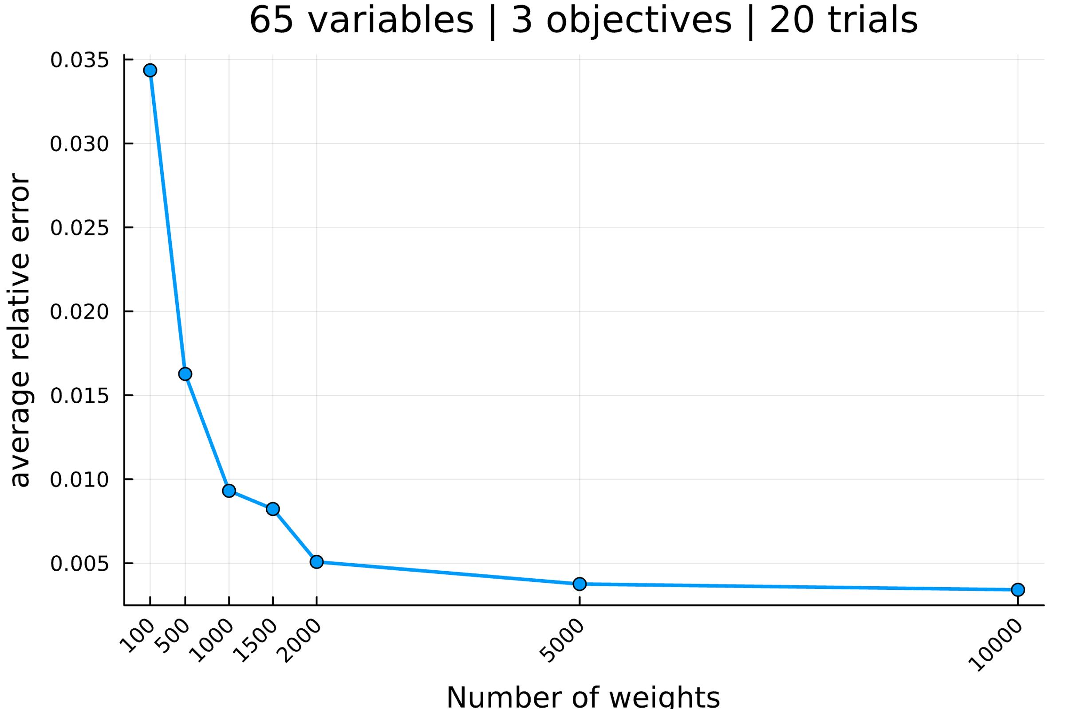

--------------------------------------------------------------------------------

Setup the parameters...

number of variables : 70

number of objectives : 3

reference point : [0, 0, 0]

interval of #weights : [(100, 100), (500, 500), (1000, 1000), (1500, 1500), (2000, 2000), (5000, 5000), (10000, 10000)]

solver MIP invoked : GLPK.Optimizer

number of trials : 20

Generate an mo01UKP instance...

Compute S, the set of nondominated points...

|S| = 757 (39.71s)

Compute H, the hypervolume measure...

H(S) = 23121911521.0

Compute H̃, the estimation of H...

H estimated with rp=[0, 0, 0] and 100 weight: 23553886600.4 (0.33s)

H estimated with rp=[0, 0, 0] and 100 weight: 22358578394.9 (0.15s)

H estimated with rp=[0, 0, 0] and 100 weight: 23842553538.9 (0.16s)

H estimated with rp=[0, 0, 0] and 100 weight: 24664730210.4 (0.17s)

H estimated with rp=[0, 0, 0] and 100 weight: 23577847653.0 (0.14s)

H estimated with rp=[0, 0, 0] and 100 weight: 22977141366.9 (0.16s)

H estimated with rp=[0, 0, 0] and 100 weight: 23705267083.8 (0.17s)

H estimated with rp=[0, 0, 0] and 100 weight: 23612234689.5 (0.15s)

H estimated with rp=[0, 0, 0] and 100 weight: 23413767221.2 (0.15s)

H estimated with rp=[0, 0, 0] and 100 weight: 22702570741.4 (0.16s)

H estimated with rp=[0, 0, 0] and 100 weight: 23199981056.0 (0.15s)

H estimated with rp=[0, 0, 0] and 100 weight: 23169734782.7 (0.16s)

H estimated with rp=[0, 0, 0] and 100 weight: 23143895589.7 (0.14s)

H estimated with rp=[0, 0, 0] and 100 weight: 23337941272.6 (0.15s)

H estimated with rp=[0, 0, 0] and 100 weight: 23168947587.8 (0.16s)

H estimated with rp=[0, 0, 0] and 100 weight: 22016078329.3 (0.15s)

H estimated with rp=[0, 0, 0] and 100 weight: 22400610694.4 (0.15s)

H estimated with rp=[0, 0, 0] and 100 weight: 22724861055.4 (0.16s)

H estimated with rp=[0, 0, 0] and 100 weight: 23464435748.6 (0.16s)

H estimated with rp=[0, 0, 0] and 100 weight: 22662908610.0 (0.16s)

Analyze the results...

value H(S) = 23121911521.0

average value H̃ = 23184898611.3

average absolue error H̃ = 464050235.8

average relative error H̃ = 0.020070

Compute H̃, the estimation of H...

H estimated with rp=[0, 0, 0] and 500 weight: 23702494308.5 (0.77s)

H estimated with rp=[0, 0, 0] and 500 weight: 22325081399.2 (0.69s)

H estimated with rp=[0, 0, 0] and 500 weight: 23277332331.1 (0.75s)

H estimated with rp=[0, 0, 0] and 500 weight: 23577562261.6 (0.78s)

H estimated with rp=[0, 0, 0] and 500 weight: 23266400987.4 (0.79s)

H estimated with rp=[0, 0, 0] and 500 weight: 23781018216.7 (0.79s)

H estimated with rp=[0, 0, 0] and 500 weight: 22731377482.3 (0.74s)

H estimated with rp=[0, 0, 0] and 500 weight: 22925524049.0 (0.77s)

H estimated with rp=[0, 0, 0] and 500 weight: 23332615499.3 (0.78s)

H estimated with rp=[0, 0, 0] and 500 weight: 23069434469.0 (0.79s)

H estimated with rp=[0, 0, 0] and 500 weight: 23125599860.8 (0.78s)

H estimated with rp=[0, 0, 0] and 500 weight: 23555301126.3 (0.81s)

H estimated with rp=[0, 0, 0] and 500 weight: 22966725350.7 (0.74s)

H estimated with rp=[0, 0, 0] and 500 weight: 23044736110.9 (0.74s)

H estimated with rp=[0, 0, 0] and 500 weight: 22810748896.7 (0.76s)

H estimated with rp=[0, 0, 0] and 500 weight: 22934787231.1 (0.71s)

H estimated with rp=[0, 0, 0] and 500 weight: 22619504480.8 (0.79s)

H estimated with rp=[0, 0, 0] and 500 weight: 22849226316.0 (0.73s)

H estimated with rp=[0, 0, 0] and 500 weight: 22995033406.9 (0.78s)

H estimated with rp=[0, 0, 0] and 500 weight: 23027954356.4 (0.75s)

Analyze the results...

value H(S) = 23121911521.0

average value H̃ = 23095922907.0

average absolue error H̃ = 290291856.3

average relative error H̃ = 0.012555

Compute H̃, the estimation of H...

H estimated with rp=[0, 0, 0] and 1000 weight: 23033830815.7 (1.47s)

H estimated with rp=[0, 0, 0] and 1000 weight: 23338987730.7 (1.57s)

H estimated with rp=[0, 0, 0] and 1000 weight: 23214259093.1 (1.55s)

H estimated with rp=[0, 0, 0] and 1000 weight: 23169322144.2 (1.55s)

H estimated with rp=[0, 0, 0] and 1000 weight: 22962816055.2 (1.56s)

H estimated with rp=[0, 0, 0] and 1000 weight: 22620915567.1 (1.5s)

H estimated with rp=[0, 0, 0] and 1000 weight: 23100903095.4 (1.57s)

H estimated with rp=[0, 0, 0] and 1000 weight: 23163107042.9 (1.57s)

H estimated with rp=[0, 0, 0] and 1000 weight: 22655578649.0 (1.56s)

H estimated with rp=[0, 0, 0] and 1000 weight: 23322970675.2 (1.52s)

H estimated with rp=[0, 0, 0] and 1000 weight: 22974482732.0 (1.53s)

H estimated with rp=[0, 0, 0] and 1000 weight: 22752198118.1 (1.53s)

H estimated with rp=[0, 0, 0] and 1000 weight: 22771668610.8 (1.59s)

H estimated with rp=[0, 0, 0] and 1000 weight: 23634165232.2 (1.59s)

H estimated with rp=[0, 0, 0] and 1000 weight: 23279364311.4 (1.55s)

H estimated with rp=[0, 0, 0] and 1000 weight: 23386787955.5 (1.5s)

H estimated with rp=[0, 0, 0] and 1000 weight: 22963899200.8 (1.54s)

H estimated with rp=[0, 0, 0] and 1000 weight: 22973766468.5 (1.55s)

H estimated with rp=[0, 0, 0] and 1000 weight: 23009873523.7 (1.57s)

H estimated with rp=[0, 0, 0] and 1000 weight: 22993742180.8 (1.53s)

Analyze the results...

value H(S) = 23121911521.0

average value H̃ = 23066131960.1

average absolue error H̃ = 209146762.6

average relative error H̃ = 0.009045

Compute H̃, the estimation of H...

H estimated with rp=[0, 0, 0] and 1500 weight: 23263228715.8 (2.32s)

H estimated with rp=[0, 0, 0] and 1500 weight: 23183131194.2 (2.34s)

H estimated with rp=[0, 0, 0] and 1500 weight: 23277785409.9 (2.29s)

H estimated with rp=[0, 0, 0] and 1500 weight: 23117599199.5 (2.33s)

H estimated with rp=[0, 0, 0] and 1500 weight: 23187622531.9 (2.3s)

H estimated with rp=[0, 0, 0] and 1500 weight: 23359516853.2 (2.3s)

H estimated with rp=[0, 0, 0] and 1500 weight: 22927214101.5 (2.28s)

H estimated with rp=[0, 0, 0] and 1500 weight: 23174813973.4 (2.35s)

H estimated with rp=[0, 0, 0] and 1500 weight: 22968951782.9 (2.33s)

H estimated with rp=[0, 0, 0] and 1500 weight: 23346208824.2 (2.33s)

H estimated with rp=[0, 0, 0] and 1500 weight: 23162767060.8 (2.32s)

H estimated with rp=[0, 0, 0] and 1500 weight: 23112146627.7 (2.3s)

H estimated with rp=[0, 0, 0] and 1500 weight: 22654550888.7 (2.28s)

H estimated with rp=[0, 0, 0] and 1500 weight: 23401701711.0 (2.32s)

H estimated with rp=[0, 0, 0] and 1500 weight: 23300547604.1 (2.29s)

H estimated with rp=[0, 0, 0] and 1500 weight: 23194358862.4 (2.34s)

H estimated with rp=[0, 0, 0] and 1500 weight: 23138288126.0 (2.32s)

H estimated with rp=[0, 0, 0] and 1500 weight: 23155980716.4 (2.36s)

H estimated with rp=[0, 0, 0] and 1500 weight: 23192800126.9 (2.28s)

H estimated with rp=[0, 0, 0] and 1500 weight: 22846442462.2 (2.29s)

Analyze the results...

value H(S) = 23121911521.0

average value H̃ = 23148282838.6

average absolue error H̃ = 136827724.0

average relative error H̃ = 0.005918

Compute H̃, the estimation of H...

H estimated with rp=[0, 0, 0] and 2000 weight: 23334785334.0 (3.18s)

H estimated with rp=[0, 0, 0] and 2000 weight: 23183221455.3 (3.0s)

H estimated with rp=[0, 0, 0] and 2000 weight: 23278336261.9 (3.08s)

H estimated with rp=[0, 0, 0] and 2000 weight: 23023889465.9 (3.12s)

H estimated with rp=[0, 0, 0] and 2000 weight: 22872674164.3 (2.97s)

H estimated with rp=[0, 0, 0] and 2000 weight: 23177730264.8 (3.11s)

H estimated with rp=[0, 0, 0] and 2000 weight: 22951766793.9 (3.05s)

H estimated with rp=[0, 0, 0] and 2000 weight: 23006995118.3 (3.08s)

H estimated with rp=[0, 0, 0] and 2000 weight: 23083128438.7 (3.09s)

H estimated with rp=[0, 0, 0] and 2000 weight: 23093786090.3 (3.08s)

H estimated with rp=[0, 0, 0] and 2000 weight: 23271188874.6 (3.11s)

H estimated with rp=[0, 0, 0] and 2000 weight: 23002982925.8 (3.02s)

H estimated with rp=[0, 0, 0] and 2000 weight: 22884520837.0 (3.09s)

H estimated with rp=[0, 0, 0] and 2000 weight: 23236141194.6 (3.1s)

H estimated with rp=[0, 0, 0] and 2000 weight: 22872991645.1 (3.05s)

H estimated with rp=[0, 0, 0] and 2000 weight: 23150618381.1 (3.12s)

H estimated with rp=[0, 0, 0] and 2000 weight: 23219632771.3 (3.18s)

H estimated with rp=[0, 0, 0] and 2000 weight: 22954668519.0 (3.13s)

H estimated with rp=[0, 0, 0] and 2000 weight: 22868334033.2 (3.09s)

H estimated with rp=[0, 0, 0] and 2000 weight: 23232562458.0 (3.15s)

Analyze the results...

value H(S) = 23121911521.0

average value H̃ = 23084997751.4

average absolue error H̃ = 135615100.3

average relative error H̃ = 0.005865

Compute H̃, the estimation of H...

H estimated with rp=[0, 0, 0] and 5000 weight: 23137168665.3 (7.92s)

H estimated with rp=[0, 0, 0] and 5000 weight: 23176627727.5 (7.85s)

H estimated with rp=[0, 0, 0] and 5000 weight: 23176097744.9 (7.99s)

H estimated with rp=[0, 0, 0] and 5000 weight: 23289879472.4 (7.9s)

H estimated with rp=[0, 0, 0] and 5000 weight: 23136321224.1 (7.85s)

H estimated with rp=[0, 0, 0] and 5000 weight: 23279856984.0 (7.98s)

H estimated with rp=[0, 0, 0] and 5000 weight: 23370990493.7 (7.92s)

H estimated with rp=[0, 0, 0] and 5000 weight: 23212898242.6 (7.94s)

H estimated with rp=[0, 0, 0] and 5000 weight: 23063304408.8 (7.83s)

H estimated with rp=[0, 0, 0] and 5000 weight: 23108326560.6 (7.83s)

H estimated with rp=[0, 0, 0] and 5000 weight: 23246678696.2 (7.88s)

H estimated with rp=[0, 0, 0] and 5000 weight: 22947825015.5 (7.88s)

H estimated with rp=[0, 0, 0] and 5000 weight: 22902966659.2 (7.83s)

H estimated with rp=[0, 0, 0] and 5000 weight: 23268238886.2 (7.79s)

H estimated with rp=[0, 0, 0] and 5000 weight: 23393054936.3 (7.94s)

H estimated with rp=[0, 0, 0] and 5000 weight: 23222667623.7 (7.89s)

H estimated with rp=[0, 0, 0] and 5000 weight: 23200945643.4 (7.91s)

H estimated with rp=[0, 0, 0] and 5000 weight: 23160108161.5 (7.85s)

H estimated with rp=[0, 0, 0] and 5000 weight: 23413270636.5 (7.89s)

H estimated with rp=[0, 0, 0] and 5000 weight: 23133982762.7 (7.98s)

Analyze the results...

value H(S) = 23121911521.0

average value H̃ = 23192060527.3

average absolue error H̃ = 116671350.3

average relative error H̃ = 0.005046

Compute H̃, the estimation of H...

H estimated with rp=[0, 0, 0] and 10000 weight: 23325201403.0 (15.94s)

H estimated with rp=[0, 0, 0] and 10000 weight: 23138649465.6 (15.97s)

H estimated with rp=[0, 0, 0] and 10000 weight: 23098389064.3 (15.82s)

H estimated with rp=[0, 0, 0] and 10000 weight: 23090774064.0 (15.84s)

H estimated with rp=[0, 0, 0] and 10000 weight: 23060604449.1 (15.68s)

H estimated with rp=[0, 0, 0] and 10000 weight: 23193538395.8 (15.58s)

H estimated with rp=[0, 0, 0] and 10000 weight: 22900716430.2 (15.64s)

H estimated with rp=[0, 0, 0] and 10000 weight: 23054967100.1 (15.82s)

H estimated with rp=[0, 0, 0] and 10000 weight: 23227163244.2 (15.96s)

H estimated with rp=[0, 0, 0] and 10000 weight: 23084019822.0 (15.96s)

H estimated with rp=[0, 0, 0] and 10000 weight: 23231508969.3 (15.82s)

H estimated with rp=[0, 0, 0] and 10000 weight: 22882742099.1 (15.67s)

H estimated with rp=[0, 0, 0] and 10000 weight: 23191430596.1 (16.0s)

H estimated with rp=[0, 0, 0] and 10000 weight: 23044453035.9 (15.86s)

H estimated with rp=[0, 0, 0] and 10000 weight: 23071019417.4 (15.95s)

H estimated with rp=[0, 0, 0] and 10000 weight: 23130802335.2 (16.03s)

H estimated with rp=[0, 0, 0] and 10000 weight: 23197424045.0 (15.9s)

H estimated with rp=[0, 0, 0] and 10000 weight: 23105496256.6 (15.61s)

H estimated with rp=[0, 0, 0] and 10000 weight: 23169704158.7 (15.37s)

H estimated with rp=[0, 0, 0] and 10000 weight: 23097327409.8 (15.39s)

Analyze the results...

value H(S) = 23121911521.0

average value H̃ = 23114796588.1

average absolue error H̃ = 77936825.3

average relative error H̃ = 0.003371

All average relative error H̃ = [0.020069717652457908, 0.012554838126696801, 0.009045392393753203, 0.005917664889665048, 0.005865220104129602, 0.005045921490773084, 0.003370691270375133]

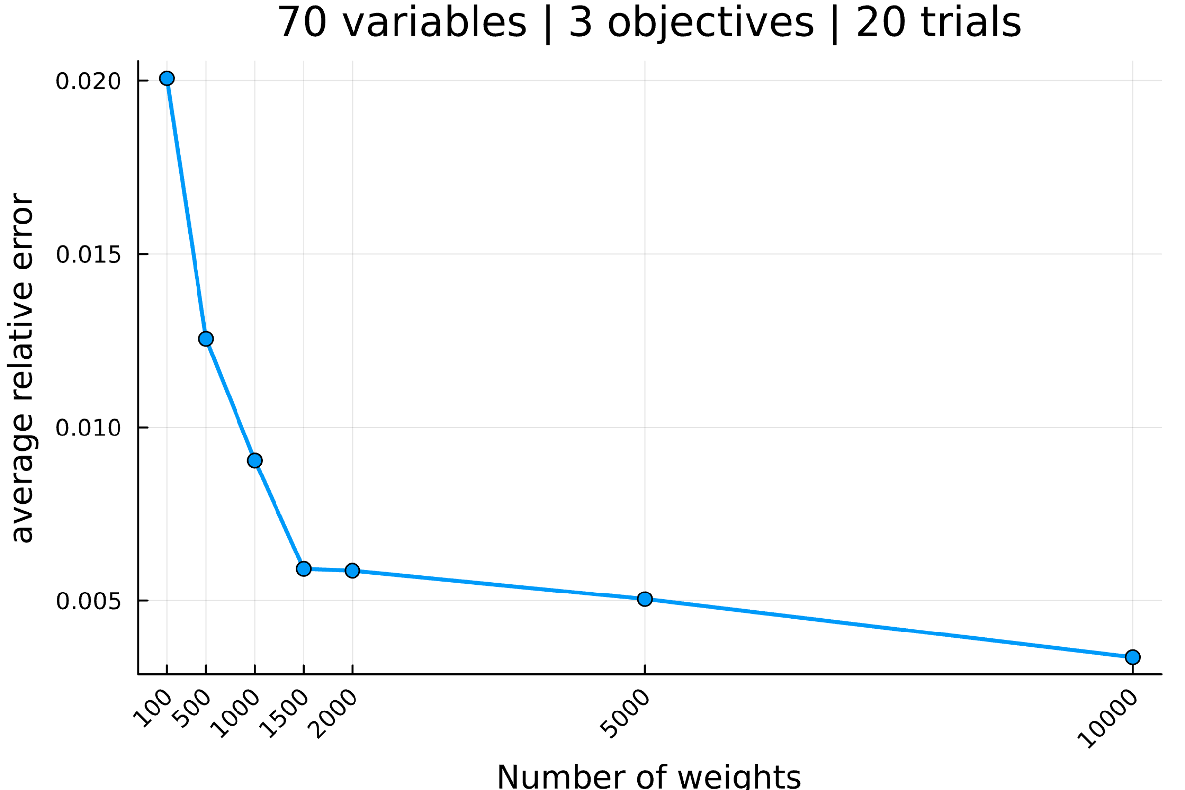

--------------------------------------------------------------------------------

Setup the parameters...

number of variables : 75

number of objectives : 3

reference point : [0, 0, 0]

interval of #weights : [(100, 100), (500, 500), (1000, 1000), (1500, 1500), (2000, 2000), (5000, 5000), (10000, 10000)]

solver MIP invoked : GLPK.Optimizer

number of trials : 20

Generate an mo01UKP instance...

Compute S, the set of nondominated points...

|S| = 1798 (239.64s)

Compute H, the hypervolume measure...

H(S) = 23807212219.0

Compute H̃, the estimation of H...

H estimated with rp=[0, 0, 0] and 100 weight: 23379143662.1 (0.36s)

H estimated with rp=[0, 0, 0] and 100 weight: 25048247426.5 (0.21s)

H estimated with rp=[0, 0, 0] and 100 weight: 24976634645.0 (0.19s)

H estimated with rp=[0, 0, 0] and 100 weight: 23284338083.1 (0.15s)

H estimated with rp=[0, 0, 0] and 100 weight: 25319283151.4 (0.21s)

H estimated with rp=[0, 0, 0] and 100 weight: 23583081146.7 (0.2s)

H estimated with rp=[0, 0, 0] and 100 weight: 24098202342.1 (0.19s)

H estimated with rp=[0, 0, 0] and 100 weight: 24022938268.2 (0.17s)

H estimated with rp=[0, 0, 0] and 100 weight: 24542858606.2 (0.18s)

H estimated with rp=[0, 0, 0] and 100 weight: 24234578811.0 (0.19s)

H estimated with rp=[0, 0, 0] and 100 weight: 24411970957.3 (0.2s)

H estimated with rp=[0, 0, 0] and 100 weight: 23850582822.1 (0.16s)

H estimated with rp=[0, 0, 0] and 100 weight: 23628922650.9 (0.2s)

H estimated with rp=[0, 0, 0] and 100 weight: 22303837155.6 (0.17s)

H estimated with rp=[0, 0, 0] and 100 weight: 25469529884.5 (0.2s)

H estimated with rp=[0, 0, 0] and 100 weight: 22693343708.8 (0.2s)

H estimated with rp=[0, 0, 0] and 100 weight: 22867623158.8 (0.16s)

H estimated with rp=[0, 0, 0] and 100 weight: 25095417958.8 (0.18s)

H estimated with rp=[0, 0, 0] and 100 weight: 23967611513.5 (0.18s)

H estimated with rp=[0, 0, 0] and 100 weight: 24212773677.7 (0.19s)

Analyze the results...

value H(S) = 23807212219.0

average value H̃ = 24049545981.5

average absolue error H̃ = 733353359.2

average relative error H̃ = 0.030804

Compute H̃, the estimation of H...

H estimated with rp=[0, 0, 0] and 500 weight: 23644618801.5 (0.89s)

H estimated with rp=[0, 0, 0] and 500 weight: 24003660470.7 (0.91s)

H estimated with rp=[0, 0, 0] and 500 weight: 23482961311.3 (0.84s)

H estimated with rp=[0, 0, 0] and 500 weight: 23947187834.3 (0.98s)

H estimated with rp=[0, 0, 0] and 500 weight: 23735255891.0 (0.88s)

H estimated with rp=[0, 0, 0] and 500 weight: 23391320027.7 (0.87s)

H estimated with rp=[0, 0, 0] and 500 weight: 23957385555.3 (0.98s)

H estimated with rp=[0, 0, 0] and 500 weight: 23241546702.3 (0.81s)

H estimated with rp=[0, 0, 0] and 500 weight: 23300740590.3 (0.86s)

H estimated with rp=[0, 0, 0] and 500 weight: 23646606311.0 (0.9s)

H estimated with rp=[0, 0, 0] and 500 weight: 23405402869.7 (0.9s)

H estimated with rp=[0, 0, 0] and 500 weight: 24063873959.2 (0.9s)

H estimated with rp=[0, 0, 0] and 500 weight: 24492767436.0 (0.95s)

H estimated with rp=[0, 0, 0] and 500 weight: 23315130056.3 (0.83s)

H estimated with rp=[0, 0, 0] and 500 weight: 23671299668.4 (0.86s)

H estimated with rp=[0, 0, 0] and 500 weight: 24090844709.5 (0.9s)

H estimated with rp=[0, 0, 0] and 500 weight: 24184746410.3 (0.88s)

H estimated with rp=[0, 0, 0] and 500 weight: 23354162329.0 (0.87s)

H estimated with rp=[0, 0, 0] and 500 weight: 23709498806.3 (0.92s)

H estimated with rp=[0, 0, 0] and 500 weight: 23901069105.3 (0.89s)

Analyze the results...

value H(S) = 23807212219.0

average value H̃ = 23727003942.3

average absolue error H̃ = 298592049.6

average relative error H̃ = 0.012542

Compute H̃, the estimation of H...

H estimated with rp=[0, 0, 0] and 1000 weight: 24342974855.0 (1.83s)

H estimated with rp=[0, 0, 0] and 1000 weight: 23852284380.0 (1.74s)

H estimated with rp=[0, 0, 0] and 1000 weight: 24154498109.2 (1.89s)

H estimated with rp=[0, 0, 0] and 1000 weight: 23676408541.3 (1.84s)

H estimated with rp=[0, 0, 0] and 1000 weight: 23718646892.0 (1.82s)

H estimated with rp=[0, 0, 0] and 1000 weight: 23926313525.7 (1.74s)

H estimated with rp=[0, 0, 0] and 1000 weight: 23973967625.7 (1.87s)

H estimated with rp=[0, 0, 0] and 1000 weight: 24233020358.8 (1.92s)

H estimated with rp=[0, 0, 0] and 1000 weight: 23876421345.4 (1.79s)

H estimated with rp=[0, 0, 0] and 1000 weight: 23667939386.8 (1.87s)

H estimated with rp=[0, 0, 0] and 1000 weight: 23520983324.2 (1.7s)

H estimated with rp=[0, 0, 0] and 1000 weight: 24207193349.9 (1.79s)

H estimated with rp=[0, 0, 0] and 1000 weight: 23736979168.7 (1.77s)

H estimated with rp=[0, 0, 0] and 1000 weight: 23933541503.9 (1.86s)

H estimated with rp=[0, 0, 0] and 1000 weight: 23984727824.5 (1.85s)

H estimated with rp=[0, 0, 0] and 1000 weight: 23766330330.5 (1.83s)

H estimated with rp=[0, 0, 0] and 1000 weight: 23778561143.3 (1.86s)

H estimated with rp=[0, 0, 0] and 1000 weight: 23635818261.0 (1.87s)

H estimated with rp=[0, 0, 0] and 1000 weight: 24129656053.4 (1.93s)

H estimated with rp=[0, 0, 0] and 1000 weight: 24018636196.2 (1.8s)

Analyze the results...

value H(S) = 23807212219.0

average value H̃ = 23906745108.8

average absolue error H̃ = 195135960.2

average relative error H̃ = 0.008197

Compute H̃, the estimation of H...

H estimated with rp=[0, 0, 0] and 1500 weight: 23824637805.2 (2.77s)

H estimated with rp=[0, 0, 0] and 1500 weight: 23917898742.5 (2.7s)

H estimated with rp=[0, 0, 0] and 1500 weight: 24438734418.0 (2.86s)

H estimated with rp=[0, 0, 0] and 1500 weight: 24151976240.0 (2.71s)

H estimated with rp=[0, 0, 0] and 1500 weight: 23794888228.4 (2.74s)

H estimated with rp=[0, 0, 0] and 1500 weight: 23808970154.5 (2.71s)

H estimated with rp=[0, 0, 0] and 1500 weight: 23790220138.6 (2.68s)

H estimated with rp=[0, 0, 0] and 1500 weight: 23728762610.4 (2.71s)

H estimated with rp=[0, 0, 0] and 1500 weight: 23620968621.6 (2.73s)

H estimated with rp=[0, 0, 0] and 1500 weight: 23600775167.7 (2.7s)

H estimated with rp=[0, 0, 0] and 1500 weight: 23615565424.3 (2.76s)

H estimated with rp=[0, 0, 0] and 1500 weight: 23589550405.8 (2.69s)

H estimated with rp=[0, 0, 0] and 1500 weight: 23631289579.4 (2.7s)

H estimated with rp=[0, 0, 0] and 1500 weight: 24170455652.1 (2.86s)

H estimated with rp=[0, 0, 0] and 1500 weight: 23780509503.8 (2.77s)

H estimated with rp=[0, 0, 0] and 1500 weight: 23841209391.3 (2.68s)

H estimated with rp=[0, 0, 0] and 1500 weight: 24271903570.3 (2.78s)

H estimated with rp=[0, 0, 0] and 1500 weight: 24118359315.3 (2.7s)

H estimated with rp=[0, 0, 0] and 1500 weight: 23554181094.6 (2.76s)

H estimated with rp=[0, 0, 0] and 1500 weight: 24003816241.4 (2.72s)

Analyze the results...

value H(S) = 23807212219.0

average value H̃ = 23862733615.3

average absolue error H̃ = 192062537.8

average relative error H̃ = 0.008067

Compute H̃, the estimation of H...

H estimated with rp=[0, 0, 0] and 2000 weight: 23582069318.8 (3.58s)

H estimated with rp=[0, 0, 0] and 2000 weight: 23447539089.6 (3.56s)

H estimated with rp=[0, 0, 0] and 2000 weight: 23761231331.7 (3.68s)

H estimated with rp=[0, 0, 0] and 2000 weight: 23628762645.2 (3.69s)

H estimated with rp=[0, 0, 0] and 2000 weight: 23872367036.5 (3.71s)

H estimated with rp=[0, 0, 0] and 2000 weight: 23793566795.9 (3.65s)

H estimated with rp=[0, 0, 0] and 2000 weight: 23901283720.2 (3.63s)

H estimated with rp=[0, 0, 0] and 2000 weight: 23759158594.5 (3.64s)

H estimated with rp=[0, 0, 0] and 2000 weight: 23585676913.1 (3.54s)

H estimated with rp=[0, 0, 0] and 2000 weight: 23798532392.8 (3.64s)

H estimated with rp=[0, 0, 0] and 2000 weight: 23958459765.2 (3.71s)

H estimated with rp=[0, 0, 0] and 2000 weight: 23796532066.7 (3.69s)

H estimated with rp=[0, 0, 0] and 2000 weight: 24005433913.3 (3.78s)

H estimated with rp=[0, 0, 0] and 2000 weight: 23717594455.1 (3.69s)

H estimated with rp=[0, 0, 0] and 2000 weight: 23969091880.1 (3.67s)

H estimated with rp=[0, 0, 0] and 2000 weight: 24141872955.1 (3.82s)

H estimated with rp=[0, 0, 0] and 2000 weight: 23602723986.0 (3.51s)

H estimated with rp=[0, 0, 0] and 2000 weight: 23906576384.1 (3.81s)

H estimated with rp=[0, 0, 0] and 2000 weight: 23893620541.2 (3.64s)

H estimated with rp=[0, 0, 0] and 2000 weight: 23709053434.0 (3.74s)

Analyze the results...

value H(S) = 23807212219.0

average value H̃ = 23791557361.0

average absolue error H̃ = 134755702.4

average relative error H̃ = 0.005660

Compute H̃, the estimation of H...

H estimated with rp=[0, 0, 0] and 5000 weight: 23605090749.9 (8.82s)

H estimated with rp=[0, 0, 0] and 5000 weight: 23898678757.0 (9.27s)

H estimated with rp=[0, 0, 0] and 5000 weight: 23915992513.6 (9.15s)

H estimated with rp=[0, 0, 0] and 5000 weight: 23785916988.9 (9.06s)

H estimated with rp=[0, 0, 0] and 5000 weight: 23852986521.8 (9.19s)

H estimated with rp=[0, 0, 0] and 5000 weight: 23742190285.4 (8.99s)

H estimated with rp=[0, 0, 0] and 5000 weight: 23849590685.6 (9.14s)

H estimated with rp=[0, 0, 0] and 5000 weight: 23676859428.2 (9.15s)

H estimated with rp=[0, 0, 0] and 5000 weight: 23784914131.7 (9.17s)

H estimated with rp=[0, 0, 0] and 5000 weight: 23654886167.3 (8.93s)

H estimated with rp=[0, 0, 0] and 5000 weight: 23676532440.6 (8.99s)

H estimated with rp=[0, 0, 0] and 5000 weight: 23771711162.2 (8.97s)

H estimated with rp=[0, 0, 0] and 5000 weight: 23804581092.1 (8.94s)

H estimated with rp=[0, 0, 0] and 5000 weight: 23808412795.2 (9.0s)

H estimated with rp=[0, 0, 0] and 5000 weight: 23710418288.1 (8.95s)

H estimated with rp=[0, 0, 0] and 5000 weight: 23943744594.6 (9.3s)

H estimated with rp=[0, 0, 0] and 5000 weight: 23994859244.7 (9.04s)

H estimated with rp=[0, 0, 0] and 5000 weight: 23783122557.2 (9.18s)

H estimated with rp=[0, 0, 0] and 5000 weight: 23924674611.6 (8.92s)

H estimated with rp=[0, 0, 0] and 5000 weight: 23806449071.2 (9.04s)

Analyze the results...

value H(S) = 23807212219.0

average value H̃ = 23799580604.3

average absolue error H̃ = 80755811.9

average relative error H̃ = 0.003392

Compute H̃, the estimation of H...

H estimated with rp=[0, 0, 0] and 10000 weight: 23821543647.2 (18.14s)

H estimated with rp=[0, 0, 0] and 10000 weight: 23689205004.6 (18.21s)

H estimated with rp=[0, 0, 0] and 10000 weight: 23848716883.2 (17.84s)

H estimated with rp=[0, 0, 0] and 10000 weight: 23806774190.3 (17.76s)

H estimated with rp=[0, 0, 0] and 10000 weight: 23916146277.7 (17.86s)

H estimated with rp=[0, 0, 0] and 10000 weight: 23878967140.5 (17.79s)

H estimated with rp=[0, 0, 0] and 10000 weight: 23791424647.7 (17.74s)

H estimated with rp=[0, 0, 0] and 10000 weight: 23952661675.5 (17.95s)

H estimated with rp=[0, 0, 0] and 10000 weight: 23794357827.7 (17.81s)

H estimated with rp=[0, 0, 0] and 10000 weight: 23730709582.2 (17.6s)

H estimated with rp=[0, 0, 0] and 10000 weight: 23805951455.5 (18.0s)

H estimated with rp=[0, 0, 0] and 10000 weight: 23697911348.0 (17.63s)

H estimated with rp=[0, 0, 0] and 10000 weight: 23936022061.2 (17.94s)

H estimated with rp=[0, 0, 0] and 10000 weight: 23841147438.3 (18.06s)

H estimated with rp=[0, 0, 0] and 10000 weight: 23836286476.8 (17.94s)

H estimated with rp=[0, 0, 0] and 10000 weight: 23810218041.3 (17.94s)

H estimated with rp=[0, 0, 0] and 10000 weight: 23844208874.9 (17.89s)

H estimated with rp=[0, 0, 0] and 10000 weight: 23895813690.3 (18.18s)

H estimated with rp=[0, 0, 0] and 10000 weight: 23806853780.6 (18.04s)

H estimated with rp=[0, 0, 0] and 10000 weight: 23815529454.5 (17.78s)

Analyze the results...

value H(S) = 23807212219.0

average value H̃ = 23826022474.9

average absolue error H̃ = 52261247.4

average relative error H̃ = 0.002195

All average relative error H̃ = [0.030803831732957542, 0.012542083752599284, 0.008196506100726187, 0.008067409826184632, 0.005660289040648725, 0.0033920734240085243, 0.0021951855152161515]

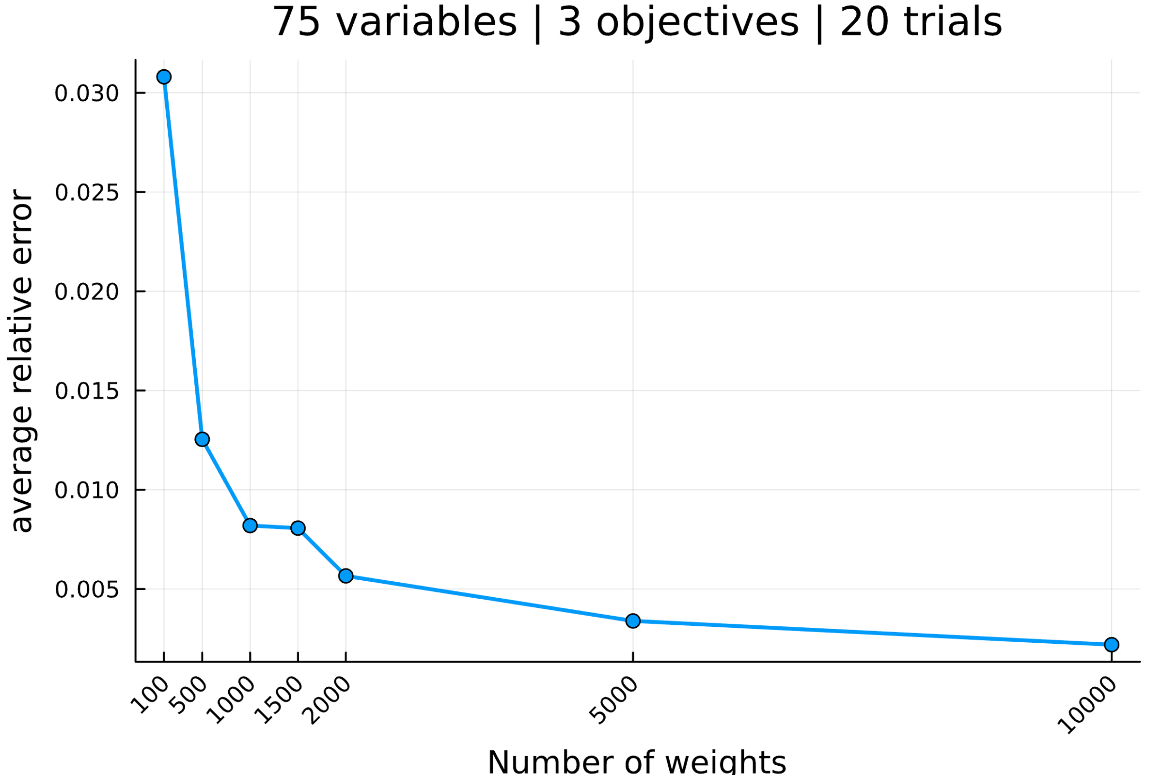

--------------------------------------------------------------------------------

Setup the parameters...

number of variables : 80

number of objectives : 3

reference point : [0, 0, 0]

interval of #weights : [(100, 100), (500, 500), (1000, 1000), (1500, 1500), (2000, 2000), (5000, 5000), (10000, 10000)]

solver MIP invoked : GLPK.Optimizer

number of trials : 20

Generate an mo01UKP instance...

Compute S, the set of nondominated points...

|S| = 1923 (289.19s)

Compute H, the hypervolume measure...

H(S) = 33977486555.0

Compute H̃, the estimation of H...

H estimated with rp=[0, 0, 0] and 100 weight: 35080943092.4 (0.38s)

H estimated with rp=[0, 0, 0] and 100 weight: 33450505131.2 (0.16s)

H estimated with rp=[0, 0, 0] and 100 weight: 32934614709.4 (0.17s)

H estimated with rp=[0, 0, 0] and 100 weight: 33314099818.8 (0.18s)

H estimated with rp=[0, 0, 0] and 100 weight: 35021873795.6 (0.19s)

H estimated with rp=[0, 0, 0] and 100 weight: 33412231453.3 (0.19s)

H estimated with rp=[0, 0, 0] and 100 weight: 33676933495.7 (0.16s)

H estimated with rp=[0, 0, 0] and 100 weight: 32688384774.0 (0.17s)

H estimated with rp=[0, 0, 0] and 100 weight: 33534842520.9 (0.14s)

H estimated with rp=[0, 0, 0] and 100 weight: 34166240915.4 (0.14s)

H estimated with rp=[0, 0, 0] and 100 weight: 35463749224.4 (0.18s)

H estimated with rp=[0, 0, 0] and 100 weight: 34363905232.0 (0.18s)

H estimated with rp=[0, 0, 0] and 100 weight: 34504103259.6 (0.16s)

H estimated with rp=[0, 0, 0] and 100 weight: 33747040762.1 (0.22s)

H estimated with rp=[0, 0, 0] and 100 weight: 32991365342.2 (0.18s)

H estimated with rp=[0, 0, 0] and 100 weight: 33420565859.2 (0.17s)

H estimated with rp=[0, 0, 0] and 100 weight: 36036122566.7 (0.17s)

H estimated with rp=[0, 0, 0] and 100 weight: 33748280637.3 (0.18s)

H estimated with rp=[0, 0, 0] and 100 weight: 31609652581.7 (0.14s)

H estimated with rp=[0, 0, 0] and 100 weight: 33040695175.3 (0.17s)

Analyze the results...

value H(S) = 33977486555.0

average value H̃ = 33810307517.4

average absolue error H̃ = 846632257.7

average relative error H̃ = 0.024917

Compute H̃, the estimation of H...

H estimated with rp=[0, 0, 0] and 500 weight: 34386406076.4 (0.9s)

H estimated with rp=[0, 0, 0] and 500 weight: 34292510419.1 (0.88s)

H estimated with rp=[0, 0, 0] and 500 weight: 33345812776.3 (0.86s)

H estimated with rp=[0, 0, 0] and 500 weight: 34544231775.7 (0.96s)

H estimated with rp=[0, 0, 0] and 500 weight: 33485994607.5 (0.88s)

H estimated with rp=[0, 0, 0] and 500 weight: 34647862099.9 (0.89s)

H estimated with rp=[0, 0, 0] and 500 weight: 34413902053.2 (0.86s)

H estimated with rp=[0, 0, 0] and 500 weight: 34224450286.2 (0.85s)

H estimated with rp=[0, 0, 0] and 500 weight: 33589133049.3 (0.93s)

H estimated with rp=[0, 0, 0] and 500 weight: 33643276932.6 (0.81s)

H estimated with rp=[0, 0, 0] and 500 weight: 33938265288.3 (0.91s)

H estimated with rp=[0, 0, 0] and 500 weight: 33599613423.6 (0.91s)

H estimated with rp=[0, 0, 0] and 500 weight: 33523866909.0 (0.86s)

H estimated with rp=[0, 0, 0] and 500 weight: 34734354039.2 (0.91s)

H estimated with rp=[0, 0, 0] and 500 weight: 33874850361.2 (0.89s)

H estimated with rp=[0, 0, 0] and 500 weight: 33587596684.8 (0.84s)

H estimated with rp=[0, 0, 0] and 500 weight: 33202904482.1 (0.9s)

H estimated with rp=[0, 0, 0] and 500 weight: 34263260576.1 (0.91s)

H estimated with rp=[0, 0, 0] and 500 weight: 34302170032.7 (0.89s)

H estimated with rp=[0, 0, 0] and 500 weight: 34619583659.0 (0.93s)

Analyze the results...

value H(S) = 33977486555.0

average value H̃ = 34011002276.6

average absolue error H̃ = 431870825.1

average relative error H̃ = 0.012710

Compute H̃, the estimation of H...

H estimated with rp=[0, 0, 0] and 1000 weight: 33955046320.9 (1.82s)

H estimated with rp=[0, 0, 0] and 1000 weight: 34292625872.7 (1.85s)

H estimated with rp=[0, 0, 0] and 1000 weight: 34252130095.0 (1.66s)

H estimated with rp=[0, 0, 0] and 1000 weight: 34001241207.5 (1.75s)

H estimated with rp=[0, 0, 0] and 1000 weight: 33601974151.5 (1.78s)

H estimated with rp=[0, 0, 0] and 1000 weight: 33643883032.2 (1.64s)

H estimated with rp=[0, 0, 0] and 1000 weight: 33667906892.5 (1.75s)

H estimated with rp=[0, 0, 0] and 1000 weight: 33966050987.9 (1.67s)

H estimated with rp=[0, 0, 0] and 1000 weight: 34011450609.0 (1.79s)

H estimated with rp=[0, 0, 0] and 1000 weight: 34353139040.4 (1.85s)

H estimated with rp=[0, 0, 0] and 1000 weight: 33841119993.6 (1.75s)

H estimated with rp=[0, 0, 0] and 1000 weight: 33833868252.0 (1.72s)

H estimated with rp=[0, 0, 0] and 1000 weight: 33986790447.6 (1.79s)

H estimated with rp=[0, 0, 0] and 1000 weight: 34983965456.8 (1.84s)

H estimated with rp=[0, 0, 0] and 1000 weight: 33568475895.8 (1.61s)

H estimated with rp=[0, 0, 0] and 1000 weight: 33941986287.1 (1.81s)

H estimated with rp=[0, 0, 0] and 1000 weight: 33564974830.8 (1.63s)

H estimated with rp=[0, 0, 0] and 1000 weight: 34181546531.4 (1.67s)

H estimated with rp=[0, 0, 0] and 1000 weight: 33576361069.4 (1.71s)

H estimated with rp=[0, 0, 0] and 1000 weight: 34390302419.6 (1.77s)

Analyze the results...

value H(S) = 33977486555.0

average value H̃ = 33980741969.7

average absolue error H̃ = 262325853.8

average relative error H̃ = 0.007721

Compute H̃, the estimation of H...

H estimated with rp=[0, 0, 0] and 1500 weight: 33864993602.6 (2.59s)

H estimated with rp=[0, 0, 0] and 1500 weight: 34103310658.3 (2.61s)

H estimated with rp=[0, 0, 0] and 1500 weight: 34267821922.3 (2.59s)

H estimated with rp=[0, 0, 0] and 1500 weight: 33451313134.6 (2.47s)

H estimated with rp=[0, 0, 0] and 1500 weight: 34064884153.7 (2.73s)

H estimated with rp=[0, 0, 0] and 1500 weight: 34122320842.5 (2.6s)

H estimated with rp=[0, 0, 0] and 1500 weight: 33934428123.5 (2.58s)

H estimated with rp=[0, 0, 0] and 1500 weight: 34379878860.7 (2.65s)

H estimated with rp=[0, 0, 0] and 1500 weight: 34141636870.0 (2.66s)

H estimated with rp=[0, 0, 0] and 1500 weight: 33916281587.5 (2.65s)

H estimated with rp=[0, 0, 0] and 1500 weight: 34190223911.7 (2.61s)

H estimated with rp=[0, 0, 0] and 1500 weight: 34488024787.0 (2.73s)

H estimated with rp=[0, 0, 0] and 1500 weight: 34223532087.2 (2.58s)

H estimated with rp=[0, 0, 0] and 1500 weight: 34156097599.2 (2.64s)

H estimated with rp=[0, 0, 0] and 1500 weight: 34319998836.8 (2.73s)

H estimated with rp=[0, 0, 0] and 1500 weight: 33807637005.0 (2.65s)

H estimated with rp=[0, 0, 0] and 1500 weight: 34168221230.6 (2.8s)

H estimated with rp=[0, 0, 0] and 1500 weight: 33419408019.2 (2.4s)

H estimated with rp=[0, 0, 0] and 1500 weight: 33467972222.1 (2.53s)

H estimated with rp=[0, 0, 0] and 1500 weight: 33847460729.7 (2.58s)

Analyze the results...

value H(S) = 33977486555.0

average value H̃ = 34016772309.2

average absolue error H̃ = 250325555.8

average relative error H̃ = 0.007367

Compute H̃, the estimation of H...

H estimated with rp=[0, 0, 0] and 2000 weight: 34139459923.8 (3.47s)

H estimated with rp=[0, 0, 0] and 2000 weight: 34447717871.4 (3.64s)

H estimated with rp=[0, 0, 0] and 2000 weight: 34457431911.3 (3.68s)

H estimated with rp=[0, 0, 0] and 2000 weight: 34228832176.0 (3.51s)

H estimated with rp=[0, 0, 0] and 2000 weight: 33811835212.8 (3.43s)

H estimated with rp=[0, 0, 0] and 2000 weight: 33909097672.0 (3.35s)

H estimated with rp=[0, 0, 0] and 2000 weight: 34257390912.4 (3.5s)

H estimated with rp=[0, 0, 0] and 2000 weight: 33890376042.7 (3.42s)

H estimated with rp=[0, 0, 0] and 2000 weight: 33899113505.4 (3.35s)

H estimated with rp=[0, 0, 0] and 2000 weight: 34109450365.6 (3.47s)

H estimated with rp=[0, 0, 0] and 2000 weight: 33665686833.3 (3.4s)

H estimated with rp=[0, 0, 0] and 2000 weight: 33883685502.2 (3.58s)

H estimated with rp=[0, 0, 0] and 2000 weight: 33552254587.2 (3.33s)

H estimated with rp=[0, 0, 0] and 2000 weight: 33866526623.6 (3.55s)

H estimated with rp=[0, 0, 0] and 2000 weight: 34490394483.5 (3.71s)

H estimated with rp=[0, 0, 0] and 2000 weight: 34689911854.2 (3.55s)

H estimated with rp=[0, 0, 0] and 2000 weight: 33824448330.9 (3.39s)

H estimated with rp=[0, 0, 0] and 2000 weight: 34486681687.6 (3.63s)

H estimated with rp=[0, 0, 0] and 2000 weight: 34113360682.3 (3.41s)

H estimated with rp=[0, 0, 0] and 2000 weight: 33864301059.5 (3.37s)

Analyze the results...

value H(S) = 33977486555.0

average value H̃ = 34079397861.9

average absolue error H̃ = 262665324.9

average relative error H̃ = 0.007731

Compute H̃, the estimation of H...

H estimated with rp=[0, 0, 0] and 5000 weight: 33911695238.6 (8.64s)

H estimated with rp=[0, 0, 0] and 5000 weight: 33753881066.5 (8.46s)

H estimated with rp=[0, 0, 0] and 5000 weight: 34239415451.1 (8.85s)

H estimated with rp=[0, 0, 0] and 5000 weight: 33953875637.9 (8.9s)

H estimated with rp=[0, 0, 0] and 5000 weight: 33938868053.9 (8.99s)

H estimated with rp=[0, 0, 0] and 5000 weight: 34283910742.5 (8.86s)

H estimated with rp=[0, 0, 0] and 5000 weight: 33718340006.7 (8.69s)

H estimated with rp=[0, 0, 0] and 5000 weight: 34027197918.2 (8.61s)

H estimated with rp=[0, 0, 0] and 5000 weight: 34052822032.8 (8.83s)

H estimated with rp=[0, 0, 0] and 5000 weight: 34327871606.2 (9.06s)

H estimated with rp=[0, 0, 0] and 5000 weight: 33995988737.9 (8.74s)

H estimated with rp=[0, 0, 0] and 5000 weight: 33961919245.5 (8.68s)

H estimated with rp=[0, 0, 0] and 5000 weight: 33929285826.7 (8.74s)

H estimated with rp=[0, 0, 0] and 5000 weight: 34026190061.0 (8.83s)

H estimated with rp=[0, 0, 0] and 5000 weight: 34038259811.3 (8.66s)

H estimated with rp=[0, 0, 0] and 5000 weight: 34269850527.1 (9.05s)

H estimated with rp=[0, 0, 0] and 5000 weight: 33962208700.6 (8.68s)

H estimated with rp=[0, 0, 0] and 5000 weight: 33881227546.8 (8.74s)

H estimated with rp=[0, 0, 0] and 5000 weight: 33965831352.2 (8.77s)

H estimated with rp=[0, 0, 0] and 5000 weight: 34158384368.5 (8.96s)

Analyze the results...

value H(S) = 33977486555.0

average value H̃ = 34019851196.6

average absolue error H̃ = 122137929.1

average relative error H̃ = 0.003595

Compute H̃, the estimation of H...

H estimated with rp=[0, 0, 0] and 10000 weight: 34017878001.5 (17.34s)

H estimated with rp=[0, 0, 0] and 10000 weight: 34106962151.2 (17.52s)

H estimated with rp=[0, 0, 0] and 10000 weight: 34060420693.7 (17.58s)

H estimated with rp=[0, 0, 0] and 10000 weight: 33961368202.1 (17.75s)

H estimated with rp=[0, 0, 0] and 10000 weight: 34001825969.1 (17.52s)

H estimated with rp=[0, 0, 0] and 10000 weight: 34077448771.3 (17.25s)

H estimated with rp=[0, 0, 0] and 10000 weight: 34035113725.0 (17.34s)

H estimated with rp=[0, 0, 0] and 10000 weight: 33973452725.0 (17.19s)

H estimated with rp=[0, 0, 0] and 10000 weight: 33916793232.7 (17.48s)

H estimated with rp=[0, 0, 0] and 10000 weight: 34001100900.0 (17.57s)

H estimated with rp=[0, 0, 0] and 10000 weight: 34074698075.5 (17.54s)

H estimated with rp=[0, 0, 0] and 10000 weight: 34245307776.4 (17.64s)

H estimated with rp=[0, 0, 0] and 10000 weight: 33914140612.8 (17.27s)

H estimated with rp=[0, 0, 0] and 10000 weight: 33934071831.8 (17.61s)

H estimated with rp=[0, 0, 0] and 10000 weight: 34050935163.5 (17.65s)

H estimated with rp=[0, 0, 0] and 10000 weight: 34098191796.1 (17.44s)

H estimated with rp=[0, 0, 0] and 10000 weight: 33943572818.4 (17.7s)

H estimated with rp=[0, 0, 0] and 10000 weight: 34002353931.8 (17.51s)

H estimated with rp=[0, 0, 0] and 10000 weight: 33837772106.6 (17.41s)

H estimated with rp=[0, 0, 0] and 10000 weight: 33645322149.0 (16.84s)

Analyze the results...

value H(S) = 33977486555.0

average value H̃ = 33994936531.7

average absolue error H̃ = 86789852.8

average relative error H̃ = 0.002554

All average relative error H̃ = [0.02491744809826962, 0.012710499478795248, 0.0077205785483326975, 0.0073673947421426435, 0.007730569607662117, 0.0035946722799725162, 0.002554334108546945]

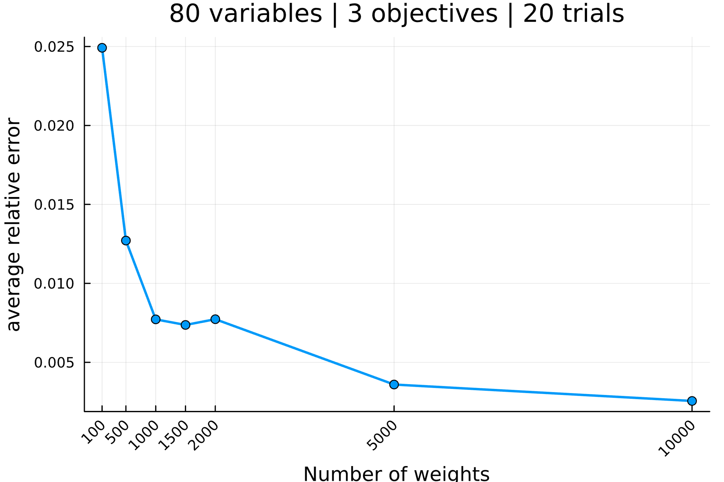

--------------------------------------------------------------------------------

Setup the parameters...

number of variables : 85

number of objectives : 3

reference point : [0, 0, 0]

interval of #weights : [(100, 100), (500, 500), (1000, 1000), (1500, 1500), (2000, 2000), (5000, 5000), (10000, 10000)]

solver MIP invoked : GLPK.Optimizer

number of trials : 20

Generate an mo01UKP instance...

Compute S, the set of nondominated points...

|S| = 3068 (891.2s)

Compute H, the hypervolume measure...

H(S) = 39357025854.0

Compute H̃, the estimation of H...

H estimated with rp=[0, 0, 0] and 100 weight: 39254801231.1 (0.4s)

H estimated with rp=[0, 0, 0] and 100 weight: 38896638410.3 (0.2s)

H estimated with rp=[0, 0, 0] and 100 weight: 39703041535.2 (0.24s)

H estimated with rp=[0, 0, 0] and 100 weight: 39921393934.7 (0.24s)

H estimated with rp=[0, 0, 0] and 100 weight: 38552520313.2 (0.18s)

H estimated with rp=[0, 0, 0] and 100 weight: 38838347859.6 (0.16s)

H estimated with rp=[0, 0, 0] and 100 weight: 38645696110.3 (0.19s)

H estimated with rp=[0, 0, 0] and 100 weight: 38117642641.0 (0.22s)

H estimated with rp=[0, 0, 0] and 100 weight: 38345865906.7 (0.22s)

H estimated with rp=[0, 0, 0] and 100 weight: 40756933785.3 (0.21s)

H estimated with rp=[0, 0, 0] and 100 weight: 40901787721.9 (0.25s)

H estimated with rp=[0, 0, 0] and 100 weight: 41091737273.1 (0.23s)

H estimated with rp=[0, 0, 0] and 100 weight: 39790091359.2 (0.23s)

H estimated with rp=[0, 0, 0] and 100 weight: 39916369427.6 (0.22s)

H estimated with rp=[0, 0, 0] and 100 weight: 39120242559.8 (0.2s)

H estimated with rp=[0, 0, 0] and 100 weight: 37481343611.3 (0.18s)

H estimated with rp=[0, 0, 0] and 100 weight: 38895810268.5 (0.21s)

H estimated with rp=[0, 0, 0] and 100 weight: 41269088312.5 (0.24s)

H estimated with rp=[0, 0, 0] and 100 weight: 37951942475.6 (0.18s)

H estimated with rp=[0, 0, 0] and 100 weight: 40287088538.2 (0.2s)

Analyze the results...

value H(S) = 39357025854.0

average value H̃ = 39386919163.8

average absolue error H̃ = 912536610.4

average relative error H̃ = 0.023186

Compute H̃, the estimation of H...

H estimated with rp=[0, 0, 0] and 500 weight: 38406639568.6 (1.0s)

H estimated with rp=[0, 0, 0] and 500 weight: 39578273166.0 (1.02s)

H estimated with rp=[0, 0, 0] and 500 weight: 39269833421.5 (0.98s)

H estimated with rp=[0, 0, 0] and 500 weight: 38973824820.1 (1.05s)

H estimated with rp=[0, 0, 0] and 500 weight: 39765780145.4 (1.02s)

H estimated with rp=[0, 0, 0] and 500 weight: 39571375769.8 (1.08s)

H estimated with rp=[0, 0, 0] and 500 weight: 39992732768.8 (1.15s)

H estimated with rp=[0, 0, 0] and 500 weight: 39933882387.2 (1.13s)

H estimated with rp=[0, 0, 0] and 500 weight: 39737443720.3 (1.06s)

H estimated with rp=[0, 0, 0] and 500 weight: 40009870195.2 (1.1s)

H estimated with rp=[0, 0, 0] and 500 weight: 39056648213.2 (1.02s)

H estimated with rp=[0, 0, 0] and 500 weight: 39813800194.9 (1.09s)

H estimated with rp=[0, 0, 0] and 500 weight: 38883878255.8 (1.05s)

H estimated with rp=[0, 0, 0] and 500 weight: 39576119527.7 (1.13s)

H estimated with rp=[0, 0, 0] and 500 weight: 40490221497.9 (1.17s)

H estimated with rp=[0, 0, 0] and 500 weight: 39619957602.1 (1.04s)

H estimated with rp=[0, 0, 0] and 500 weight: 39643908413.7 (1.17s)

H estimated with rp=[0, 0, 0] and 500 weight: 39855765293.0 (1.03s)

H estimated with rp=[0, 0, 0] and 500 weight: 39556848373.6 (1.05s)

H estimated with rp=[0, 0, 0] and 500 weight: 40003489037.2 (1.13s)

Analyze the results...

value H(S) = 39357025854.0

average value H̃ = 39587014618.6

average absolue error H̃ = 449419263.7

average relative error H̃ = 0.011419

Compute H̃, the estimation of H...

H estimated with rp=[0, 0, 0] and 1000 weight: 38828560621.7 (2.01s)

H estimated with rp=[0, 0, 0] and 1000 weight: 39774468882.5 (2.16s)

H estimated with rp=[0, 0, 0] and 1000 weight: 39824636122.9 (2.37s)

H estimated with rp=[0, 0, 0] and 1000 weight: 39163408229.9 (2.14s)

H estimated with rp=[0, 0, 0] and 1000 weight: 39049073534.9 (2.18s)

H estimated with rp=[0, 0, 0] and 1000 weight: 39940458676.1 (2.17s)

H estimated with rp=[0, 0, 0] and 1000 weight: 39553172022.4 (2.14s)

H estimated with rp=[0, 0, 0] and 1000 weight: 39671124209.4 (2.33s)

H estimated with rp=[0, 0, 0] and 1000 weight: 39229277485.7 (2.05s)

H estimated with rp=[0, 0, 0] and 1000 weight: 39832115713.6 (2.27s)

H estimated with rp=[0, 0, 0] and 1000 weight: 39710803004.3 (2.32s)

H estimated with rp=[0, 0, 0] and 1000 weight: 38828184179.7 (2.08s)

H estimated with rp=[0, 0, 0] and 1000 weight: 39660473537.4 (2.13s)

H estimated with rp=[0, 0, 0] and 1000 weight: 39721849111.7 (2.28s)

H estimated with rp=[0, 0, 0] and 1000 weight: 39252508967.1 (2.17s)

H estimated with rp=[0, 0, 0] and 1000 weight: 39287266945.0 (2.19s)

H estimated with rp=[0, 0, 0] and 1000 weight: 39789564568.6 (2.26s)

H estimated with rp=[0, 0, 0] and 1000 weight: 39632985758.7 (2.28s)

H estimated with rp=[0, 0, 0] and 1000 weight: 39446427280.8 (2.34s)

H estimated with rp=[0, 0, 0] and 1000 weight: 38864676607.3 (2.11s)

Analyze the results...

value H(S) = 39357025854.0

average value H̃ = 39453051773.0

average absolue error H̃ = 331350945.0

average relative error H̃ = 0.008419

Compute H̃, the estimation of H...

H estimated with rp=[0, 0, 0] and 1500 weight: 39575425327.1 (3.23s)

H estimated with rp=[0, 0, 0] and 1500 weight: 39467125060.9 (3.36s)

H estimated with rp=[0, 0, 0] and 1500 weight: 39337330427.7 (3.2s)

H estimated with rp=[0, 0, 0] and 1500 weight: 39207912556.7 (3.01s)

H estimated with rp=[0, 0, 0] and 1500 weight: 39179776186.9 (3.19s)

H estimated with rp=[0, 0, 0] and 1500 weight: 38848550094.3 (3.14s)

H estimated with rp=[0, 0, 0] and 1500 weight: 39260707133.9 (3.27s)

H estimated with rp=[0, 0, 0] and 1500 weight: 39492475295.9 (3.33s)

H estimated with rp=[0, 0, 0] and 1500 weight: 39518291368.8 (3.24s)

H estimated with rp=[0, 0, 0] and 1500 weight: 39812971953.5 (3.14s)

H estimated with rp=[0, 0, 0] and 1500 weight: 39296496329.2 (3.26s)

H estimated with rp=[0, 0, 0] and 1500 weight: 39151764246.7 (3.2s)

H estimated with rp=[0, 0, 0] and 1500 weight: 39131769266.1 (3.1s)

H estimated with rp=[0, 0, 0] and 1500 weight: 39622945454.1 (3.14s)

H estimated with rp=[0, 0, 0] and 1500 weight: 39410242159.2 (3.35s)

H estimated with rp=[0, 0, 0] and 1500 weight: 39458875025.2 (3.09s)

H estimated with rp=[0, 0, 0] and 1500 weight: 39472463903.6 (3.24s)

H estimated with rp=[0, 0, 0] and 1500 weight: 39899991523.5 (3.21s)

H estimated with rp=[0, 0, 0] and 1500 weight: 39647961289.5 (3.44s)

H estimated with rp=[0, 0, 0] and 1500 weight: 39798161181.7 (3.1s)

Analyze the results...

value H(S) = 39357025854.0

average value H̃ = 39429561789.2

average absolue error H̃ = 216725994.3

average relative error H̃ = 0.005507

Compute H̃, the estimation of H...

H estimated with rp=[0, 0, 0] and 2000 weight: 39461545633.5 (4.28s)

H estimated with rp=[0, 0, 0] and 2000 weight: 39265247767.5 (4.21s)

H estimated with rp=[0, 0, 0] and 2000 weight: 39507967429.8 (4.36s)

H estimated with rp=[0, 0, 0] and 2000 weight: 39425552902.6 (4.26s)

H estimated with rp=[0, 0, 0] and 2000 weight: 40057344270.2 (4.58s)

H estimated with rp=[0, 0, 0] and 2000 weight: 40055829429.5 (4.45s)

H estimated with rp=[0, 0, 0] and 2000 weight: 39784891248.9 (4.6s)

H estimated with rp=[0, 0, 0] and 2000 weight: 39157025151.9 (4.36s)

H estimated with rp=[0, 0, 0] and 2000 weight: 39263139053.4 (4.32s)

H estimated with rp=[0, 0, 0] and 2000 weight: 39404120690.7 (4.34s)

H estimated with rp=[0, 0, 0] and 2000 weight: 39196994019.5 (4.18s)

H estimated with rp=[0, 0, 0] and 2000 weight: 38817045369.9 (4.16s)

H estimated with rp=[0, 0, 0] and 2000 weight: 39429469198.4 (4.45s)

H estimated with rp=[0, 0, 0] and 2000 weight: 39858203397.9 (4.49s)

H estimated with rp=[0, 0, 0] and 2000 weight: 38973225586.5 (4.33s)

H estimated with rp=[0, 0, 0] and 2000 weight: 39698833920.8 (4.38s)

H estimated with rp=[0, 0, 0] and 2000 weight: 40177743200.9 (4.35s)

H estimated with rp=[0, 0, 0] and 2000 weight: 39803375097.4 (4.3s)

H estimated with rp=[0, 0, 0] and 2000 weight: 39213837795.7 (4.33s)

H estimated with rp=[0, 0, 0] and 2000 weight: 38923694714.6 (4.28s)

Analyze the results...

value H(S) = 39357025854.0

average value H̃ = 39473754294.0

average absolue error H̃ = 321328177.3

average relative error H̃ = 0.008164

Compute H̃, the estimation of H...

H estimated with rp=[0, 0, 0] and 5000 weight: 39461364080.8 (10.95s)

H estimated with rp=[0, 0, 0] and 5000 weight: 39281828515.5 (10.99s)

H estimated with rp=[0, 0, 0] and 5000 weight: 39185710818.5 (10.46s)

H estimated with rp=[0, 0, 0] and 5000 weight: 39481775072.0 (11.0s)

H estimated with rp=[0, 0, 0] and 5000 weight: 38935947432.3 (10.43s)

H estimated with rp=[0, 0, 0] and 5000 weight: 39728062201.9 (10.99s)

H estimated with rp=[0, 0, 0] and 5000 weight: 39076144429.1 (10.48s)

H estimated with rp=[0, 0, 0] and 5000 weight: 38988007263.1 (10.33s)

H estimated with rp=[0, 0, 0] and 5000 weight: 39244612940.6 (10.46s)

H estimated with rp=[0, 0, 0] and 5000 weight: 39000562021.4 (10.51s)

H estimated with rp=[0, 0, 0] and 5000 weight: 39488322317.3 (10.8s)

H estimated with rp=[0, 0, 0] and 5000 weight: 39395394512.8 (10.7s)

H estimated with rp=[0, 0, 0] and 5000 weight: 39271962291.2 (10.64s)

H estimated with rp=[0, 0, 0] and 5000 weight: 39550491119.9 (10.85s)

H estimated with rp=[0, 0, 0] and 5000 weight: 39316019809.0 (10.72s)

H estimated with rp=[0, 0, 0] and 5000 weight: 39171050551.5 (10.99s)

H estimated with rp=[0, 0, 0] and 5000 weight: 39612381171.4 (10.88s)

H estimated with rp=[0, 0, 0] and 5000 weight: 39136666485.8 (10.69s)

H estimated with rp=[0, 0, 0] and 5000 weight: 39662036348.7 (10.79s)

H estimated with rp=[0, 0, 0] and 5000 weight: 39246679689.6 (10.74s)

Analyze the results...

value H(S) = 39357025854.0

average value H̃ = 39311750953.6

average absolue error H̃ = 197636899.7

average relative error H̃ = 0.005022

Compute H̃, the estimation of H...

H estimated with rp=[0, 0, 0] and 10000 weight: 39337771729.2 (21.26s)

H estimated with rp=[0, 0, 0] and 10000 weight: 39451698669.3 (21.32s)

H estimated with rp=[0, 0, 0] and 10000 weight: 39284272412.3 (20.98s)

H estimated with rp=[0, 0, 0] and 10000 weight: 39490369157.5 (21.66s)

H estimated with rp=[0, 0, 0] and 10000 weight: 39326984665.0 (21.4s)

H estimated with rp=[0, 0, 0] and 10000 weight: 39540463404.1 (21.99s)

H estimated with rp=[0, 0, 0] and 10000 weight: 39426966943.1 (21.62s)

H estimated with rp=[0, 0, 0] and 10000 weight: 39431959691.9 (21.55s)

H estimated with rp=[0, 0, 0] and 10000 weight: 39543438988.4 (21.77s)

H estimated with rp=[0, 0, 0] and 10000 weight: 39328556375.5 (21.77s)

H estimated with rp=[0, 0, 0] and 10000 weight: 39259365831.3 (21.91s)

H estimated with rp=[0, 0, 0] and 10000 weight: 39407388604.3 (21.82s)

H estimated with rp=[0, 0, 0] and 10000 weight: 39512412356.3 (22.0s)

H estimated with rp=[0, 0, 0] and 10000 weight: 39415528731.1 (21.65s)

H estimated with rp=[0, 0, 0] and 10000 weight: 39487186239.7 (22.05s)

H estimated with rp=[0, 0, 0] and 10000 weight: 39328206158.2 (21.72s)

H estimated with rp=[0, 0, 0] and 10000 weight: 39208722479.2 (21.25s)

H estimated with rp=[0, 0, 0] and 10000 weight: 39364070505.9 (21.92s)

H estimated with rp=[0, 0, 0] and 10000 weight: 39280406436.3 (21.61s)

H estimated with rp=[0, 0, 0] and 10000 weight: 39399929107.7 (21.69s)

Analyze the results...

value H(S) = 39357025854.0

average value H̃ = 39391284924.3

average absolue error H̃ = 84451144.8

average relative error H̃ = 0.002146

All average relative error H̃ = [0.023186117106544384, 0.011419035202230459, 0.008419105302200946, 0.005506665952765835, 0.00816444256927657, 0.005021642143054859, 0.002145770494607471]

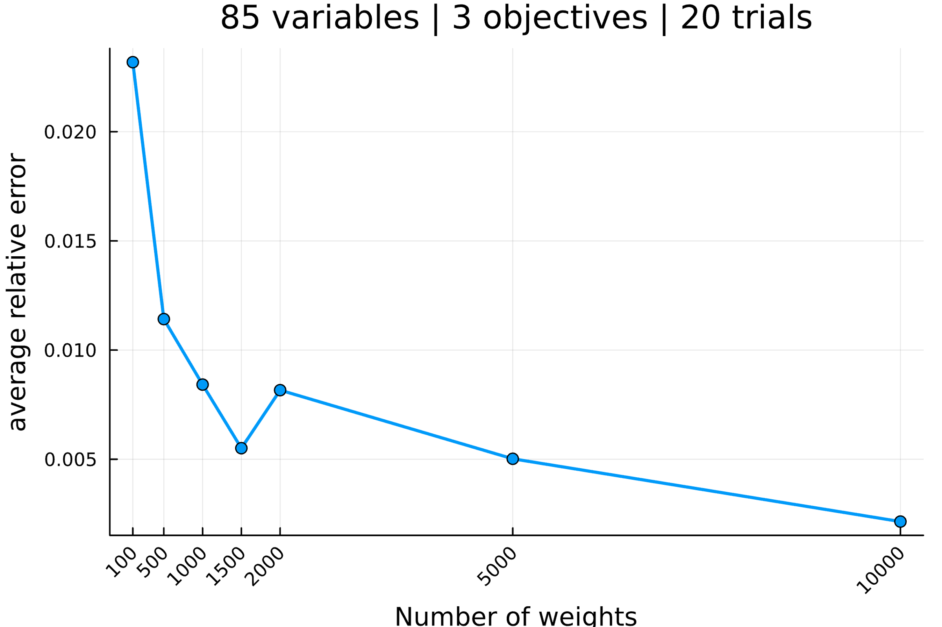

--------------------------------------------------------------------------------

Setup the parameters...

number of variables : 90

number of objectives : 3

reference point : [0, 0, 0]

interval of #weights : [(100, 100), (500, 500), (1000, 1000), (1500, 1500), (2000, 2000), (5000, 5000), (10000, 10000)]

solver MIP invoked : GLPK.Optimizer

number of trials : 20

Generate an mo01UKP instance...

Compute S, the set of nondominated points...

|S| = 1449 (162.75s)

Compute H, the hypervolume measure...

H(S) = 53804123672.0

Compute H̃, the estimation of H...

H estimated with rp=[0, 0, 0] and 100 weight: 52744426860.0 (0.32s)

H estimated with rp=[0, 0, 0] and 100 weight: 52721139828.4 (0.16s)

H estimated with rp=[0, 0, 0] and 100 weight: 59587522621.4 (0.15s)

H estimated with rp=[0, 0, 0] and 100 weight: 53952359261.3 (0.13s)

H estimated with rp=[0, 0, 0] and 100 weight: 53059055799.9 (0.13s)

H estimated with rp=[0, 0, 0] and 100 weight: 53462713886.5 (0.17s)

H estimated with rp=[0, 0, 0] and 100 weight: 53811726919.2 (0.15s)

H estimated with rp=[0, 0, 0] and 100 weight: 55223688488.3 (0.14s)

H estimated with rp=[0, 0, 0] and 100 weight: 52410108293.8 (0.12s)

H estimated with rp=[0, 0, 0] and 100 weight: 54656003745.2 (0.14s)

H estimated with rp=[0, 0, 0] and 100 weight: 53238273802.2 (0.13s)

H estimated with rp=[0, 0, 0] and 100 weight: 52645631092.1 (0.14s)

H estimated with rp=[0, 0, 0] and 100 weight: 54490251342.4 (0.17s)

H estimated with rp=[0, 0, 0] and 100 weight: 53313014094.6 (0.1s)

H estimated with rp=[0, 0, 0] and 100 weight: 52460076148.0 (0.14s)

H estimated with rp=[0, 0, 0] and 100 weight: 50359132687.2 (0.13s)

H estimated with rp=[0, 0, 0] and 100 weight: 51499408445.6 (0.14s)

H estimated with rp=[0, 0, 0] and 100 weight: 49277163328.7 (0.13s)

H estimated with rp=[0, 0, 0] and 100 weight: 53764738035.2 (0.15s)

H estimated with rp=[0, 0, 0] and 100 weight: 51777545384.4 (0.13s)

Analyze the results...

value H(S) = 53804123672.0

average value H̃ = 53222699003.2

average absolue error H̃ = 1471105703.4

average relative error H̃ = 0.027342

Compute H̃, the estimation of H...

H estimated with rp=[0, 0, 0] and 500 weight: 55212448198.8 (0.72s)

H estimated with rp=[0, 0, 0] and 500 weight: 54189162683.2 (0.68s)

H estimated with rp=[0, 0, 0] and 500 weight: 53757723599.3 (0.72s)

H estimated with rp=[0, 0, 0] and 500 weight: 52340084368.2 (0.63s)

H estimated with rp=[0, 0, 0] and 500 weight: 54014998409.6 (0.68s)

H estimated with rp=[0, 0, 0] and 500 weight: 53085410504.8 (0.66s)

H estimated with rp=[0, 0, 0] and 500 weight: 53250802724.9 (0.66s)

H estimated with rp=[0, 0, 0] and 500 weight: 54264140682.5 (0.75s)

H estimated with rp=[0, 0, 0] and 500 weight: 55589487299.2 (0.72s)

H estimated with rp=[0, 0, 0] and 500 weight: 54270600418.5 (0.68s)

H estimated with rp=[0, 0, 0] and 500 weight: 53471413984.7 (0.62s)

H estimated with rp=[0, 0, 0] and 500 weight: 53445871885.2 (0.68s)

H estimated with rp=[0, 0, 0] and 500 weight: 53041127913.8 (0.7s)

H estimated with rp=[0, 0, 0] and 500 weight: 54365642898.1 (0.68s)

H estimated with rp=[0, 0, 0] and 500 weight: 54194356331.7 (0.65s)

H estimated with rp=[0, 0, 0] and 500 weight: 53829386012.0 (0.73s)

H estimated with rp=[0, 0, 0] and 500 weight: 54388600482.0 (0.66s)

H estimated with rp=[0, 0, 0] and 500 weight: 52205063187.9 (0.66s)

H estimated with rp=[0, 0, 0] and 500 weight: 53493223263.3 (0.64s)

H estimated with rp=[0, 0, 0] and 500 weight: 53920433317.6 (0.65s)

Analyze the results...

value H(S) = 53804123672.0

average value H̃ = 53816498908.3

average absolue error H̃ = 627014397.9

average relative error H̃ = 0.011654

Compute H̃, the estimation of H...

H estimated with rp=[0, 0, 0] and 1000 weight: 54383219302.4 (1.32s)

H estimated with rp=[0, 0, 0] and 1000 weight: 54178181155.2 (1.37s)

H estimated with rp=[0, 0, 0] and 1000 weight: 53503390916.7 (1.41s)

H estimated with rp=[0, 0, 0] and 1000 weight: 53138126828.7 (1.32s)

H estimated with rp=[0, 0, 0] and 1000 weight: 54380742411.1 (1.35s)

H estimated with rp=[0, 0, 0] and 1000 weight: 54356614860.9 (1.42s)

H estimated with rp=[0, 0, 0] and 1000 weight: 54195895465.8 (1.39s)

H estimated with rp=[0, 0, 0] and 1000 weight: 53933382803.4 (1.38s)

H estimated with rp=[0, 0, 0] and 1000 weight: 54401880763.3 (1.39s)

H estimated with rp=[0, 0, 0] and 1000 weight: 53864121346.3 (1.41s)

H estimated with rp=[0, 0, 0] and 1000 weight: 53483714368.1 (1.38s)

H estimated with rp=[0, 0, 0] and 1000 weight: 54228891725.2 (1.6s)

H estimated with rp=[0, 0, 0] and 1000 weight: 53260336508.6 (1.28s)

H estimated with rp=[0, 0, 0] and 1000 weight: 53309115688.2 (1.36s)

H estimated with rp=[0, 0, 0] and 1000 weight: 54893733331.9 (1.45s)

H estimated with rp=[0, 0, 0] and 1000 weight: 53748931266.3 (1.32s)

H estimated with rp=[0, 0, 0] and 1000 weight: 54373137384.2 (1.36s)

H estimated with rp=[0, 0, 0] and 1000 weight: 54198503818.0 (1.42s)

H estimated with rp=[0, 0, 0] and 1000 weight: 53981097842.9 (1.4s)

H estimated with rp=[0, 0, 0] and 1000 weight: 52924637850.2 (1.28s)

Analyze the results...

value H(S) = 53804123672.0

average value H̃ = 53936882781.9

average absolue error H̃ = 458820337.6

average relative error H̃ = 0.008528

Compute H̃, the estimation of H...

H estimated with rp=[0, 0, 0] and 1500 weight: 53656378338.2 (2.13s)

H estimated with rp=[0, 0, 0] and 1500 weight: 54220376231.2 (2.18s)

H estimated with rp=[0, 0, 0] and 1500 weight: 54487566162.0 (2.17s)

H estimated with rp=[0, 0, 0] and 1500 weight: 53411335644.7 (1.96s)

H estimated with rp=[0, 0, 0] and 1500 weight: 53034343516.9 (2.08s)

H estimated with rp=[0, 0, 0] and 1500 weight: 52856426772.7 (1.96s)

H estimated with rp=[0, 0, 0] and 1500 weight: 54083005997.7 (2.16s)

H estimated with rp=[0, 0, 0] and 1500 weight: 53441905509.0 (2.16s)

H estimated with rp=[0, 0, 0] and 1500 weight: 53661310557.7 (2.03s)

H estimated with rp=[0, 0, 0] and 1500 weight: 54093975441.4 (2.1s)

H estimated with rp=[0, 0, 0] and 1500 weight: 54166225403.2 (2.06s)

H estimated with rp=[0, 0, 0] and 1500 weight: 53071122744.1 (2.05s)

H estimated with rp=[0, 0, 0] and 1500 weight: 53733635607.7 (2.06s)

H estimated with rp=[0, 0, 0] and 1500 weight: 54036884151.3 (2.11s)

H estimated with rp=[0, 0, 0] and 1500 weight: 54347915980.7 (2.1s)

H estimated with rp=[0, 0, 0] and 1500 weight: 53223234574.2 (1.99s)

H estimated with rp=[0, 0, 0] and 1500 weight: 53663967811.2 (1.96s)

H estimated with rp=[0, 0, 0] and 1500 weight: 53364132357.9 (1.95s)

H estimated with rp=[0, 0, 0] and 1500 weight: 54075793251.8 (2.12s)

H estimated with rp=[0, 0, 0] and 1500 weight: 53052445103.1 (2.02s)

Analyze the results...

value H(S) = 53804123672.0

average value H̃ = 53684099057.8

average absolue error H̃ = 427899938.5

average relative error H̃ = 0.007953

Compute H̃, the estimation of H...

H estimated with rp=[0, 0, 0] and 2000 weight: 52924964817.7 (2.63s)

H estimated with rp=[0, 0, 0] and 2000 weight: 53310558019.7 (2.61s)

H estimated with rp=[0, 0, 0] and 2000 weight: 54355064903.2 (2.81s)

H estimated with rp=[0, 0, 0] and 2000 weight: 53307842272.8 (2.72s)

H estimated with rp=[0, 0, 0] and 2000 weight: 53501777993.0 (2.83s)

H estimated with rp=[0, 0, 0] and 2000 weight: 53551023204.1 (2.76s)

H estimated with rp=[0, 0, 0] and 2000 weight: 53644630142.1 (2.73s)

H estimated with rp=[0, 0, 0] and 2000 weight: 53687016541.6 (2.66s)

H estimated with rp=[0, 0, 0] and 2000 weight: 54292411089.3 (2.8s)

H estimated with rp=[0, 0, 0] and 2000 weight: 53166451127.2 (2.6s)

H estimated with rp=[0, 0, 0] and 2000 weight: 53224165965.7 (2.6s)

H estimated with rp=[0, 0, 0] and 2000 weight: 53399137446.3 (2.74s)

H estimated with rp=[0, 0, 0] and 2000 weight: 54043088306.5 (2.83s)

H estimated with rp=[0, 0, 0] and 2000 weight: 53157460966.7 (2.66s)

H estimated with rp=[0, 0, 0] and 2000 weight: 53996918507.9 (2.76s)

H estimated with rp=[0, 0, 0] and 2000 weight: 54326058846.0 (2.81s)

H estimated with rp=[0, 0, 0] and 2000 weight: 53922555304.1 (2.84s)

H estimated with rp=[0, 0, 0] and 2000 weight: 53750124707.5 (2.74s)

H estimated with rp=[0, 0, 0] and 2000 weight: 53977098333.2 (2.86s)

H estimated with rp=[0, 0, 0] and 2000 weight: 53344502048.2 (2.77s)

Analyze the results...

value H(S) = 53804123672.0

average value H̃ = 53644142527.1

average absolue error H̃ = 388414103.5

average relative error H̃ = 0.007219

Compute H̃, the estimation of H...

H estimated with rp=[0, 0, 0] and 5000 weight: 53858007885.7 (6.93s)

H estimated with rp=[0, 0, 0] and 5000 weight: 53733282594.9 (6.79s)

H estimated with rp=[0, 0, 0] and 5000 weight: 53483143718.6 (6.88s)

H estimated with rp=[0, 0, 0] and 5000 weight: 53618917932.7 (6.95s)

H estimated with rp=[0, 0, 0] and 5000 weight: 53799240012.2 (6.87s)

H estimated with rp=[0, 0, 0] and 5000 weight: 53791071617.3 (6.81s)

H estimated with rp=[0, 0, 0] and 5000 weight: 53903651735.2 (7.08s)

H estimated with rp=[0, 0, 0] and 5000 weight: 53882082578.8 (6.93s)

H estimated with rp=[0, 0, 0] and 5000 weight: 54163491927.4 (6.88s)

H estimated with rp=[0, 0, 0] and 5000 weight: 53735684339.8 (6.85s)

H estimated with rp=[0, 0, 0] and 5000 weight: 53449564396.1 (6.9s)

H estimated with rp=[0, 0, 0] and 5000 weight: 54073419507.1 (6.9s)

H estimated with rp=[0, 0, 0] and 5000 weight: 53901261425.0 (6.94s)

H estimated with rp=[0, 0, 0] and 5000 weight: 53955022751.8 (6.94s)

H estimated with rp=[0, 0, 0] and 5000 weight: 53310164855.3 (6.87s)

H estimated with rp=[0, 0, 0] and 5000 weight: 53731559045.6 (6.76s)

H estimated with rp=[0, 0, 0] and 5000 weight: 53749025139.1 (6.95s)

H estimated with rp=[0, 0, 0] and 5000 weight: 53548589267.9 (6.9s)

H estimated with rp=[0, 0, 0] and 5000 weight: 53788225040.5 (6.91s)

H estimated with rp=[0, 0, 0] and 5000 weight: 53758109918.9 (6.88s)

Analyze the results...

value H(S) = 53804123672.0

average value H̃ = 53761675784.5

average absolue error H̃ = 153255098.2

average relative error H̃ = 0.002848

Compute H̃, the estimation of H...

H estimated with rp=[0, 0, 0] and 10000 weight: 54141355952.5 (14.08s)

H estimated with rp=[0, 0, 0] and 10000 weight: 54115810879.8 (14.24s)

H estimated with rp=[0, 0, 0] and 10000 weight: 53952668293.2 (14.02s)

H estimated with rp=[0, 0, 0] and 10000 weight: 53862942291.0 (13.61s)

H estimated with rp=[0, 0, 0] and 10000 weight: 53902924960.3 (13.9s)

H estimated with rp=[0, 0, 0] and 10000 weight: 54047867478.2 (13.76s)

H estimated with rp=[0, 0, 0] and 10000 weight: 53112527819.3 (13.76s)

H estimated with rp=[0, 0, 0] and 10000 weight: 53931689056.5 (13.67s)

H estimated with rp=[0, 0, 0] and 10000 weight: 53935514521.5 (14.06s)

H estimated with rp=[0, 0, 0] and 10000 weight: 53699356435.4 (13.83s)

H estimated with rp=[0, 0, 0] and 10000 weight: 53665968693.1 (13.4s)

H estimated with rp=[0, 0, 0] and 10000 weight: 53762346677.4 (13.74s)

H estimated with rp=[0, 0, 0] and 10000 weight: 54153447975.5 (13.97s)

H estimated with rp=[0, 0, 0] and 10000 weight: 54071997253.1 (14.2s)

H estimated with rp=[0, 0, 0] and 10000 weight: 53926554790.9 (13.79s)

H estimated with rp=[0, 0, 0] and 10000 weight: 53672626607.0 (13.85s)

H estimated with rp=[0, 0, 0] and 10000 weight: 53924238252.3 (13.61s)

H estimated with rp=[0, 0, 0] and 10000 weight: 53905794289.3 (13.96s)

H estimated with rp=[0, 0, 0] and 10000 weight: 54017280156.7 (13.98s)

H estimated with rp=[0, 0, 0] and 10000 weight: 53955248527.4 (13.81s)

Analyze the results...

value H(S) = 53804123672.0

average value H̃ = 53887908045.5

average absolue error H̃ = 194563586.3

average relative error H̃ = 0.003616

All average relative error H̃ = [0.027341876476428956, 0.011653649480120994, 0.008527605437542388, 0.007952920878461039, 0.007219039675242159, 0.0028483894494080353, 0.0036161463662737195]

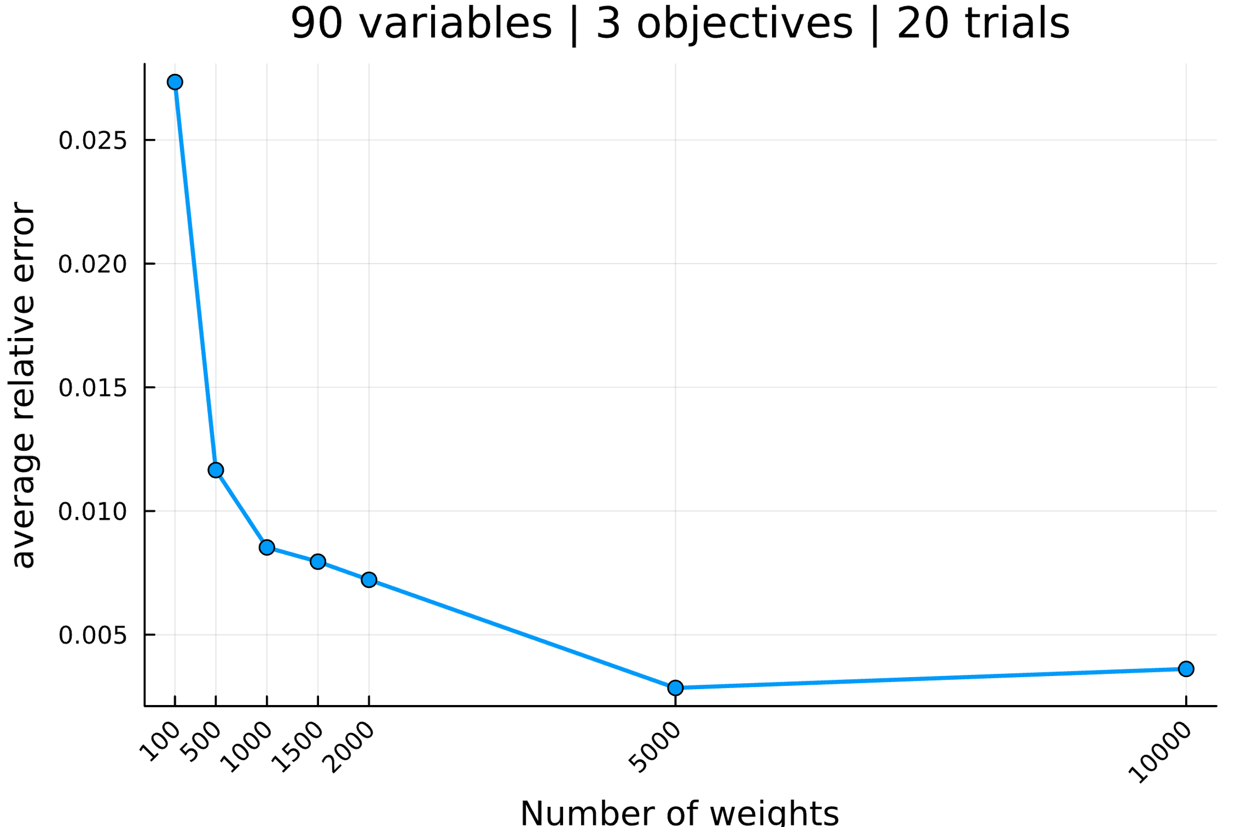

--------------------------------------------------------------------------------

Setup the parameters...

number of variables : 95

number of objectives : 3

reference point : [0, 0, 0]

interval of #weights : [(100, 100), (500, 500), (1000, 1000), (1500, 1500), (2000, 2000), (5000, 5000), (10000, 10000)]

solver MIP invoked : GLPK.Optimizer

number of trials : 20

Generate an mo01UKP instance...

Compute S, the set of nondominated points...

|S| = 3598 (1251.49s)

Compute H, the hypervolume measure...

H(S) = 61642484664.0

Compute H̃, the estimation of H...

H estimated with rp=[0, 0, 0] and 100 weight: 60327309680.5 (0.47s)

H estimated with rp=[0, 0, 0] and 100 weight: 64341997392.3 (0.31s)

H estimated with rp=[0, 0, 0] and 100 weight: 58857857304.2 (0.28s)

H estimated with rp=[0, 0, 0] and 100 weight: 63807374787.3 (0.31s)

H estimated with rp=[0, 0, 0] and 100 weight: 61142782392.2 (0.31s)

H estimated with rp=[0, 0, 0] and 100 weight: 59767008903.9 (0.25s)

H estimated with rp=[0, 0, 0] and 100 weight: 62686819484.5 (0.31s)

H estimated with rp=[0, 0, 0] and 100 weight: 63137649973.2 (0.28s)

H estimated with rp=[0, 0, 0] and 100 weight: 65312818437.7 (0.26s)

H estimated with rp=[0, 0, 0] and 100 weight: 58789973670.3 (0.24s)

H estimated with rp=[0, 0, 0] and 100 weight: 59646763888.6 (0.27s)

H estimated with rp=[0, 0, 0] and 100 weight: 62314995331.1 (0.27s)

H estimated with rp=[0, 0, 0] and 100 weight: 62771552902.8 (0.28s)

H estimated with rp=[0, 0, 0] and 100 weight: 59854448881.7 (0.28s)

H estimated with rp=[0, 0, 0] and 100 weight: 62941094855.1 (0.33s)

H estimated with rp=[0, 0, 0] and 100 weight: 62957702698.9 (0.28s)

H estimated with rp=[0, 0, 0] and 100 weight: 66658103890.7 (0.33s)

H estimated with rp=[0, 0, 0] and 100 weight: 60639194081.8 (0.28s)

H estimated with rp=[0, 0, 0] and 100 weight: 63638958127.3 (0.26s)

H estimated with rp=[0, 0, 0] and 100 weight: 63068724809.1 (0.31s)

Analyze the results...

value H(S) = 61642484664.0

average value H̃ = 62133156574.7

average absolue error H̃ = 1902125761.5

average relative error H̃ = 0.030857

Compute H̃, the estimation of H...

H estimated with rp=[0, 0, 0] and 500 weight: 61030572133.3 (1.3s)

H estimated with rp=[0, 0, 0] and 500 weight: 59458343315.9 (1.24s)

H estimated with rp=[0, 0, 0] and 500 weight: 62866765922.5 (1.45s)

H estimated with rp=[0, 0, 0] and 500 weight: 61316736887.1 (1.38s)

H estimated with rp=[0, 0, 0] and 500 weight: 60587186104.5 (1.42s)

H estimated with rp=[0, 0, 0] and 500 weight: 64085990522.3 (1.6s)

H estimated with rp=[0, 0, 0] and 500 weight: 60882292564.7 (1.43s)

H estimated with rp=[0, 0, 0] and 500 weight: 61862507150.8 (1.31s)

H estimated with rp=[0, 0, 0] and 500 weight: 60036613868.4 (1.23s)

H estimated with rp=[0, 0, 0] and 500 weight: 62913014416.7 (1.4s)

H estimated with rp=[0, 0, 0] and 500 weight: 59730603718.1 (1.37s)

H estimated with rp=[0, 0, 0] and 500 weight: 62182095639.8 (1.44s)

H estimated with rp=[0, 0, 0] and 500 weight: 62481649270.9 (1.4s)

H estimated with rp=[0, 0, 0] and 500 weight: 61761920660.3 (1.34s)

H estimated with rp=[0, 0, 0] and 500 weight: 61411527462.7 (1.49s)

H estimated with rp=[0, 0, 0] and 500 weight: 61436876061.8 (1.47s)

H estimated with rp=[0, 0, 0] and 500 weight: 61760271348.8 (1.36s)

H estimated with rp=[0, 0, 0] and 500 weight: 62177383974.7 (1.44s)

H estimated with rp=[0, 0, 0] and 500 weight: 60722670832.4 (1.39s)

H estimated with rp=[0, 0, 0] and 500 weight: 63153484472.1 (1.44s)

Analyze the results...

value H(S) = 61642484664.0

average value H̃ = 61592925316.4

average absolue error H̃ = 931583021.5

average relative error H̃ = 0.015113

Compute H̃, the estimation of H...

H estimated with rp=[0, 0, 0] and 1000 weight: 60991412223.4 (2.7s)

H estimated with rp=[0, 0, 0] and 1000 weight: 62115447693.9 (2.72s)

H estimated with rp=[0, 0, 0] and 1000 weight: 62206276605.7 (2.65s)

H estimated with rp=[0, 0, 0] and 1000 weight: 62129073164.4 (2.79s)

H estimated with rp=[0, 0, 0] and 1000 weight: 61839453595.1 (2.9s)

H estimated with rp=[0, 0, 0] and 1000 weight: 61691687112.1 (2.83s)

H estimated with rp=[0, 0, 0] and 1000 weight: 61558735723.2 (2.63s)

H estimated with rp=[0, 0, 0] and 1000 weight: 61612720403.7 (2.67s)

H estimated with rp=[0, 0, 0] and 1000 weight: 60594943451.7 (2.74s)

H estimated with rp=[0, 0, 0] and 1000 weight: 61344515928.0 (2.78s)

H estimated with rp=[0, 0, 0] and 1000 weight: 61643098755.2 (2.7s)

H estimated with rp=[0, 0, 0] and 1000 weight: 61737138709.7 (2.73s)

H estimated with rp=[0, 0, 0] and 1000 weight: 62076714422.3 (2.82s)

H estimated with rp=[0, 0, 0] and 1000 weight: 61385578781.9 (2.98s)

H estimated with rp=[0, 0, 0] and 1000 weight: 62348659459.8 (2.77s)

H estimated with rp=[0, 0, 0] and 1000 weight: 62231995077.0 (2.85s)

H estimated with rp=[0, 0, 0] and 1000 weight: 61587427063.8 (2.65s)

H estimated with rp=[0, 0, 0] and 1000 weight: 63936738262.0 (3.03s)

H estimated with rp=[0, 0, 0] and 1000 weight: 60910500791.0 (2.68s)

H estimated with rp=[0, 0, 0] and 1000 weight: 61222937731.6 (2.65s)

Analyze the results...

value H(S) = 61642484664.0

average value H̃ = 61758252747.8

average absolue error H̃ = 473127071.6

average relative error H̃ = 0.007675

Compute H̃, the estimation of H...

H estimated with rp=[0, 0, 0] and 1500 weight: 61419424387.6 (4.1s)

H estimated with rp=[0, 0, 0] and 1500 weight: 61696920236.2 (4.02s)

H estimated with rp=[0, 0, 0] and 1500 weight: 62517256162.8 (4.12s)

H estimated with rp=[0, 0, 0] and 1500 weight: 61107700365.6 (3.99s)

H estimated with rp=[0, 0, 0] and 1500 weight: 60898026691.2 (4.19s)

H estimated with rp=[0, 0, 0] and 1500 weight: 60569495765.2 (4.09s)

H estimated with rp=[0, 0, 0] and 1500 weight: 61821720430.5 (4.3s)

H estimated with rp=[0, 0, 0] and 1500 weight: 61865891223.5 (4.05s)

H estimated with rp=[0, 0, 0] and 1500 weight: 61298410533.1 (4.04s)

H estimated with rp=[0, 0, 0] and 1500 weight: 61509408580.2 (4.15s)

H estimated with rp=[0, 0, 0] and 1500 weight: 61422026930.3 (4.11s)

H estimated with rp=[0, 0, 0] and 1500 weight: 62287351215.6 (4.22s)

H estimated with rp=[0, 0, 0] and 1500 weight: 62132311883.7 (4.22s)

H estimated with rp=[0, 0, 0] and 1500 weight: 61070373150.4 (4.09s)

H estimated with rp=[0, 0, 0] and 1500 weight: 61663424766.8 (4.22s)

H estimated with rp=[0, 0, 0] and 1500 weight: 60449895145.8 (3.98s)

H estimated with rp=[0, 0, 0] and 1500 weight: 62673100636.3 (4.36s)

H estimated with rp=[0, 0, 0] and 1500 weight: 61804692711.8 (4.01s)

H estimated with rp=[0, 0, 0] and 1500 weight: 60930148296.7 (4.22s)

H estimated with rp=[0, 0, 0] and 1500 weight: 61401028161.7 (4.07s)

Analyze the results...

value H(S) = 61642484664.0

average value H̃ = 61526930363.7

average absolue error H̃ = 483585029.4

average relative error H̃ = 0.007845

Compute H̃, the estimation of H...

H estimated with rp=[0, 0, 0] and 2000 weight: 61239643008.9 (5.5s)

H estimated with rp=[0, 0, 0] and 2000 weight: 61670367350.6 (5.66s)

H estimated with rp=[0, 0, 0] and 2000 weight: 61900035893.9 (5.59s)

H estimated with rp=[0, 0, 0] and 2000 weight: 61106243140.6 (5.63s)

H estimated with rp=[0, 0, 0] and 2000 weight: 61808498690.8 (5.59s)

H estimated with rp=[0, 0, 0] and 2000 weight: 61425321510.7 (5.62s)

H estimated with rp=[0, 0, 0] and 2000 weight: 62123454511.3 (5.63s)

H estimated with rp=[0, 0, 0] and 2000 weight: 61859240954.8 (5.61s)

H estimated with rp=[0, 0, 0] and 2000 weight: 62108788995.0 (5.84s)

H estimated with rp=[0, 0, 0] and 2000 weight: 61862522669.4 (5.67s)

H estimated with rp=[0, 0, 0] and 2000 weight: 61213930995.0 (5.38s)

H estimated with rp=[0, 0, 0] and 2000 weight: 61603027257.2 (5.62s)

H estimated with rp=[0, 0, 0] and 2000 weight: 61351104240.5 (5.64s)

H estimated with rp=[0, 0, 0] and 2000 weight: 61497149074.7 (5.72s)

H estimated with rp=[0, 0, 0] and 2000 weight: 62363631498.0 (5.74s)

H estimated with rp=[0, 0, 0] and 2000 weight: 63127707313.1 (5.99s)

H estimated with rp=[0, 0, 0] and 2000 weight: 61138584601.9 (5.57s)

H estimated with rp=[0, 0, 0] and 2000 weight: 61387876227.3 (5.42s)

H estimated with rp=[0, 0, 0] and 2000 weight: 61774296640.9 (5.75s)

H estimated with rp=[0, 0, 0] and 2000 weight: 62108118684.4 (5.78s)

Analyze the results...

value H(S) = 61642484664.0

average value H̃ = 61733477163.0

average absolue error H̃ = 372940690.9

average relative error H̃ = 0.006050

Compute H̃, the estimation of H...

H estimated with rp=[0, 0, 0] and 5000 weight: 61262686460.2 (13.75s)

H estimated with rp=[0, 0, 0] and 5000 weight: 61794441571.2 (13.91s)

H estimated with rp=[0, 0, 0] and 5000 weight: 61428639937.9 (13.79s)

H estimated with rp=[0, 0, 0] and 5000 weight: 61328020881.1 (13.75s)

H estimated with rp=[0, 0, 0] and 5000 weight: 61950152575.6 (13.81s)

H estimated with rp=[0, 0, 0] and 5000 weight: 61655482237.4 (13.72s)

H estimated with rp=[0, 0, 0] and 5000 weight: 61949767969.0 (13.68s)

H estimated with rp=[0, 0, 0] and 5000 weight: 61451409507.3 (13.88s)

H estimated with rp=[0, 0, 0] and 5000 weight: 61789406438.7 (13.92s)

H estimated with rp=[0, 0, 0] and 5000 weight: 61911745595.9 (14.12s)

H estimated with rp=[0, 0, 0] and 5000 weight: 61716084310.3 (13.72s)

H estimated with rp=[0, 0, 0] and 5000 weight: 61227894260.7 (13.69s)

H estimated with rp=[0, 0, 0] and 5000 weight: 61294106686.3 (14.01s)

H estimated with rp=[0, 0, 0] and 5000 weight: 61254867788.3 (13.66s)

H estimated with rp=[0, 0, 0] and 5000 weight: 61829844740.0 (14.13s)

H estimated with rp=[0, 0, 0] and 5000 weight: 61572913999.5 (13.95s)

H estimated with rp=[0, 0, 0] and 5000 weight: 61939672913.3 (14.17s)

H estimated with rp=[0, 0, 0] and 5000 weight: 61359804625.0 (13.91s)

H estimated with rp=[0, 0, 0] and 5000 weight: 61649496322.2 (14.13s)

H estimated with rp=[0, 0, 0] and 5000 weight: 61238191507.5 (13.65s)

Analyze the results...

value H(S) = 61642484664.0

average value H̃ = 61580231516.4

average absolue error H̃ = 238377951.0

average relative error H̃ = 0.003867

Compute H̃, the estimation of H...

H estimated with rp=[0, 0, 0] and 10000 weight: 61624592453.3 (27.87s)

H estimated with rp=[0, 0, 0] and 10000 weight: 61509770555.3 (27.6s)

H estimated with rp=[0, 0, 0] and 10000 weight: 61623346499.3 (28.32s)

H estimated with rp=[0, 0, 0] and 10000 weight: 61514252443.5 (27.7s)

H estimated with rp=[0, 0, 0] and 10000 weight: 61798475812.5 (28.48s)

H estimated with rp=[0, 0, 0] and 10000 weight: 61670572061.8 (27.44s)

H estimated with rp=[0, 0, 0] and 10000 weight: 61396188406.6 (27.36s)

H estimated with rp=[0, 0, 0] and 10000 weight: 61740158268.4 (27.84s)

H estimated with rp=[0, 0, 0] and 10000 weight: 61509655333.2 (27.71s)

H estimated with rp=[0, 0, 0] and 10000 weight: 61523200032.9 (27.55s)

H estimated with rp=[0, 0, 0] and 10000 weight: 61798270792.6 (27.74s)

H estimated with rp=[0, 0, 0] and 10000 weight: 61761500782.2 (28.04s)

H estimated with rp=[0, 0, 0] and 10000 weight: 61367137593.6 (27.55s)

H estimated with rp=[0, 0, 0] and 10000 weight: 61301340523.5 (27.61s)

H estimated with rp=[0, 0, 0] and 10000 weight: 61634682323.0 (27.87s)

H estimated with rp=[0, 0, 0] and 10000 weight: 61619778000.2 (27.74s)

H estimated with rp=[0, 0, 0] and 10000 weight: 61548424179.8 (27.47s)

H estimated with rp=[0, 0, 0] and 10000 weight: 61782591846.4 (28.02s)

H estimated with rp=[0, 0, 0] and 10000 weight: 61682407943.2 (28.4s)

H estimated with rp=[0, 0, 0] and 10000 weight: 61574604182.1 (27.26s)

Analyze the results...

value H(S) = 61642484664.0

average value H̃ = 61599047501.7

average absolue error H̃ = 117095648.2

average relative error H̃ = 0.001900

All average relative error H̃ = [0.030857383051805888, 0.015112677994310045, 0.007675340702641235, 0.007844995736500767, 0.006050059352901628, 0.003867104842929846, 0.001899593257331817]

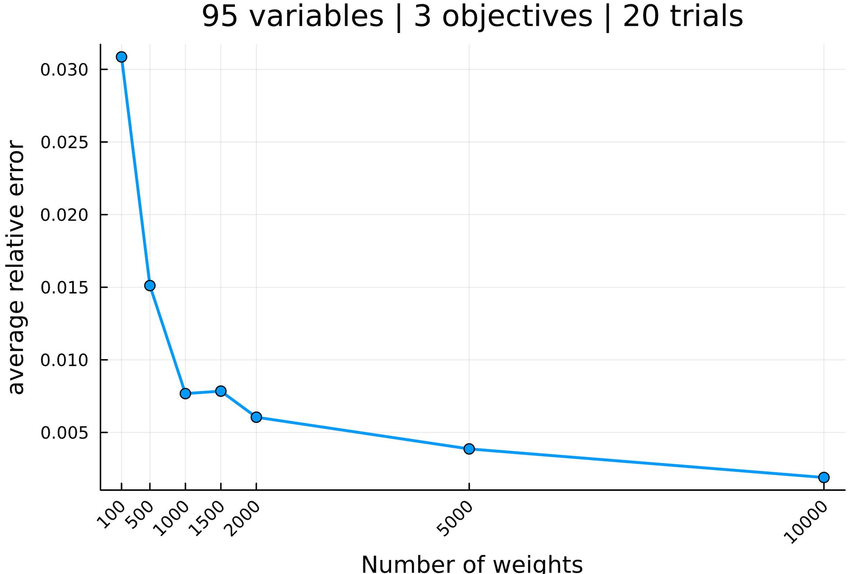

--------------------------------------------------------------------------------

Setup the parameters...

number of variables : 100

number of objectives : 3

reference point : [0, 0, 0]

interval of #weights : [(100, 100), (500, 500), (1000, 1000), (1500, 1500), (2000, 2000), (5000, 5000), (10000, 10000)]

solver MIP invoked : GLPK.Optimizer

number of trials : 20

Generate an mo01UKP instance...

Compute S, the set of nondominated points...

|S| = 2604 (656.35s)

Compute H, the hypervolume measure...

H(S) = 74337112839.0

Compute H̃, the estimation of H...

H estimated with rp=[0, 0, 0] and 100 weight: 74774415178.8 (0.41s)

H estimated with rp=[0, 0, 0] and 100 weight: 75578842389.9 (0.22s)

H estimated with rp=[0, 0, 0] and 100 weight: 74471076310.3 (0.21s)

H estimated with rp=[0, 0, 0] and 100 weight: 76213964078.7 (0.27s)

H estimated with rp=[0, 0, 0] and 100 weight: 69814987916.5 (0.15s)

H estimated with rp=[0, 0, 0] and 100 weight: 72723168641.6 (0.2s)

H estimated with rp=[0, 0, 0] and 100 weight: 71215089603.1 (0.19s)

H estimated with rp=[0, 0, 0] and 100 weight: 76235584442.1 (0.31s)

H estimated with rp=[0, 0, 0] and 100 weight: 74533658580.3 (0.23s)

H estimated with rp=[0, 0, 0] and 100 weight: 71229466799.1 (0.23s)

H estimated with rp=[0, 0, 0] and 100 weight: 76648384412.4 (0.3s)

H estimated with rp=[0, 0, 0] and 100 weight: 71025204550.6 (0.2s)

H estimated with rp=[0, 0, 0] and 100 weight: 73875492909.4 (0.2s)

H estimated with rp=[0, 0, 0] and 100 weight: 73639473619.4 (0.25s)

H estimated with rp=[0, 0, 0] and 100 weight: 74396896417.3 (0.26s)

H estimated with rp=[0, 0, 0] and 100 weight: 70205205551.0 (0.18s)

H estimated with rp=[0, 0, 0] and 100 weight: 75745623067.0 (0.19s)

H estimated with rp=[0, 0, 0] and 100 weight: 75690754581.9 (0.27s)

H estimated with rp=[0, 0, 0] and 100 weight: 74081584049.3 (0.25s)

H estimated with rp=[0, 0, 0] and 100 weight: 73714046329.2 (0.2s)

Analyze the results...

value H(S) = 74337112839.0

average value H̃ = 73790645971.4

average absolue error H̃ = 1638273974.5

average relative error H̃ = 0.022038

Compute H̃, the estimation of H...

H estimated with rp=[0, 0, 0] and 500 weight: 74382858375.0 (1.16s)

H estimated with rp=[0, 0, 0] and 500 weight: 74223598481.4 (1.17s)

H estimated with rp=[0, 0, 0] and 500 weight: 73020026813.0 (0.99s)

H estimated with rp=[0, 0, 0] and 500 weight: 75665873042.6 (1.13s)

H estimated with rp=[0, 0, 0] and 500 weight: 76257421836.2 (1.2s)

H estimated with rp=[0, 0, 0] and 500 weight: 73532510750.1 (1.12s)

H estimated with rp=[0, 0, 0] and 500 weight: 72874720681.9 (0.97s)

H estimated with rp=[0, 0, 0] and 500 weight: 74915238044.2 (1.18s)

H estimated with rp=[0, 0, 0] and 500 weight: 74695738282.7 (1.21s)

H estimated with rp=[0, 0, 0] and 500 weight: 73882209711.1 (1.21s)

H estimated with rp=[0, 0, 0] and 500 weight: 73365839059.0 (1.15s)

H estimated with rp=[0, 0, 0] and 500 weight: 74966481093.1 (1.15s)

H estimated with rp=[0, 0, 0] and 500 weight: 73387963527.3 (1.1s)

H estimated with rp=[0, 0, 0] and 500 weight: 75196751249.8 (1.06s)

H estimated with rp=[0, 0, 0] and 500 weight: 74849981018.7 (1.07s)

H estimated with rp=[0, 0, 0] and 500 weight: 74924974754.1 (1.1s)

H estimated with rp=[0, 0, 0] and 500 weight: 72882999893.4 (1.03s)

H estimated with rp=[0, 0, 0] and 500 weight: 72202845902.8 (1.09s)

H estimated with rp=[0, 0, 0] and 500 weight: 74037959293.4 (1.09s)

H estimated with rp=[0, 0, 0] and 500 weight: 76141202431.5 (1.28s)

Analyze the results...

value H(S) = 74337112839.0

average value H̃ = 74270359712.1

average absolue error H̃ = 929292300.7

average relative error H̃ = 0.012501

Compute H̃, the estimation of H...

H estimated with rp=[0, 0, 0] and 1000 weight: 72769955065.3 (2.12s)

H estimated with rp=[0, 0, 0] and 1000 weight: 74877208109.0 (2.44s)

H estimated with rp=[0, 0, 0] and 1000 weight: 75024179739.5 (2.38s)

H estimated with rp=[0, 0, 0] and 1000 weight: 73572854111.6 (2.19s)

H estimated with rp=[0, 0, 0] and 1000 weight: 73106395673.9 (2.35s)

H estimated with rp=[0, 0, 0] and 1000 weight: 73038281676.8 (2.19s)

H estimated with rp=[0, 0, 0] and 1000 weight: 73594975236.6 (2.3s)

H estimated with rp=[0, 0, 0] and 1000 weight: 74509294686.5 (2.38s)

H estimated with rp=[0, 0, 0] and 1000 weight: 74322501781.8 (2.35s)

H estimated with rp=[0, 0, 0] and 1000 weight: 74985228700.9 (2.28s)

H estimated with rp=[0, 0, 0] and 1000 weight: 74800348168.2 (2.31s)

H estimated with rp=[0, 0, 0] and 1000 weight: 74601672625.9 (2.43s)

H estimated with rp=[0, 0, 0] and 1000 weight: 74113565906.1 (2.19s)

H estimated with rp=[0, 0, 0] and 1000 weight: 74072030948.2 (2.51s)

H estimated with rp=[0, 0, 0] and 1000 weight: 73997861226.7 (2.44s)

H estimated with rp=[0, 0, 0] and 1000 weight: 73307928942.1 (2.18s)

H estimated with rp=[0, 0, 0] and 1000 weight: 74754258639.6 (2.3s)

H estimated with rp=[0, 0, 0] and 1000 weight: 74057102691.9 (2.15s)

H estimated with rp=[0, 0, 0] and 1000 weight: 74594799596.8 (2.51s)

H estimated with rp=[0, 0, 0] and 1000 weight: 72914134151.4 (2.11s)

Analyze the results...

value H(S) = 74337112839.0

average value H̃ = 74050728883.9

average absolue error H̃ = 631392710.5

average relative error H̃ = 0.008494

Compute H̃, the estimation of H...

H estimated with rp=[0, 0, 0] and 1500 weight: 75036904564.7 (3.46s)

H estimated with rp=[0, 0, 0] and 1500 weight: 74581341383.7 (3.54s)

H estimated with rp=[0, 0, 0] and 1500 weight: 75223819142.3 (3.44s)

H estimated with rp=[0, 0, 0] and 1500 weight: 74357904965.2 (3.26s)

H estimated with rp=[0, 0, 0] and 1500 weight: 74304014024.2 (3.5s)

H estimated with rp=[0, 0, 0] and 1500 weight: 74556718593.1 (3.66s)

H estimated with rp=[0, 0, 0] and 1500 weight: 74986144390.8 (3.52s)

H estimated with rp=[0, 0, 0] and 1500 weight: 74142925937.6 (3.48s)

H estimated with rp=[0, 0, 0] and 1500 weight: 74424149576.8 (3.35s)

H estimated with rp=[0, 0, 0] and 1500 weight: 74200858474.7 (3.56s)

H estimated with rp=[0, 0, 0] and 1500 weight: 73256407488.0 (3.15s)

H estimated with rp=[0, 0, 0] and 1500 weight: 74962340824.9 (3.38s)

H estimated with rp=[0, 0, 0] and 1500 weight: 74994547631.5 (3.53s)

H estimated with rp=[0, 0, 0] and 1500 weight: 73548425067.1 (3.27s)

H estimated with rp=[0, 0, 0] and 1500 weight: 74256341822.9 (3.34s)

H estimated with rp=[0, 0, 0] and 1500 weight: 74740761693.5 (3.54s)

H estimated with rp=[0, 0, 0] and 1500 weight: 74327399436.9 (3.58s)

H estimated with rp=[0, 0, 0] and 1500 weight: 74575937620.6 (3.65s)

H estimated with rp=[0, 0, 0] and 1500 weight: 74110116468.5 (3.24s)

H estimated with rp=[0, 0, 0] and 1500 weight: 74666607165.7 (3.62s)

Analyze the results...

value H(S) = 74337112839.0

average value H̃ = 74462683313.6

average absolue error H̃ = 380611873.8

average relative error H̃ = 0.005120

Compute H̃, the estimation of H...

H estimated with rp=[0, 0, 0] and 2000 weight: 74588874423.6 (4.54s)

H estimated with rp=[0, 0, 0] and 2000 weight: 74321511784.4 (4.32s)

H estimated with rp=[0, 0, 0] and 2000 weight: 74776344754.6 (4.58s)

H estimated with rp=[0, 0, 0] and 2000 weight: 74535321138.5 (4.56s)

H estimated with rp=[0, 0, 0] and 2000 weight: 73939051988.7 (4.47s)

H estimated with rp=[0, 0, 0] and 2000 weight: 74674391283.2 (4.73s)

H estimated with rp=[0, 0, 0] and 2000 weight: 74356168131.2 (4.64s)

H estimated with rp=[0, 0, 0] and 2000 weight: 74832027334.6 (4.28s)

H estimated with rp=[0, 0, 0] and 2000 weight: 74231173464.7 (4.53s)

H estimated with rp=[0, 0, 0] and 2000 weight: 73655474612.7 (4.39s)

H estimated with rp=[0, 0, 0] and 2000 weight: 75621425018.7 (4.85s)

H estimated with rp=[0, 0, 0] and 2000 weight: 73611298539.4 (4.2s)

H estimated with rp=[0, 0, 0] and 2000 weight: 73949688902.8 (4.45s)

H estimated with rp=[0, 0, 0] and 2000 weight: 73915444731.1 (4.44s)

H estimated with rp=[0, 0, 0] and 2000 weight: 74725862712.1 (4.51s)

H estimated with rp=[0, 0, 0] and 2000 weight: 74797722391.3 (4.8s)

H estimated with rp=[0, 0, 0] and 2000 weight: 75155860215.6 (4.79s)

H estimated with rp=[0, 0, 0] and 2000 weight: 73579248455.7 (4.45s)

H estimated with rp=[0, 0, 0] and 2000 weight: 74809184514.1 (4.59s)

H estimated with rp=[0, 0, 0] and 2000 weight: 74736211357.7 (4.74s)

Analyze the results...

value H(S) = 74337112839.0

average value H̃ = 74440614287.7

average absolue error H̃ = 452902472.0

average relative error H̃ = 0.006093

Compute H̃, the estimation of H...

H estimated with rp=[0, 0, 0] and 5000 weight: 74874937774.2 (11.72s)

H estimated with rp=[0, 0, 0] and 5000 weight: 74169639451.1 (11.49s)

H estimated with rp=[0, 0, 0] and 5000 weight: 74634091348.7 (11.72s)

H estimated with rp=[0, 0, 0] and 5000 weight: 74695473848.8 (11.8s)

H estimated with rp=[0, 0, 0] and 5000 weight: 74275143681.5 (11.23s)

H estimated with rp=[0, 0, 0] and 5000 weight: 74035241384.4 (11.64s)

H estimated with rp=[0, 0, 0] and 5000 weight: 73848532185.0 (11.25s)

H estimated with rp=[0, 0, 0] and 5000 weight: 74299966434.5 (11.44s)

H estimated with rp=[0, 0, 0] and 5000 weight: 74314218588.2 (11.13s)

H estimated with rp=[0, 0, 0] and 5000 weight: 73441966151.7 (11.29s)

H estimated with rp=[0, 0, 0] and 5000 weight: 74123145967.4 (11.48s)

H estimated with rp=[0, 0, 0] and 5000 weight: 74284442104.4 (11.25s)

H estimated with rp=[0, 0, 0] and 5000 weight: 73784864500.5 (11.79s)

H estimated with rp=[0, 0, 0] and 5000 weight: 74428568534.9 (11.81s)

H estimated with rp=[0, 0, 0] and 5000 weight: 74580202978.2 (11.39s)

H estimated with rp=[0, 0, 0] and 5000 weight: 74418537140.7 (11.11s)

H estimated with rp=[0, 0, 0] and 5000 weight: 74389037307.1 (11.61s)

H estimated with rp=[0, 0, 0] and 5000 weight: 74212194354.8 (11.5s)

H estimated with rp=[0, 0, 0] and 5000 weight: 74331717713.7 (11.48s)

H estimated with rp=[0, 0, 0] and 5000 weight: 74308569530.4 (11.44s)

Analyze the results...

value H(S) = 74337112839.0

average value H̃ = 74272524549.0

average absolue error H̃ = 230694196.0

average relative error H̃ = 0.003103

Compute H̃, the estimation of H...

H estimated with rp=[0, 0, 0] and 10000 weight: 74170655798.1 (22.51s)

H estimated with rp=[0, 0, 0] and 10000 weight: 74144270948.1 (22.88s)

H estimated with rp=[0, 0, 0] and 10000 weight: 74455987427.3 (22.99s)

H estimated with rp=[0, 0, 0] and 10000 weight: 74500892719.0 (23.15s)

H estimated with rp=[0, 0, 0] and 10000 weight: 74888153546.2 (22.85s)

H estimated with rp=[0, 0, 0] and 10000 weight: 74354520450.1 (22.73s)

H estimated with rp=[0, 0, 0] and 10000 weight: 74418168043.1 (22.8s)

H estimated with rp=[0, 0, 0] and 10000 weight: 74730903836.1 (23.22s)

H estimated with rp=[0, 0, 0] and 10000 weight: 73985321705.6 (22.64s)

H estimated with rp=[0, 0, 0] and 10000 weight: 74722049206.2 (22.9s)

H estimated with rp=[0, 0, 0] and 10000 weight: 74109576847.7 (22.9s)

H estimated with rp=[0, 0, 0] and 10000 weight: 74440939964.6 (22.99s)

H estimated with rp=[0, 0, 0] and 10000 weight: 74439579111.1 (23.22s)

H estimated with rp=[0, 0, 0] and 10000 weight: 74648523611.4 (23.35s)

H estimated with rp=[0, 0, 0] and 10000 weight: 74195218821.2 (22.71s)

H estimated with rp=[0, 0, 0] and 10000 weight: 74528237484.1 (22.79s)

H estimated with rp=[0, 0, 0] and 10000 weight: 74417834475.0 (22.76s)

H estimated with rp=[0, 0, 0] and 10000 weight: 74445861414.1 (23.12s)

H estimated with rp=[0, 0, 0] and 10000 weight: 74354095428.9 (22.6s)

H estimated with rp=[0, 0, 0] and 10000 weight: 73967135332.9 (22.79s)

Analyze the results...

value H(S) = 74337112839.0

average value H̃ = 74395896308.5

average absolue error H̃ = 203833227.6

average relative error H̃ = 0.002742

All average relative error H̃ = [0.022038439642096758, 0.01250105452366588, 0.008493640476286465, 0.005120078777680977, 0.00609254858970998, 0.0031033515715183906, 0.002742011625001295]

